UNITED STATES
SECURITIES AND EXCHANGE COMMISSION
Washington, D.C. 20549
FORM 8-K
CURRENT REPORT
Pursuant to Section 13 OR 15(d) of the Securities Exchange Act of 1934

Date of Report (Date of earliest event reported): September 30, 2026

Progress Software Corporation
(Exact name of registrant as specified in its charter)

Delaware |  |  | 0-19417 |  |  | 04-2746201
(State or other jurisdiction of incorporation or organization) |  |  | (Commission file number) |  |  | (I.R.S. Employer Identification No.)
15 Wayside Road, Suite 400, Burlington, Massachusetts |  |  |  |  |  | 01803
(Address of principal executive offices) |  |  |  |  |  | (Zip code)
Registrant’s telephone number, including area code: (781) 280-4000
Not applicable
(Former name or former address, if changed since last report.)

Check the appropriate box below if the Form 8-K filing is intended to simultaneously satisfy the filing obligation of the registrant under any of the following provisions:
☐ |  |  | Written communications pursuant to Rule 425 under the Securities Act (17 CFR 230.425)
☐ |  |  | Soliciting material pursuant to Rule 14a-12 under the Exchange Act (17 CFR 240.14a-12)
☐ |  |  | Pre-commencement communications pursuant to Rule 14d-2(b) under the Exchange Act (17 CFR 240.14d-2(b))
☐ |  |  | Pre-commencement communications pursuant to Rule 13e-4(c) under the Exchange Act (17 CFR 240.13e-4(c))

Securities registered pursuant to Section 12(b) of the Act:
Title of each class |  |  |  |  |  | Trading Symbol(s) |  |  |  |  |  | Name of each exchange on which registered
Common Stock, $0.01 par value per share |  |  |  |  |  | PRGS |  |  |  |  |  | The Nasdaq Stock Market LLC

Indicate by check mark whether the registrant is an emerging growth company as defined in Rule 405 of the Securities Act of 1933 (§230.405 of this chapter) or Rule 12b-2 of the Securities Exchange Act of 1934 (§240.12b-2 of this chapter).

Emerging growth company ☐

If an emerging growth company, indicate by check mark if the registrant has elected not to use the extended transition period for complying with any new or revised financial accounting standards provided pursuant to Section 13(a) of the Exchange Act.
☐

Item 2.02 Results of Operations and Financial Condition

On September 30, 2026, Progress Software Corporation ("Progress") issued a press release announcing its financial results for the fiscal third quarter ended August 31, 2026. A copy of the press release is attached to this Current Report on Form 8-K as Exhibit 99.1 and is incorporated herein by reference.

The information furnished pursuant to this Item 2.02, including Exhibit 99.1, shall not be deemed "filed" for purposes of Section 18 of the Securities Exchange Act of 1934, as amended (the "Exchange Act"), or otherwise subject to the liability of that Section, and shall not be incorporated by reference into any other filing by Progress under the Securities Act of 1933, as amended (the "Securities Act"), or the Exchange Act, except as shall be expressly set forth by specific reference in such a filing.

Item 7.01 Regulation FD Disclosure

In connection with the issuance of the press release attached hereto as Exhibit 99.1, the supplemental data attached as Exhibit 99.2 to this Current Report will be available on the Progress website within the investor relations section prior to the live conference call.

The information furnished pursuant to this Item 7.01, including Exhibit 99.2, shall not be deemed "filed" for purposes of Section 18 of the Exchange Act, or otherwise subject to the liability of that Section, and shall not be incorporated by reference into any other filing by Progress under the Securities Act or the Exchange Act, except as shall be expressly set forth by specific reference in such a filing.

Item 9.01 Financial Statements and Exhibits

(d) Exhibits.
Exhibit No. |  |  |  |  |  | Description
99.1 |  |  |  |  |  | Press release issued by Progress Software Corporation dated September 30, 2026
99.2 |  |  |  |  |  | Q3 2026 Supplemental Data
104 |  |  |  |  |  | Cover Page Interactive Data File (embedded within the Inline XBRL document)

SIGNATURES
Pursuant to the requirements of the Securities Exchange Act of 1934, the registrant has duly caused this report to be signed on its behalf by the undersigned hereunto duly authorized.

Date: |  |  | September 30, 2026 |  |  | Progress Software Corporation
 |  |  |  |  |  | By: |  |  | /s/ ANTHONY FOLGER
 |  |  |  |  |  |  |  |  | Anthony Folger
 |  |  |  |  |  |  |  |  | Chief Financial Officer

 |  |  |  |  |  | Exhibit 99.1

P R E S S A N N O U N C E M E N T

Progress Software Announces Third Quarter 2026 Financial Results

ARR of $873 million grew 1% year-over-year
Acquisition of Domo's AI and Data Platform Business Closed

BURLINGTON, Mass., Sept. 30, 2026 — Progress Software (Nasdaq: PRGS), an AI infrastructure software leader, today announced financial results for its fiscal third quarter ended August 31, 2026.

Third Quarter 2026 Highlights:

•Revenue of $246 million decreased 2% year-over-year both on an actual and a constant currency basis.
•Annualized Recurring Revenue ("ARR") of $873 million increased 1% year-over-year on a constant currency basis.
•Operating margin was 19% and non-GAAP operating margin was 43%.
•Diluted earnings per share was $0.55 compared to $0.44 in the same quarter last year, an increase of 25%.
•Non-GAAP diluted earnings per share was $1.69 compared to $1.50 in the same quarter last year, an increase of 13%.

"This quarter's results reflect the strength of our strategy, the resilience of our business model, and the value our differentiated software portfolio delivers to customers worldwide," said Yogesh Gupta, CEO of Progress Software. "As organizations seek the context and control required to realize the full potential of AI, Progress is uniquely positioned to help them drive business outcomes with confidence. We delivered steady growth in ARR and earnings through strong execution and disciplined expense management, while continuing to improve our balance sheet. With the recent close of the Domo AI and Data platform acquisition, we are further strengthening our ability to help customers unlock the value of their data and accelerate AI-powered innovation."

Additional financial highlights included:
 |  |  | Three Months Ended
 |  |  | GAAP |  |  |  |  |  |  |  |  |  |  |  |  |  |  |  |  |  | Non-GAAP
(in thousands, except percentages and per share amounts) |  |  | August 31, 2026 |  |  |  |  |  | August 31, 2025 |  |  |  |  |  | % Change |  |  |  |  |  | August 31, 2026 |  |  |  |  |  | August 31, 2025 |  |  |  |  |  | % Change
Revenue |  |  | $ | 246,005 |  |  |  |  | $ | 249,795 |  |  |  |  | (2) |  | % |  |  |  | $ | 246,005 |  |  |  |  | $ | 249,795 |  |  |  |  | (2) |  | %
Income from operations |  |  | $ | 46,550 |  |  |  |  | $ | 43,874 |  |  |  |  | 6 |  | % |  |  |  | $ | 105,257 |  |  |  |  | $ | 99,423 |  |  |  |  | 6 |  | %
Operating margin |  |  | 19 |  | % |  |  |  | 18 |  | % |  |  |  | 100 bps |  |  |  |  |  | 43 |  | % |  |  |  | 40 |  | % |  |  |  | 300 bps
Net income |  |  | $ | 22,776 |  |  |  |  | $ | 19,413 |  |  |  |  | 17 |  | % |  |  |  | $ | 70,204 |  |  |  |  | $ | 65,723 |  |  |  |  | 7 |  | %
Diluted earnings per share |  |  | $ | 0.55 |  |  |  |  | $ | 0.44 |  |  |  |  | 25 |  | % |  |  |  | $ | 1.69 |  |  |  |  | $ | 1.50 |  |  |  |  | 13 |  | %
Cash from operations (GAAP) /  Adjusted free cash flow (non-GAAP) / Unlevered free cash flow (non-GAAP) |  |  | $ | 88,011 |  |  |  |  | $ | 73,446 |  |  |  |  | 20 |  | % |  |  |  | $ | 87,161 |  |  |  |  | $ | 74,428 |  |  |  |  | 17 |  | %
 |  |  |  |  |  |  |  |  |  |  |  |  |  |  |  |  |  |  |  |  | $ | 100,687 |  |  |  |  | $ | 88,617 |  |  |  |  | 14 |  | %

See Important Information Regarding Non-GAAP Financial Measures, Liquidity Measures, and Select Performance Metrics and a reconciliation of non-GAAP adjustments to Progress' GAAP financial results at the end of this press release.

Other fiscal third quarter 2026 metrics and recent results included:

•Cash and cash equivalents were $113.7 million at the end of the quarter.
•Days sales outstanding was 42 days compared to 55 days in the fiscal third quarter of 2025 and 73 days in the fiscal fourth quarter of 2025.

Anthony Folger, Progress CFO, said: "Our execution in the third quarter was very strong with year-over-year growth in ARR and adjusted free cash flow of more than 1% and 17%, respectively. In addition, we delivered a non-GAAP operating margin of 43%. All of this is a testament to the stability and durability of our business and the efficiency of our operating model. With the acquisition of Domo's AI and data platform business now closed, we look forward to integrating Domo and continuing to deliver on our Total Growth Strategy."

1
2026 Business Outlook

Progress provides the following guidance for the fiscal year ending November 30, 2026 and the fiscal fourth quarter ending November 30, 2026:
 |  |  | Updated FY 2026 Guidance  (September 30, 2026) |  |  |  |  |  |  |  |  |  |  |  | Prior FY 2026 Guidance  (June 30, 2026)
(in millions, except percentages and per share amounts) |  |  | GAAP |  |  |  |  |  | Non-GAAP |  |  |  |  |  | GAAP |  |  |  |  |  | Non-GAAP
Revenue |  |  | $1,044 - $1,052 |  |  |  |  |  | $1,044 - $1,052 |  |  |  |  |  | $990 - $1,002 |  |  |  |  |  | $990 - $1,002
Diluted earnings per share |  |  | $1.18 - $1.28 |  |  |  |  |  | $6.15 - $6.23 |  |  |  |  |  | $1.60 - $1.74 |  |  |  |  |  | $6.09 - $6.21
Operating margin |  |  | 13 |  | % |  |  |  | 38 |  | % |  |  |  | 16 |  | % |  |  |  | 39 |  | %
Cash from operations (GAAP) /  Adjusted free cash flow (non-GAAP) / Unlevered free cash flow (non-GAAP) |  |  | $274 - $282 |  |  |  |  |  | $275 - $283 |  |  |  |  |  | $273 - $285 |  |  |  |  |  | $271 - $283
 |  |  |  |  |  |  |  |  | $330 - $338 |  |  |  |  |  |  |  |  |  |  |  | $323 - $334
Effective tax rate |  |  | 25 |  | % |  |  |  | 20 |  | % |  |  |  | 25 |  | % |  |  |  | 20 |  | %

 |  |  | Q4 2026 Guidance
(in millions, except per share amounts) |  |  | GAAP |  |  |  |  |  | Non-GAAP
Revenue |  |  | $297 - $305 |  |  |  |  |  | $297 - $305
Diluted (loss) earnings per share |  |  | $(0.41) - $(0.32) |  |  |  |  |  | $1.24 - $1.33

Based on current exchange rates, the expected positive currency translation impact on our:

•Fiscal year 2026 business outlook compared to 2025 exchange rates is approximately $9.4 million on revenue.
•GAAP and non-GAAP diluted earnings per share for fiscal year 2026 is approximately $0.11.
•Fiscal Q4 2026 business outlook compared to 2025 exchange rates is approximately $0.6 million on revenue.
•GAAP and non-GAAP diluted (loss) earnings per share for fiscal Q4 2026 is approximately $0.02.

To the extent that there are changes in exchange rates versus the current environment and/or our expectations, this may have an impact on Progress' business outlook.

Conference Call

Progress will hold a conference call to review its financial results for the fiscal third quarter of 2026 at 5:00 p.m. ET on Wednesday, September 30, 2026. Participants must register for the conference call here: https://register-conf.media-server.com/register/BI8bdfec1cb044440bb00b3b72afef1db1. The webcast can be accessed at: https://edge.media-server.com/mmc/p/2rbf924z/. The conference call will include comments followed by questions and answers. Attendees must register for the webcast and an archived version of the conference call and supporting materials will be available on the Progress website within the investor relations section after the live conference call.

About Progress Software

Progress Software (Nasdaq: PRGS) provides the context and control organizations need to reliably extract value from AI—context drawn from an organization's data, content and workflows, and control over the security, governance and cost of their AI initiatives. Learn how hundreds of thousands of businesses, powering the work of tens of millions of professionals worldwide, realize value from trusted, enterprise-ready AI at www.progress.com.

Progress and Progress Software are trademarks or registered trademarks of Progress Software Corporation and/or its subsidiaries or affiliates in the U.S. and other countries. Any other names contained herein may be trademarks of their respective owners.
Investor Contact: |  |  |  |  |  | Press Contact:
Michael Micciche |  |  |  |  |  | Jeff Young
Progress Software |  |  |  |  |  | Progress Software
+1 781 850 8450 |  |  |  |  |  | +1 781 280 4000
Investor-Relations@progress.com |  |  |  |  |  | PR@progress.com

2
CONDENSED CONSOLIDATED STATEMENTS OF OPERATIONS
(Unaudited)
 |  |  | Three Months Ended |  |  |  |  |  |  |  |  |  |  |  |  |  |  |  |  |  | Nine Months Ended
(in thousands, except per share data) |  |  | August 31, 2026 |  |  |  |  |  | August 31, 2025 |  |  |  |  |  | % Change |  |  |  |  |  | August 31, 2026 |  |  |  |  |  | August 31, 2025 |  |  |  |  |  | % Change
Revenue:
Software licenses |  |  | $ | 63,556 |  |  |  |  | $ | 63,437 |  |  |  |  | — |  | % |  |  |  | $ | 200,116 |  |  |  |  | $ | 172,677 |  |  |  |  | 16 |  | %
Maintenance, SaaS, and professional services |  |  | 182,449 |  |  |  |  |  | 186,358 |  |  |  |  |  | (2) |  | % |  |  |  | 547,153 |  |  |  |  |  | 552,488 |  |  |  |  |  | (1) |  | %
Total revenue |  |  | 246,005 |  |  |  |  |  | 249,795 |  |  |  |  |  | (2) |  | % |  |  |  | 747,269 |  |  |  |  |  | 725,165 |  |  |  |  |  | 3 |  | %
Costs of revenue:
Cost of software licenses |  |  | 2,715 |  |  |  |  |  | 2,833 |  |  |  |  |  | (4) |  | % |  |  |  | 9,403 |  |  |  |  |  | 8,745 |  |  |  |  |  | 8 |  | %
Cost of maintenance, SaaS, and professional services |  |  | 30,815 |  |  |  |  |  | 33,919 |  |  |  |  |  | (9) |  | % |  |  |  | 95,174 |  |  |  |  |  | 100,567 |  |  |  |  |  | (5) |  | %
Amortization of acquired intangibles |  |  | 8,937 |  |  |  |  |  | 10,784 |  |  |  |  |  | (17) |  | % |  |  |  | 26,626 |  |  |  |  |  | 31,743 |  |  |  |  |  | (16) |  | %
Total costs of revenue |  |  | 42,467 |  |  |  |  |  | 47,536 |  |  |  |  |  | (11) |  | % |  |  |  | 131,203 |  |  |  |  |  | 141,055 |  |  |  |  |  | (7) |  | %
Gross profit |  |  | 203,538 |  |  |  |  |  | 202,259 |  |  |  |  |  | 1 |  | % |  |  |  | 616,066 |  |  |  |  |  | 584,110 |  |  |  |  |  | 5 |  | %
Operating expenses:
Sales and marketing |  |  | 50,462 |  |  |  |  |  | 51,850 |  |  |  |  |  | (3) |  | % |  |  |  | 156,800 |  |  |  |  |  | 152,823 |  |  |  |  |  | 3 |  | %
Product development |  |  | 46,054 |  |  |  |  |  | 49,432 |  |  |  |  |  | (7) |  | % |  |  |  | 145,368 |  |  |  |  |  | 142,377 |  |  |  |  |  | 2 |  | %
General and administrative |  |  | 26,781 |  |  |  |  |  | 28,308 |  |  |  |  |  | (5) |  | % |  |  |  | 85,521 |  |  |  |  |  | 79,568 |  |  |  |  |  | 7 |  | %
Amortization of acquired intangibles |  |  | 26,162 |  |  |  |  |  | 26,415 |  |  |  |  |  | (1) |  | % |  |  |  | 77,946 |  |  |  |  |  | 78,286 |  |  |  |  |  | — |  | %
Cyber vulnerability response expenses, net |  |  | 3,455 |  |  |  |  |  | 659 |  |  |  |  |  | 424 |  | % |  |  |  | 6,079 |  |  |  |  |  | 2,126 |  |  |  |  |  | 186 |  | %
Restructuring expenses |  |  | 146 |  |  |  |  |  | 907 |  |  |  |  |  | (84) |  | % |  |  |  | 2,332 |  |  |  |  |  | 8,979 |  |  |  |  |  | (74) |  | %
Acquisition-related expenses |  |  | 3,928 |  |  |  |  |  | 814 |  |  |  |  |  | 383 |  | % |  |  |  | 3,803 |  |  |  |  |  | 5,035 |  |  |  |  |  | (24) |  | %
Total operating expenses |  |  | 156,988 |  |  |  |  |  | 158,385 |  |  |  |  |  | (1) |  | % |  |  |  | 477,849 |  |  |  |  |  | 469,194 |  |  |  |  |  | 2 |  | %
Income from operations |  |  | 46,550 |  |  |  |  |  | 43,874 |  |  |  |  |  | 6 |  | % |  |  |  | 138,217 |  |  |  |  |  | 114,916 |  |  |  |  |  | 20 |  | %
Other expense, net |  |  | (17,017) |  |  |  |  |  | (17,668) |  |  |  |  |  | 4 |  | % |  |  |  | (49,552) |  |  |  |  |  | (55,544) |  |  |  |  |  | 11 |  | %
Income before income taxes |  |  | 29,533 |  |  |  |  |  | 26,206 |  |  |  |  |  | 13 |  | % |  |  |  | 88,665 |  |  |  |  |  | 59,372 |  |  |  |  |  | 49 |  | %
Provision for income taxes |  |  | 6,757 |  |  |  |  |  | 6,793 |  |  |  |  |  | (1) |  | % |  |  |  | 22,003 |  |  |  |  |  | 11,984 |  |  |  |  |  | 84 |  | %
Net income |  |  | $ | 22,776 |  |  |  |  | $ | 19,413 |  |  |  |  | 17 |  | % |  |  |  | $ | 66,662 |  |  |  |  | $ | 47,388 |  |  |  |  | 41 |  | %
Earnings per share:
Basic |  |  | $ | 0.55 |  |  |  |  | $ | 0.45 |  |  |  |  | 22 |  | % |  |  |  | $ | 1.60 |  |  |  |  | $ | 1.10 |  |  |  |  | 45 |  | %
Diluted |  |  | $ | 0.55 |  |  |  |  | $ | 0.44 |  |  |  |  | 25 |  | % |  |  |  | $ | 1.58 |  |  |  |  | $ | 1.07 |  |  |  |  | 48 |  | %
Weighted average shares outstanding:
Basic |  |  | 41,061 |  |  |  |  |  | 42,988 |  |  |  |  |  | (4) |  | % |  |  |  | 41,706 |  |  |  |  |  | 43,099 |  |  |  |  |  | (3) |  | %
Diluted |  |  | 41,478 |  |  |  |  |  | 43,717 |  |  |  |  |  | (5) |  | % |  |  |  | 42,172 |  |  |  |  |  | 44,253 |  |  |  |  |  | (5) |  | %

Stock-based compensation is included in the condensed consolidated statements of operations, as follows:
Costs of revenue |  |  | $ | 1,411 |  |  |  |  | $ | 1,486 |  |  |  |  | (5) |  | % |  |  |  | $ | 4,537 |  |  |  |  | $ | 4,241 |  |  |  |  | 7 |  | %
Sales and marketing |  |  | 3,385 |  |  |  |  |  | 3,275 |  |  |  |  |  | 3 |  | % |  |  |  | 11,527 |  |  |  |  |  | 9,970 |  |  |  |  |  | 16 |  | %
Product development |  |  | 4,805 |  |  |  |  |  | 4,709 |  |  |  |  |  | 2 |  | % |  |  |  | 16,247 |  |  |  |  |  | 14,103 |  |  |  |  |  | 15 |  | %
General and administrative |  |  | 6,478 |  |  |  |  |  | 6,500 |  |  |  |  |  | — |  | % |  |  |  | 22,751 |  |  |  |  |  | 19,080 |  |  |  |  |  | 19 |  | %
Total |  |  | $ | 16,079 |  |  |  |  | $ | 15,970 |  |  |  |  | 1 |  | % |  |  |  | $ | 55,062 |  |  |  |  | $ | 47,394 |  |  |  |  | 16 |  | %

3
CONDENSED CONSOLIDATED BALANCE SHEETS
(Unaudited)

(in thousands) |  |  | August 31, 2026 |  |  |  |  |  | November 30, 2025
Assets
Current assets:
Cash and cash equivalents |  |  | $ | 113,653 |  |  |  |  | $ | 94,807
Accounts receivable, net |  |  | 118,811 |  |  |  |  |  | 195,783
Unbilled receivables, current portion |  |  | 50,158 |  |  |  |  |  | 46,599
Other current assets |  |  | 47,376 |  |  |  |  |  | 62,776
Total current assets |  |  | 329,998 |  |  |  |  |  | 399,965
Property and equipment, net |  |  | 15,263 |  |  |  |  |  | 13,694
Goodwill and intangible assets, net |  |  | 1,789,210 |  |  |  |  |  | 1,893,082
Right-of-use lease assets |  |  | 29,751 |  |  |  |  |  | 25,842
Unbilled receivables, non-current portion |  |  | 39,413 |  |  |  |  |  | 29,950
Other assets |  |  | 98,958 |  |  |  |  |  | 95,125
Total assets |  |  | $ | 2,302,593 |  |  |  |  | $ | 2,457,658
Liabilities and stockholders' equity
Current liabilities:
Accounts payable and other current liabilities |  |  | $ | 94,942 |  |  |  |  | $ | 117,331
Convertible senior notes, current portion, net |  |  | — |  |  |  |  |  | 359,163
Operating lease liabilities, current portion |  |  | 7,750 |  |  |  |  |  | 8,490
Deferred revenue, current portion |  |  | 311,936 |  |  |  |  |  | 324,750
Total current liabilities |  |  | 414,628 |  |  |  |  |  | 809,734
Long-term debt |  |  | 790,000 |  |  |  |  |  | 600,000
Operating lease liabilities, non-current portion |  |  | 24,648 |  |  |  |  |  | 21,077
Deferred revenue, non-current portion |  |  | 94,531 |  |  |  |  |  | 100,329
Convertible senior notes, non-current portion, net |  |  | 442,635 |  |  |  |  |  | 441,186
Other non-current liabilities |  |  | 6,173 |  |  |  |  |  | 6,983
Stockholders' equity:
Common stock and additional paid-in capital |  |  | 432,123 |  |  |  |  |  | 384,119
Retained earnings |  |  | 97,855 |  |  |  |  |  | 94,230
Total stockholders' equity |  |  | 529,978 |  |  |  |  |  | 478,349
Total liabilities and stockholders' equity |  |  | $ | 2,302,593 |  |  |  |  | $ | 2,457,658

4
CONDENSED CONSOLIDATED STATEMENTS OF CASH FLOWS
(Unaudited)
 |  |  | Three Months Ended |  |  |  |  |  |  |  |  |  |  |  | Nine Months Ended
(in thousands) |  |  | August 31, 2026 |  |  |  |  |  | August 31, 2025 |  |  |  |  |  | August 31, 2026 |  |  |  |  |  | August 31, 2025
Operating activities:
Net income |  |  | $ | 22,776 |  |  |  |  | $ | 19,413 |  |  |  |  | $ | 66,662 |  |  |  |  | $ | 47,388
Depreciation and amortization |  |  | 37,454 |  |  |  |  |  | 40,121 |  |  |  |  |  | 113,100 |  |  |  |  |  | 118,898
Stock-based compensation |  |  | 16,079 |  |  |  |  |  | 15,970 |  |  |  |  |  | 55,062 |  |  |  |  |  | 47,394
Other non-cash adjustments |  |  | (342) |  |  |  |  |  | (2,363) |  |  |  |  |  | 10,619 |  |  |  |  |  | (625)
Changes in operating assets and liabilities |  |  | 12,044 |  |  |  |  |  | 305 |  |  |  |  |  | 20,031 |  |  |  |  |  | (40,666)
Net cash flows from operating activities |  |  | 88,011 |  |  |  |  |  | 73,446 |  |  |  |  |  | 265,474 |  |  |  |  |  | 172,389
Capital expenditures |  |  | (1,695) |  |  |  |  |  | (1,055) |  |  |  |  |  | (6,264) |  |  |  |  |  | (2,840)
Repurchases of common stock, net of issuances |  |  | (14,263) |  |  |  |  |  | (11,720) |  |  |  |  |  | (61,289) |  |  |  |  |  | (49,068)
Dividend equivalent payments to stockholders |  |  | — |  |  |  |  |  | — |  |  |  |  |  | — |  |  |  |  |  | (654)
Payments for acquisitions, net of cash acquired |  |  | — |  |  |  |  |  | (19,458) |  |  |  |  |  | — |  |  |  |  |  | (20,653)
Repurchases of convertible senior notes |  |  | — |  |  |  |  |  | — |  |  |  |  |  | (360,000) |  |  |  |  |  | —
Proceeds from revolving line of credit, net of payment of issuance costs |  |  | — |  |  |  |  |  | (5,961) |  |  |  |  |  | 360,000 |  |  |  |  |  | (5,961)
Repayment of revolving line of credit |  |  | (60,000) |  |  |  |  |  | (40,000) |  |  |  |  |  | (170,000) |  |  |  |  |  | (110,000)
Other |  |  | (1,378) |  |  |  |  |  | 1,750 |  |  |  |  |  | (9,075) |  |  |  |  |  | (2,282)
Net change in cash and cash equivalents |  |  | 10,675 |  |  |  |  |  | (2,998) |  |  |  |  |  | 18,846 |  |  |  |  |  | (19,069)
Cash and cash equivalents, beginning of period |  |  | 102,978 |  |  |  |  |  | 102,006 |  |  |  |  |  | 94,807 |  |  |  |  |  | 118,077
Cash and cash equivalents, end of period |  |  | $ | 113,653 |  |  |  |  | $ | 99,008 |  |  |  |  | $ | 113,653 |  |  |  |  | $ | 99,008

5
RECONCILIATIONS OF GAAP TO NON-GAAP SELECTED FINANCIAL MEASURES
(Unaudited)
 |  |  | Three Months Ended |  |  |  |  |  |  |  |  |  |  |  | Nine Months Ended
(in thousands, except per share data) |  |  | August 31, 2026 |  |  |  |  |  | August 31, 2025 |  |  |  |  |  | August 31, 2026 |  |  |  |  |  | August 31, 2025
Adjusted income from operations:
GAAP income from operations |  |  | $ | 46,550 |  |  |  |  | $ | 43,874 |  |  |  |  | $ | 138,217 |  |  |  |  | $ | 114,916
Amortization of acquired intangibles |  |  | 35,099 |  |  |  |  |  | 37,199 |  |  |  |  |  | 104,572 |  |  |  |  |  | 110,029
Stock-based compensation |  |  | 16,079 |  |  |  |  |  | 15,970 |  |  |  |  |  | 55,062 |  |  |  |  |  | 47,394
Restructuring expenses |  |  | 146 |  |  |  |  |  | 907 |  |  |  |  |  | 2,332 |  |  |  |  |  | 8,979
Acquisition-related expenses |  |  | 3,928 |  |  |  |  |  | 814 |  |  |  |  |  | 3,803 |  |  |  |  |  | 5,035
Cyber vulnerability response expenses, net |  |  | 3,455 |  |  |  |  |  | 659 |  |  |  |  |  | 6,079 |  |  |  |  |  | 2,126
Non-GAAP income from operations |  |  | $ | 105,257 |  |  |  |  | $ | 99,423 |  |  |  |  | $ | 310,065 |  |  |  |  | $ | 288,479
Adjusted net income:
GAAP net income |  |  | $ | 22,776 |  |  |  |  | $ | 19,413 |  |  |  |  | $ | 66,662 |  |  |  |  | $ | 47,388
Amortization of acquired intangibles |  |  | 35,099 |  |  |  |  |  | 37,199 |  |  |  |  |  | 104,572 |  |  |  |  |  | 110,029
Stock-based compensation |  |  | 16,079 |  |  |  |  |  | 15,970 |  |  |  |  |  | 55,062 |  |  |  |  |  | 47,394
Restructuring expenses |  |  | 146 |  |  |  |  |  | 907 |  |  |  |  |  | 2,332 |  |  |  |  |  | 8,979
Acquisition-related expenses |  |  | 3,928 |  |  |  |  |  | 814 |  |  |  |  |  | 3,803 |  |  |  |  |  | 5,035
Cyber vulnerability response expenses, net |  |  | 3,455 |  |  |  |  |  | 659 |  |  |  |  |  | 6,079 |  |  |  |  |  | 2,126
Provision for income taxes |  |  | (11,279) |  |  |  |  |  | (9,239) |  |  |  |  |  | (31,637) |  |  |  |  |  | (34,484)
Non-GAAP net income |  |  | $ | 70,204 |  |  |  |  | $ | 65,723 |  |  |  |  | $ | 206,873 |  |  |  |  | $ | 186,467
Adjusted diluted earnings per share:
GAAP diluted earnings per share |  |  | $ | 0.55 |  |  |  |  | $ | 0.44 |  |  |  |  | $ | 1.58 |  |  |  |  | $ | 1.07
Amortization of acquired intangibles |  |  | 0.85 |  |  |  |  |  | 0.85 |  |  |  |  |  | 2.48 |  |  |  |  |  | 2.49
Stock-based compensation |  |  | 0.39 |  |  |  |  |  | 0.36 |  |  |  |  |  | 1.31 |  |  |  |  |  | 1.07
Restructuring expenses |  |  | — |  |  |  |  |  | 0.02 |  |  |  |  |  | 0.06 |  |  |  |  |  | 0.20
Acquisition-related expenses |  |  | 0.09 |  |  |  |  |  | 0.02 |  |  |  |  |  | 0.09 |  |  |  |  |  | 0.11
Cyber vulnerability response expenses, net |  |  | 0.08 |  |  |  |  |  | 0.02 |  |  |  |  |  | 0.14 |  |  |  |  |  | 0.05
Provision for income taxes |  |  | (0.27) |  |  |  |  |  | (0.21) |  |  |  |  |  | (0.75) |  |  |  |  |  | (0.78)
Non-GAAP diluted earnings per share |  |  | $ | 1.69 |  |  |  |  | $ | 1.50 |  |  |  |  | $ | 4.91 |  |  |  |  | $ | 4.21
Non-GAAP weighted avg shares outstanding - diluted |  |  | 41,478 |  |  |  |  |  | 43,717 |  |  |  |  |  | 42,172 |  |  |  |  |  | 44,253
OTHER NON-GAAP FINANCIAL MEASURES
(Unaudited)
Adjusted Free Cash Flow and Unlevered Free Cash Flow
 |  |  | Three Months Ended |  |  |  |  |  |  |  |  |  |  |  |  |  |  |  |  |  | Nine Months Ended
(in thousands) |  |  | August 31, 2026 |  |  |  |  |  | August 31, 2025 |  |  |  |  |  | % Change |  |  |  |  |  | August 31, 2026 |  |  |  |  |  | August 31, 2025 |  |  |  |  |  | % Change
Cash flows from operations |  |  | $ | 88,011 |  |  |  |  | $ | 73,446 |  |  |  |  | 20 |  | % |  |  |  | $ | 265,474 |  |  |  |  | $ | 172,389 |  |  |  |  | 54 |  | %
Purchases of property and equipment |  |  | (1,695) |  |  |  |  |  | (1,055) |  |  |  |  |  | 61 |  | % |  |  |  | (6,264) |  |  |  |  |  | (2,840) |  |  |  |  |  | 121 |  | %
Free cash flow |  |  | 86,316 |  |  |  |  |  | 72,391 |  |  |  |  |  | 19 |  | % |  |  |  | 259,210 |  |  |  |  |  | 169,549 |  |  |  |  |  | 53 |  | %
Add back: restructuring payments |  |  | 845 |  |  |  |  |  | 2,037 |  |  |  |  |  | (59) |  | % |  |  |  | 6,002 |  |  |  |  |  | 15,158 |  |  |  |  |  | (60) |  | %
Adjusted free cash flow |  |  | $ | 87,161 |  |  |  |  | $ | 74,428 |  |  |  |  | 17 |  | % |  |  |  | $ | 265,212 |  |  |  |  | $ | 184,707 |  |  |  |  | 44 |  | %
Add back: tax-effected interest expense |  |  | 13,526 |  |  |  |  |  | 14,189 |  |  |  |  |  | (5) |  | % |  |  |  | 38,452 |  |  |  |  |  | 43,442 |  |  |  |  |  | (11) |  | %
Unlevered free cash flow |  |  | $ | 100,687 |  |  |  |  | $ | 88,617 |  |  |  |  | 14 |  | % |  |  |  | $ | 303,664 |  |  |  |  | $ | 228,149 |  |  |  |  | 33 |  | %

6
RECONCILIATIONS OF GAAP TO NON-GAAP FINANCIAL MEASURES FOR FISCAL YEAR 2026 GUIDANCE
(Unaudited)
Fiscal Year 2026 Updated Non-GAAP Operating Margin Guidance
 |  |  | Fiscal Year Ending November 30, 2026
(in millions) |  |  | Low |  |  |  |  |  | High
GAAP income from operations |  |  | $ | 136.7 |  |  |  |  | $ | 142.0
GAAP operating margin |  |  | 13 |  | % |  |  |  | 13 |  | %
Restructuring expense |  |  | 17.1 |  |  |  |  |  | 17.1
Stock-based compensation |  |  | 73.3 |  |  |  |  |  | 73.3
Acquisition-related expenses |  |  | 11.6 |  |  |  |  |  | 11.6
Amortization of acquired intangibles |  |  | 143.1 |  |  |  |  |  | 143.1
Cyber vulnerability response expenses, net |  |  | 12.4 |  |  |  |  |  | 12.4
Total adjustments(1) |  |  | 257.5 |  |  |  |  |  | 257.5
Non-GAAP income from operations |  |  | $ | 394.2 |  |  |  |  | $ | 399.5
Non-GAAP operating margin |  |  | 38 |  | % |  |  |  | 38 |  | %

Fiscal Year 2026 Updated Non-GAAP Earnings per Share and Effective Tax Rate Guidance
 |  |  | Fiscal Year Ending November 30, 2026
(in millions, except per share data) |  |  | Low |  |  |  |  |  | High
GAAP net income |  |  | $ | 49.7 |  |  |  |  | $ | 54.0
Adjustments (from previous table) |  |  | 257.5 |  |  |  |  |  | 257.5
Income tax adjustment(2) |  |  | (48.1) |  |  |  |  |  | (47.8)
Non-GAAP net income |  |  | $ | 259.1 |  |  |  |  | $ | 263.7
GAAP diluted earnings per share |  |  | $ | 1.18 |  |  |  |  | $ | 1.28
Non-GAAP diluted earnings per share |  |  | $ | 6.15 |  |  |  |  | $ | 6.23
Diluted weighted average shares outstanding |  |  | 42.1 |  |  |  |  |  | 42.3

1 Total adjustments include preliminary estimates relating to the valuation of intangible assets acquired from Domo and restructuring expenses. The final amounts will not be available until the Company's internal procedures and reviews are completed.
2 Tax adjustment is based on a non-GAAP effective tax rate of approximately 20%, calculated as follows:
 |  |  |  |  |  | Fiscal Year Ending November 30, 2026
 |  |  |  |  |  | Low |  |  |  |  |  | High
Non-GAAP income from operations |  |  |  |  |  | $ | 394.2 |  |  |  |  | $ | 399.5
Other (expense) income, net |  |  |  |  |  | (70.4) |  |  |  |  |  | (70.0)
Non-GAAP income from continuing operations before income taxes |  |  |  |  |  | 323.8 |  |  |  |  |  | 329.5
Non-GAAP net income |  |  |  |  |  | 259.1 |  |  |  |  |  | 263.7
Tax provision |  |  |  |  |  | $ | 64.7 |  |  |  |  | $ | 65.8
Non-GAAP tax rate |  |  |  |  |  | 20 |  | % |  |  |  | 20 |  | %

7
RECONCILIATIONS OF GAAP TO NON-GAAP FINANCIAL MEASURES FOR FISCAL YEAR 2026 GUIDANCE
(Unaudited)

Fiscal Year 2026 Updated Adjusted Free Cash Flow and Unlevered Free Cash Flow Guidance
 |  |  | Fiscal Year Ending November 30, 2026
(in millions) |  |  | Low |  |  |  |  |  | High
Cash flows from operations (GAAP) |  |  | $ | 274 |  |  |  |  | $ | 282
Purchases of property and equipment |  |  | (10) |  |  |  |  |  | (10)
Add back: restructuring payments |  |  | 11 |  |  |  |  |  | 11
Adjusted free cash flow (non-GAAP) |  |  | 275 |  |  |  |  |  | 283
Add back: tax-effected interest expense |  |  | 55 |  |  |  |  |  | 55
Unlevered free cash flow (non-GAAP) |  |  | $ | 330 |  |  |  |  | $ | 338

RECONCILIATIONS OF GAAP TO NON-GAAP FINANCIAL MEASURES FOR Q4 2026 GUIDANCE
(Unaudited)

Q4 2026 Non-GAAP Earnings per Share Guidance
 |  |  | Three Months Ending November 30, 2026
 |  |  | Low |  |  |  |  |  | High
GAAP diluted loss per share |  |  | $ | (0.41) |  |  |  |  | $ | (0.32)
Acquisition-related expense |  |  | 0.19 |  |  |  |  |  | 0.19
Stock-based compensation |  |  | 0.44 |  |  |  |  |  | 0.44
Amortization of acquired intangibles |  |  | 0.92 |  |  |  |  |  | 0.92
Restructuring expense |  |  | 0.35 |  |  |  |  |  | 0.35
Cyber vulnerability response expenses, net |  |  | 0.15 |  |  |  |  |  | 0.15
Total adjustments(3) |  |  | 2.05 |  |  |  |  |  | 2.05
Income tax adjustment |  |  | (0.40) |  |  |  |  |  | (0.40)
Non-GAAP diluted earnings per share |  |  | $ | 1.24 |  |  |  |  | $ | 1.33

3 Total adjustments include preliminary estimates relating to the valuation of intangible assets acquired from Domo and restructuring expenses. The final amounts will not be available until the Company's internal procedures and reviews are completed.

8
Important Information Regarding Non-GAAP Financial Measures, Liquidity Measures, and Select Performance Metrics

Progress furnishes certain non-GAAP supplemental information to our financial results. We use such non-GAAP financial measures to evaluate our period-over-period operating performance because our management team believes that excluding the effects of certain GAAP-related items helps to illustrate underlying trends in our business and provides us with a more comparable measure of our continuing business, as well as greater understanding of the results from the primary operations of our business. Management also uses such non-GAAP financial measures to establish budgets and operational goals, evaluate performance, and allocate resources. In addition, the compensation of our executives and non-executive employees is based in part on the performance of our business as evaluated by such non-GAAP financial measures. We believe these non-GAAP financial measures enhance investors' overall understanding of our current financial performance and our prospects for the future by: (i) providing more transparency for certain financial measures, (ii) presenting disclosure that helps investors understand how we plan and measure the performance of our business, (iii) affording a view of our operating results that may be more easily compared to our peer companies, and (iv) enabling investors to consider our operating results on both a GAAP and non-GAAP basis (including following the integration period of our prior acquisitions). However, this non-GAAP information is not in accordance with, or an alternative to, generally accepted accounting principles in the United States ("GAAP") and should be considered in conjunction with our GAAP results as the items excluded from the non-GAAP information may have a material impact on Progress' financial results. A reconciliation of non-GAAP adjustments to Progress' GAAP financial results is included in the tables above.

In the noted fiscal periods, we adjusted for the following items from our GAAP financial results to arrive at our non-GAAP financial measures:

•Amortization of acquired intangibles - We exclude amortization of acquired intangibles because those expenses are unrelated to our core operating performance and the intangible assets acquired vary significantly based on the timing and magnitude of our acquisition transactions and the maturities of the businesses acquired. Adjustments include preliminary estimates related to the valuation of intangible assets from Domo. The final amounts will not be available until the Company's internal procedures and reviews are completed.
•Stock-based compensation - We exclude stock-based compensation to be consistent with the way management and, in our view, the overall financial community evaluates our performance and the methods used by analysts to calculate consensus estimates. The expense related to stock-based awards is generally not controllable in the short-term and can vary significantly based on the timing, size, and nature of awards granted. As such, we do not include these charges in operating plans.
•Restructuring expenses - In all periods presented, we exclude restructuring expenses incurred because those expenses distort trends and are not part of our core operating results.
•Acquisition-related expenses - We exclude acquisition-related expenses in order to provide a more meaningful comparison of the financial results to our historical operations and forward-looking guidance and the financial results of less acquisitive peer companies. We consider these types of costs and adjustments, to a great extent, to be unpredictable and dependent on a significant number of factors that are outside of our control. Furthermore, we do not consider these acquisition-related costs and adjustments to be related to the organic continuing operations of the acquired businesses and are generally not relevant to assessing or estimating the long-term performance of the acquired assets. In addition, the size, complexity, and/or volume of past acquisitions, which often drives the magnitude of acquisition-related costs, may not be indicative of the size, complexity, and/or volume of future acquisitions.
•Cyber vulnerability response expenses, net - We exclude certain expenses resulting from the MOVEit Vulnerability, as more thoroughly described in our filings with the Securities and Exchange Commission since June 5, 2023. Such expenses primarily consist of legal and other professional services related thereto. Expenses related to such cyber matters are provided net of expected insurance recoveries, although the timing of recognizing insurance recoveries may differ from the timing of recognizing the associated expenses. Costs associated with the enhancement of our cybersecurity program are not included within this adjustment. We expect to continue to incur legal and other professional services expenses in future periods associated with the MOVEit Vulnerability. Expenses related to such cyber matters are expected to result in operating expenses that would not have otherwise been incurred in the normal course of business operations. We believe that excluding these costs facilitates a more meaningful evaluation of our operating performance and comparisons to our past operating performance.
•Provision for income taxes - We adjust our income tax provision by excluding the tax impact of the non-GAAP adjustments discussed above.

9
•Constant currency - Revenue from our international operations has historically represented a substantial portion of our total revenue. As a result, our revenue results have been impacted, and we expect will continue to be impacted, by fluctuations in foreign currency exchange rates. As exchange rates are an important factor in understanding period-to-period comparisons, we present revenue growth rates on a constant currency basis, which helps improve the understanding of our revenue results and our performance in comparison to prior periods. The constant currency information presented is calculated by translating current period results using prior period weighted average foreign currency exchange rates.

In the noted fiscal periods, we also present the following liquidity measures:

•Adjusted free cash flow ("AFCF") and unlevered free cash flow ("Unlevered FCF") - AFCF is equal to cash flows from operating activities less purchases of property and equipment, plus restructuring payments. Unlevered FCF is AFCF plus tax-effected interest expense on outstanding debt.

In the noted fiscal periods, we also present the following select performance metrics:

•Annualized Recurring Revenue ("ARR") - We disclose ARR as a performance metric to help investors better understand and assess the performance of our business because our mix of revenue generated from recurring sources currently represents the substantial majority of our revenues and is expected to continue in the future. We define ARR as the annualized revenue of all active and contractually binding term-based contracts from all customers at a point in time. ARR includes revenue from maintenance, software upgrade rights, public cloud, and on-premises subscription-based transactions and managed services. ARR mitigates fluctuations in revenue due to seasonality, contract term and the sales mix of subscriptions for term-based licenses and SaaS. We use ARR to understand customer trends and the overall health of our business, helping us to formulate strategic business decisions.

We calculate the annualized value of annual and multi-year contracts, and contracts with terms less than one year, by dividing the total contract value of each contract by the number of months in the term and then multiplying by 12. Annualizing contracts with terms less than one-year results in amounts being included in our ARR that are in excess of the total contract value for those contracts at the end of the reporting period. We generally do not sell non-SaaS-based contracts with a term of less than one year unless a customer is purchasing additional licenses under an existing annual or multi-year contract. The expectation is that at the time of renewal, such contracts with a term less than one year will renew with the same term as the existing contracts being renewed, such that both contracts are co-termed. Historically, such contracts with a term of less than one year renew at rates equal to or better than annual or multi-year contracts.

For SaaS-based contracts, there is a meaningful percentage of monthly auto-renewing contracts for which annualizing the contracts results in amounts being included in our ARR that are in excess of the total contract value for those contracts at the end of the reporting period.

Revenue from term-based license and on-premises subscription arrangements include a portion of the arrangement consideration that is allocated to the software license that is recognized up-front at the point in time control is transferred under ASC 606 revenue recognition principles. ARR for these arrangements is calculated as described above. The expectation is that the total contract value, inclusive of revenue recognized as software license, will be renewed at the end of the contract term.

The calculation is done at constant currency using the current year budgeted exchange rates for all periods presented.

ARR is not defined in GAAP and is not derived from a GAAP measure. Rather, ARR generally aligns to billings (as opposed to GAAP revenue which aligns to the transfer of control of each performance obligation). ARR does not have any standardized meaning and is therefore unlikely to be comparable to similarly titled measures presented by other companies. ARR should be viewed independently of revenue and deferred revenue and is not intended to be combined with or to replace either of those items. ARR is not a forecast and the active contracts at the end of a reporting period used in calculating ARR may or may not be extended or renewed by our customers.

10
•Net Retention Rate ("NRR") - We calculate net retention rate as of a period end by starting with the ARR from the cohort of all customers as of 12 months prior to such period end ("Prior Period ARR"). We then calculate the ARR from these same customers as of the current period end ("Current Period ARR"). Current Period ARR includes any expansion and is net of contraction or attrition over the last 12 months but excludes ARR from new customers in the current period. We then divide the total Current Period ARR by the total Prior Period ARR to arrive at the net retention rate. Net retention rate is not calculated in accordance with GAAP and is not derived from a GAAP measure.

Note Regarding Forward-Looking Statements

This press release contains statements that are "forward-looking statements" within the meaning of Section 27A of the Securities Act of 1933, as amended, and Section 21E of the Securities Exchange Act of 1934, as amended. Progress has identified some of these forward-looking statements with words like "believe," "may," "could," "would," "might," "should," "expect," "intend," "plan," "target," "anticipate" and "continue," the negative of these words, other terms of similar meaning or the use of future dates. Forward-looking statements in this press release include, but are not limited to, statements regarding Progress' business outlook (including future acquisition activity) and financial guidance. There are a number of factors that could cause actual results or future events to differ materially from those anticipated by the forward-looking statements, including, without limitation: (i) economic, geopolitical, and market conditions can adversely affect our business, results of operations, and financial condition, including our revenue growth and profitability, which in turn could adversely affect our stock price; (ii) our international sales and operations subject us to additional risks that can adversely affect our operating results, including risks relating to foreign currency gains and losses; (iii) we may fail to achieve our financial forecasts due to such factors as delays or size reductions in transactions, fewer large transactions in a particular quarter, fluctuations in currency exchange rates, or a decline in our renewal rates for contracts; (iv) if the security measures for our software, services, other offerings or our internal information technology infrastructure are compromised or subject to a successful cyber-attack, or if our software offerings contain significant coding or configuration errors or zero-day vulnerabilities, we may experience reputational harm, legal claims and financial exposure; and the results of inquiries, investigations and legal claims regarding the MOVEit Vulnerability remain uncertain, while the ultimate resolution of these matters could result in losses that may be material to our financial results for a particular period; and (v) future acquisitions may not be successful or may involve unanticipated costs or other integration issues that could disrupt our existing operations. For further information regarding risks and uncertainties associated with Progress' business, please refer to our filings with the Securities and Exchange Commission, including our Annual Report on Form 10-K for the fiscal year ended November 30, 2025. Progress undertakes no obligation to update any forward-looking statements, which speak only as of the date of this press release.



11
September 30, 2026 Q3 2026 Supplemental Information Progress Financial Results

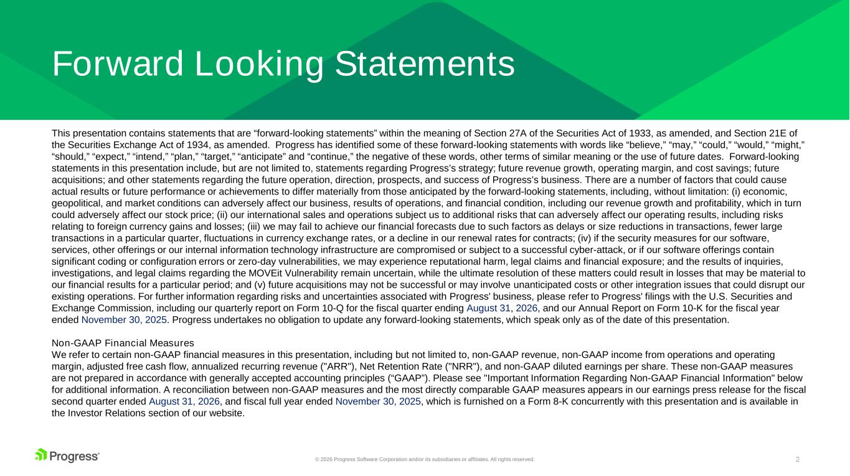
2© 2026 Progress Software Corporation and/or its subsidiaries or affiliates. All rights reserved. Forward Looking Statements This presentation contains statements that are “forward-looking statements” within the meaning of Section 27A of the Securities Act of 1933, as amended, and Section 21E of the Securities Exchange Act of 1934, as amended. Progress has identified some of these forward-looking statements with words like “believe,” “may,” “could,” “would,” “might,” “should,” “expect,” “intend,” “plan,” “target,” “anticipate” and “continue,” the negative of these words, other terms of similar meaning or the use of future dates. Forward-looking statements in this presentation include, but are not limited to, statements regarding Progress’s strategy; future revenue growth, operating margin, and cost savings; future acquisitions; and other statements regarding the future operation, direction, prospects, and success of Progress’s business. There are a number of factors that could cause actual results or future performance or achievements to differ materially from those anticipated by the forward-looking statements, including, without limitation: (i) economic, geopolitical, and market conditions can adversely affect our business, results of operations, and financial condition, including our revenue growth and profitability, which in turn could adversely affect our stock price; (ii) our international sales and operations subject us to additional risks that can adversely affect our operating results, including risks relating to foreign currency gains and losses; (iii) we may fail to achieve our financial forecasts due to such factors as delays or size reductions in transactions, fewer large transactions in a particular quarter, fluctuations in currency exchange rates, or a decline in our renewal rates for contracts; (iv) if the security measures for our software, services, other offerings or our internal information technology infrastructure are compromised or subject to a successful cyber-attack, or if our software offerings contain significant coding or configuration errors or zero-day vulnerabilities, we may experience reputational harm, legal claims and financial exposure; and the results of inquiries, investigations, and legal claims regarding the MOVEit Vulnerability remain uncertain, while the ultimate resolution of these matters could result in losses that may be material to our financial results for a particular period; and (v) future acquisitions may not be successful or may involve unanticipated costs or other integration issues that could disrupt our existing operations. For further information regarding risks and uncertainties associated with Progress' business, please refer to Progress' filings with the U.S. Securities and Exchange Commission, including our quarterly report on Form 10-Q for the fiscal quarter ending August 31, 2026, and our Annual Report on Form 10-K for the fiscal year ended November 30, 2025. Progress undertakes no obligation to update any forward-looking statements, which speak only as of the date of this presentation. Non-GAAP Financial Measures We refer to certain non-GAAP financial measures in this presentation, including but not limited to, non-GAAP revenue, non-GAAP income from operations and operating margin, adjusted free cash flow, annualized recurring revenue ("ARR"), Net Retention Rate ("NRR"), and non-GAAP diluted earnings per share. These non-GAAP measures are not prepared in accordance with generally accepted accounting principles (“GAAP”). Please see "Important Information Regarding Non-GAAP Financial Information" below for additional information. A reconciliation between non-GAAP measures and the most directly comparable GAAP measures appears in our earnings press release for the fiscal second quarter ended August 31, 2026, and fiscal full year ended November 30, 2025, which is furnished on a Form 8-K concurrently with this presentation and is available in the Investor Relations section of our website.

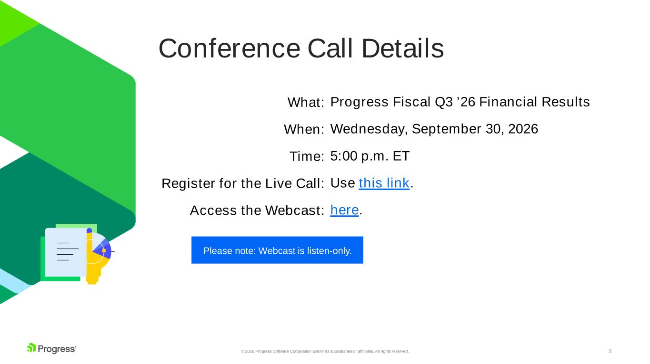
3© 2026 Progress Software Corporation and/or its subsidiaries or affiliates. All rights reserved. Conference Call Details Please note: Webcast is listen-only. What: When: Time: Register for the Live Call: Access the Webcast: Progress Fiscal Q3 ’26 Financial Results Wednesday, September 30, 2026 5:00 p.m. ET Use this link. here.

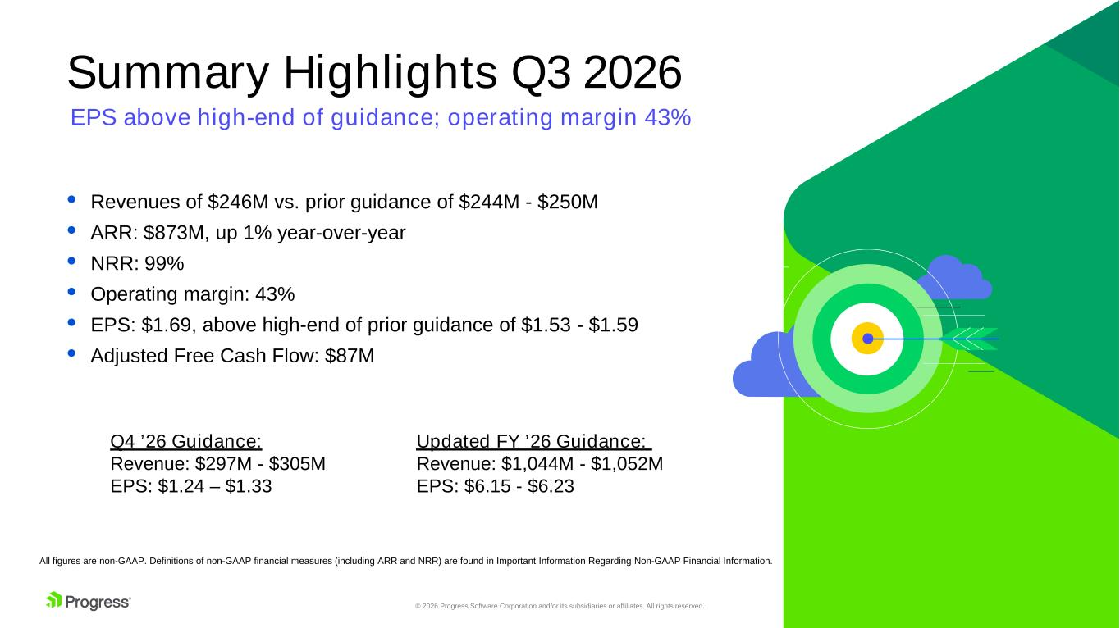
4© 2026 Progress Software Corporation and/or its subsidiaries or affiliates. All rights reserved. Summary Highlights Q3 2026 All figures are non-GAAP. Definitions of non-GAAP financial measures (including ARR and NRR) are found in Important Information Regarding Non-GAAP Financial Information. • Revenues of $246M vs. prior guidance of $244M - $250M • ARR: $873M, up 1% year-over-year • NRR: 99% • Operating margin: 43% • EPS: $1.69, above high-end of prior guidance of $1.53 - $1.59 • Adjusted Free Cash Flow: $87M EPS above high-end of guidance; operating margin 43% Updated FY ’26 Guidance: Revenue: $1,044M - $1,052M EPS: $6.15 - $6.23 Q4 ’26 Guidance: Revenue: $297M - $305M EPS: $1.24 – $1.33

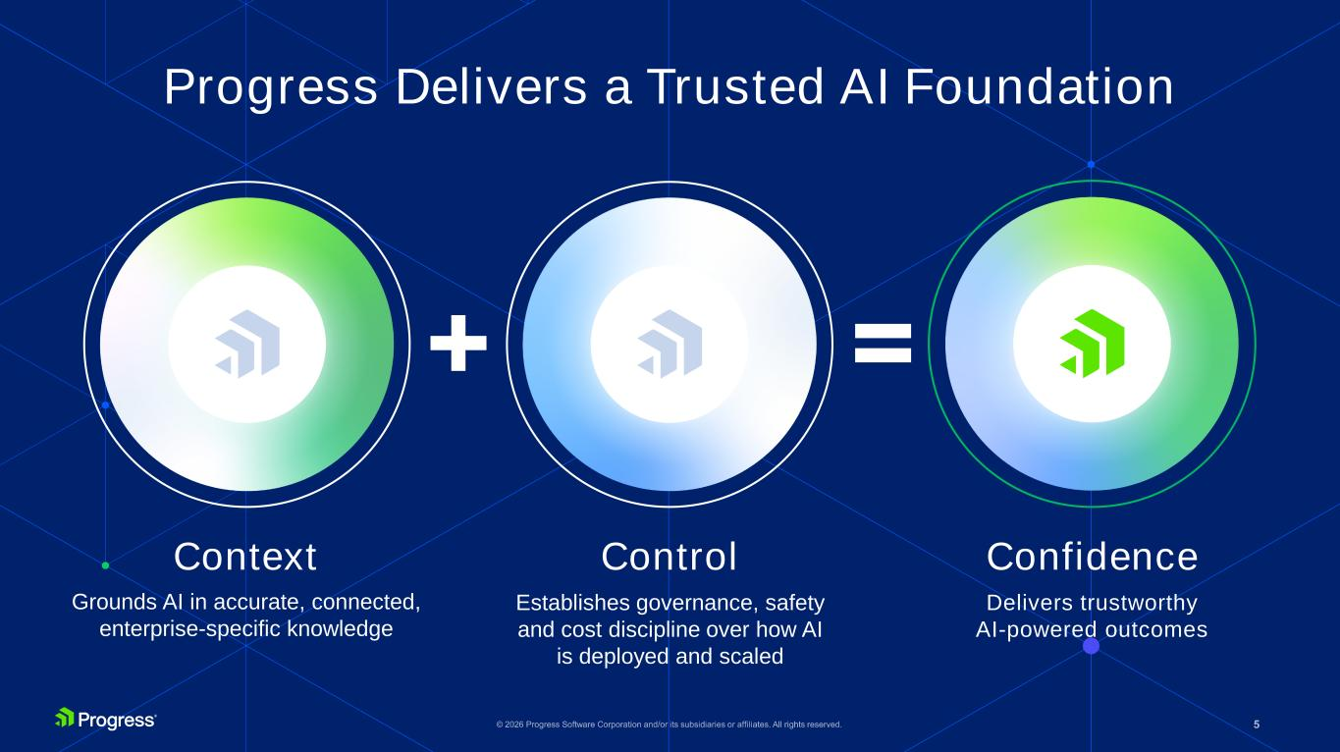
5© 2025 Progress Software Corporation and/or its subsidiaries or affiliates. All rights reserved.6 Context Control Confidence Grounds AI in accurate, connected, enterprise-specific knowledge Establishes governance, safety and cost discipline over how AI is deployed and scaled Delivers trustworthy AI-powered outcomes Progress Delivers a Trusted AI Foundation

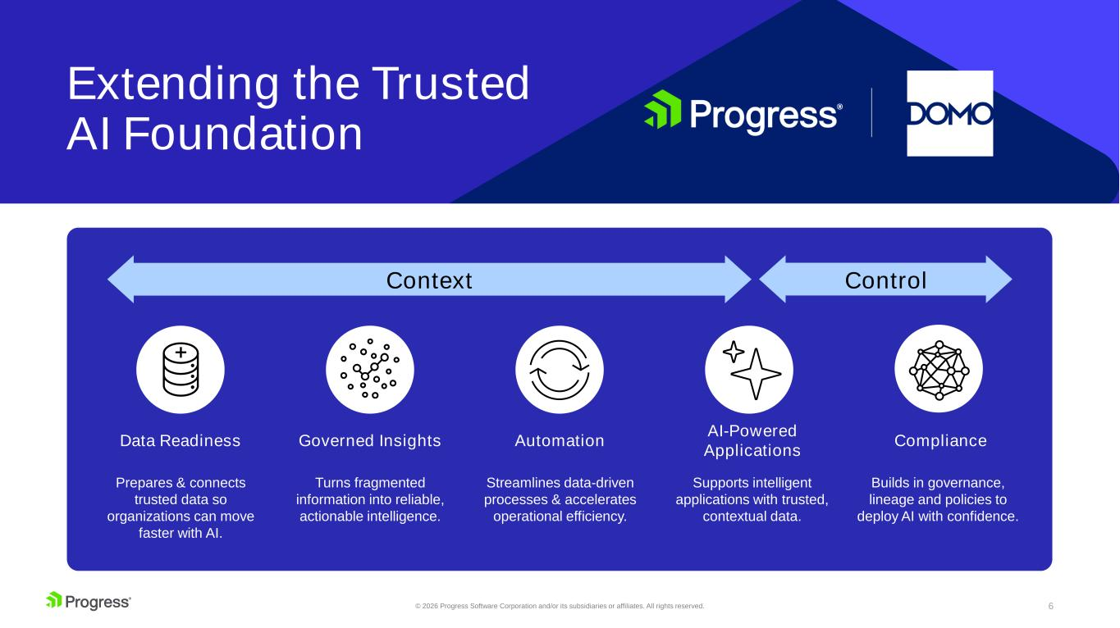
6© 2026 Progress Software Corporation and/or its subsidiaries or affiliates. All rights reserved. Data Readiness Prepares & connects trusted data so organizations can move faster with AI. Extending the Trusted AI Foundation Governed Insights Automation AI-Powered Applications Compliance Turns fragmented information into reliable, actionable intelligence. Streamlines data-driven processes & accelerates operational efficiency. Supports intelligent applications with trusted, contextual data. Builds in governance, lineage and policies to deploy AI with confidence. Context Control

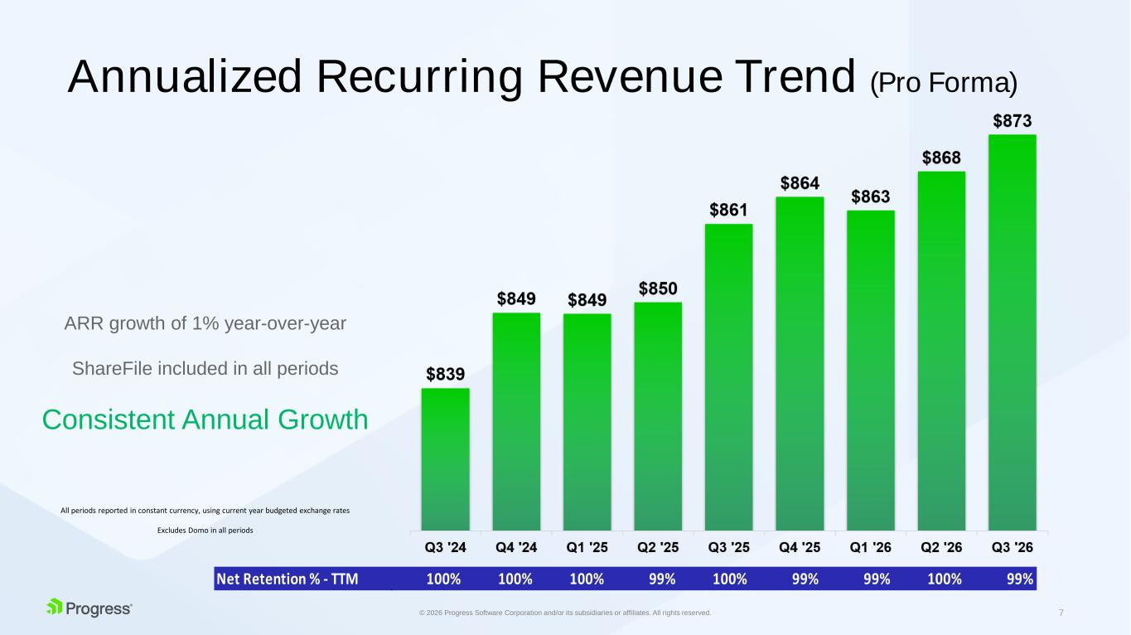
7© 2026 Progress Software Corporation and/or its subsidiaries or affiliates. All rights reserved. ARR growth of 1% year-over-year ShareFile included in all periods Consistent Annual Growth Annualized Recurring Revenue Trend (Pro Forma) All periods reported in constant currency, using current year budgeted exchange rates Excludes Domo in all periods Net Retention % - TTM 100% 100% 100% 99% 100% 99% 99% 100% 99%

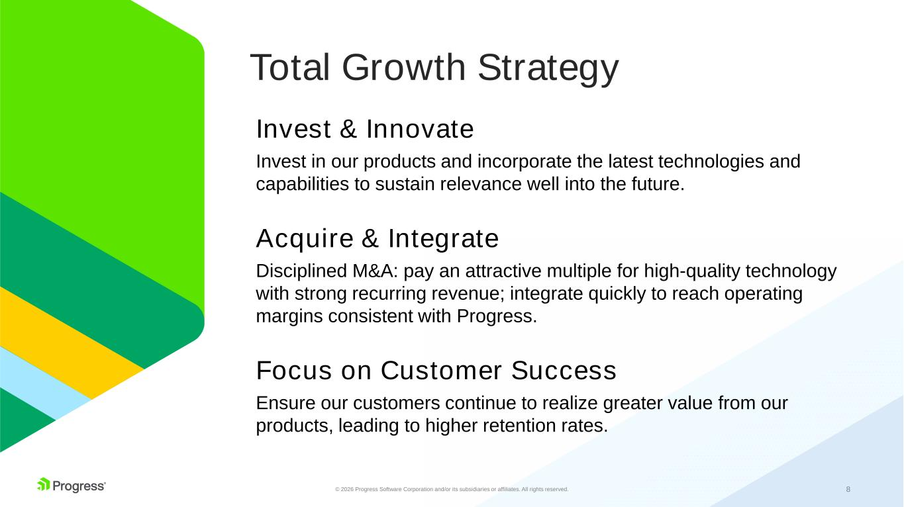
8© 2026 Progress Software Corporation and/or its subsidiaries or affiliates. All rights reserved. Total Growth Strategy Invest & Innovate Invest in our products and incorporate the latest technologies and capabilities to sustain relevance well into the future. Acquire & Integrate Disciplined M&A: pay an attractive multiple for high-quality technology with strong recurring revenue; integrate quickly to reach operating margins consistent with Progress. Focus on Customer Success Ensure our customers continue to realize greater value from our products, leading to higher retention rates.

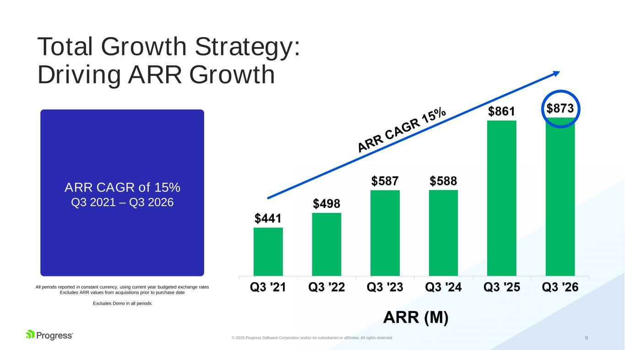
9© 2026 Progress Software Corporation and/or its subsidiaries or affiliates. All rights reserved. Total Growth Strategy: Driving ARR Growth All periods reported in constant currency, using current year budgeted exchange rates Excludes ARR values from acquisitions prior to purchase date Excludes Domo in all periods ARR CAGR of 15% Q3 2021 – Q3 2026

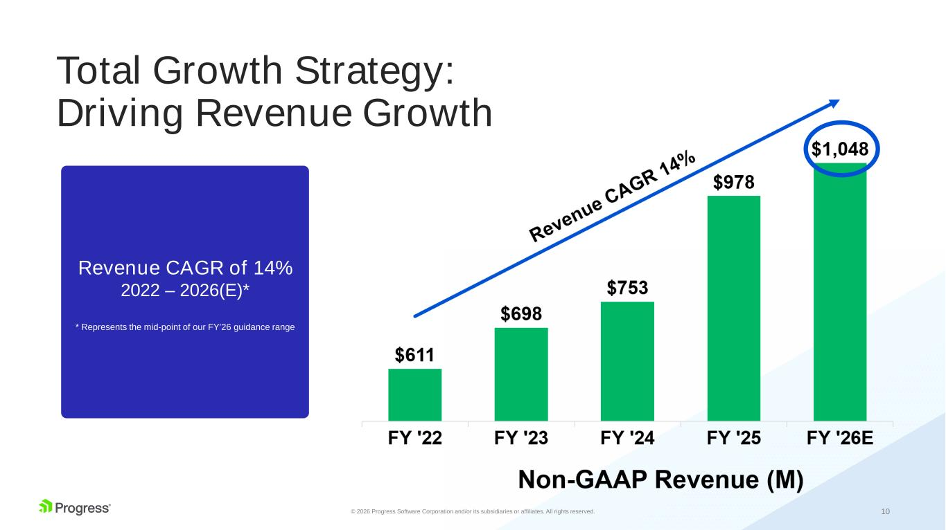
10© 2026 Progress Software Corporation and/or its subsidiaries or affiliates. All rights reserved. Total Growth Strategy: Driving Revenue Growth Revenue CAGR of 14% 2022 – 2026(E)* * Represents the mid-point of our FY’26 guidance range

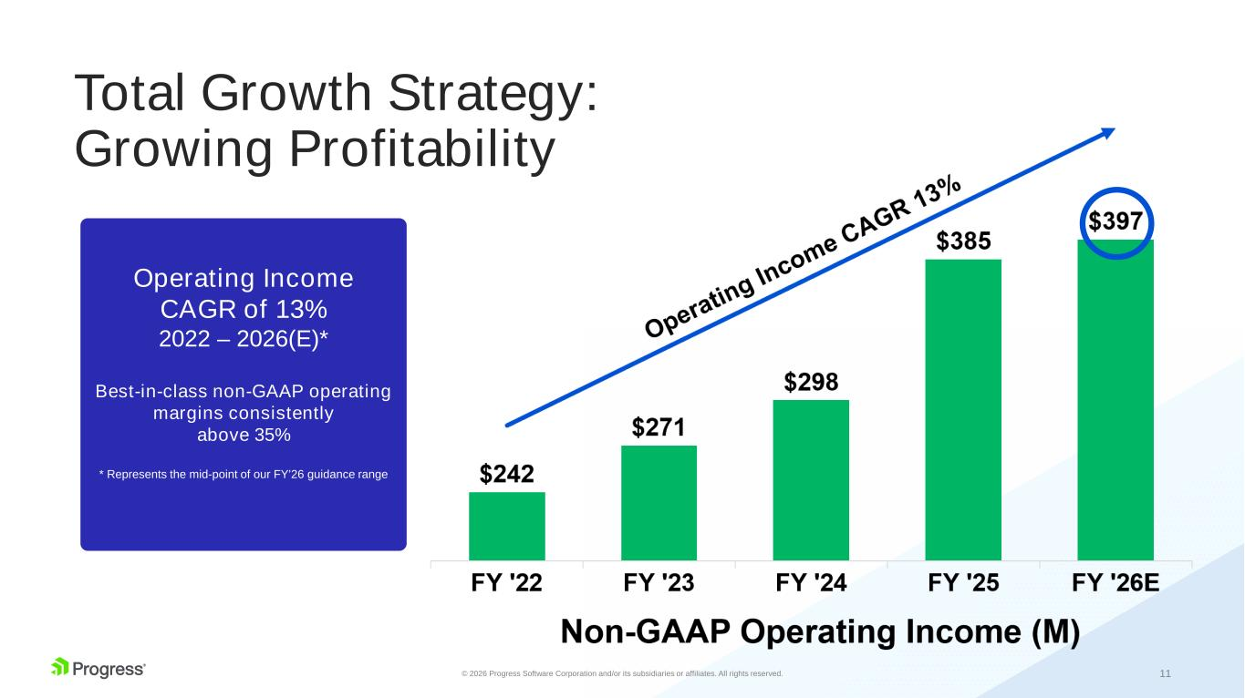
11© 2026 Progress Software Corporation and/or its subsidiaries or affiliates. All rights reserved. Total Growth Strategy: Growing Profitability Operating Income CAGR of 13% 2022 – 2026(E)* Best-in-class non-GAAP operating margins consistently above 35% * Represents the mid-point of our FY’26 guidance range

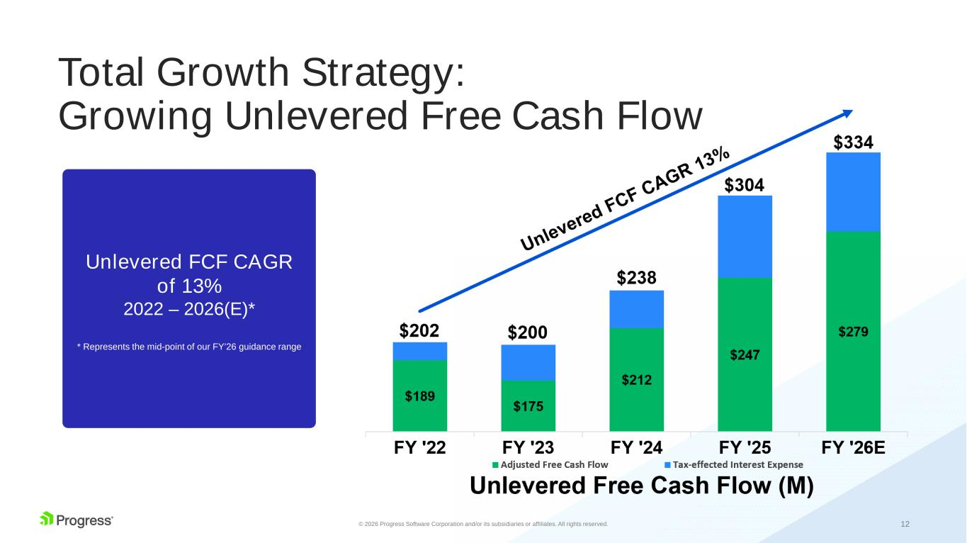
12© 2026 Progress Software Corporation and/or its subsidiaries or affiliates. All rights reserved. Total Growth Strategy: Growing Unlevered Free Cash Flow Unlevered FCF CAGR of 13% 2022 – 2026(E)* * Represents the mid-point of our FY’26 guidance range

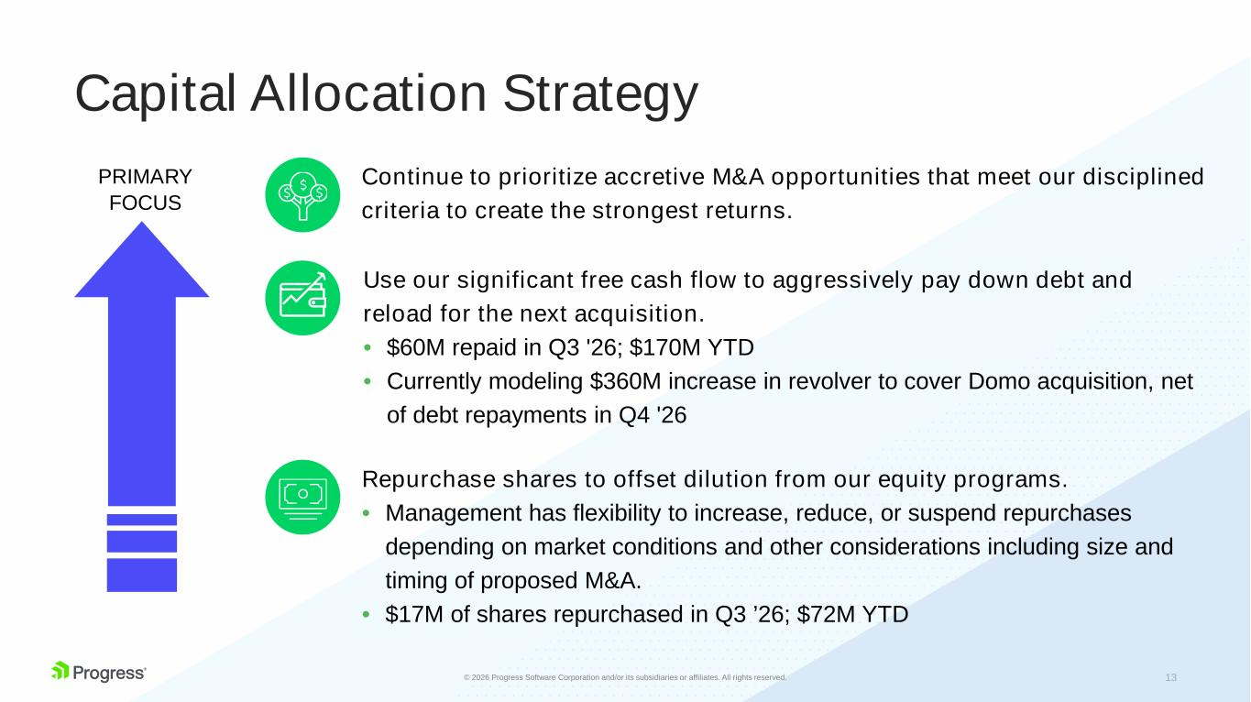
13© 2025 Progress Software Corporation and/or its subsidiaries or affiliates. All rights reserved.6 Capital Allocation Strategy PRIMARY FOCUS Continue to prioritize accretive M&A opportunities that meet our disciplined criteria to create the strongest returns. Repurchase shares to offset dilution from our equity programs. • Management has flexibility to increase, reduce, or suspend repurchases depending on market conditions and other considerations including size and timing of proposed M&A. • $17M of shares repurchased in Q3 ’26; $72M YTD Use our significant free cash flow to aggressively pay down debt and reload for the next acquisition. • $60M repaid in Q3 '26; $170M YTD • Currently modeling $360M increase in revolver to cover Domo acquisition, net of debt repayments in Q4 '26

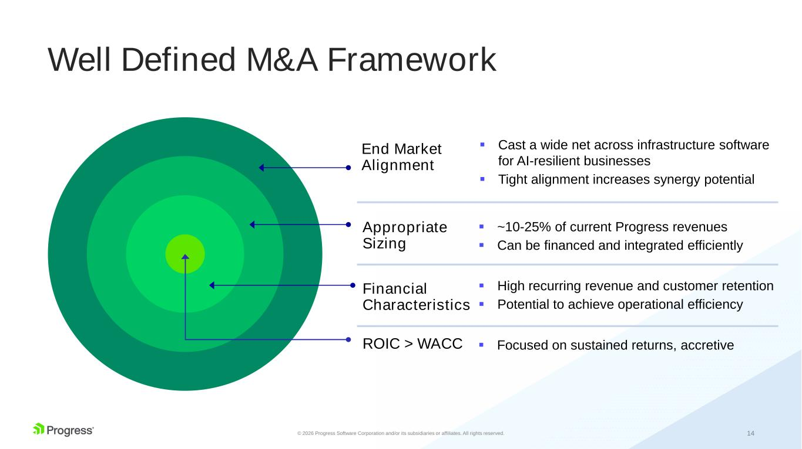
14© 2026 Progress Software Corporation and/or its subsidiaries or affiliates. All rights reserved. Well Defined M&A Framework ▪ Cast a wide net across infrastructure software for AI-resilient businesses ▪ Tight alignment increases synergy potential ▪ ~10-25% of current Progress revenues ▪ Can be financed and integrated efficiently ▪ High recurring revenue and customer retention ▪ Potential to achieve operational efficiency ▪ Focused on sustained returns, accretiveROIC > WACC Financial Characteristics Appropriate Sizing End Market Alignment

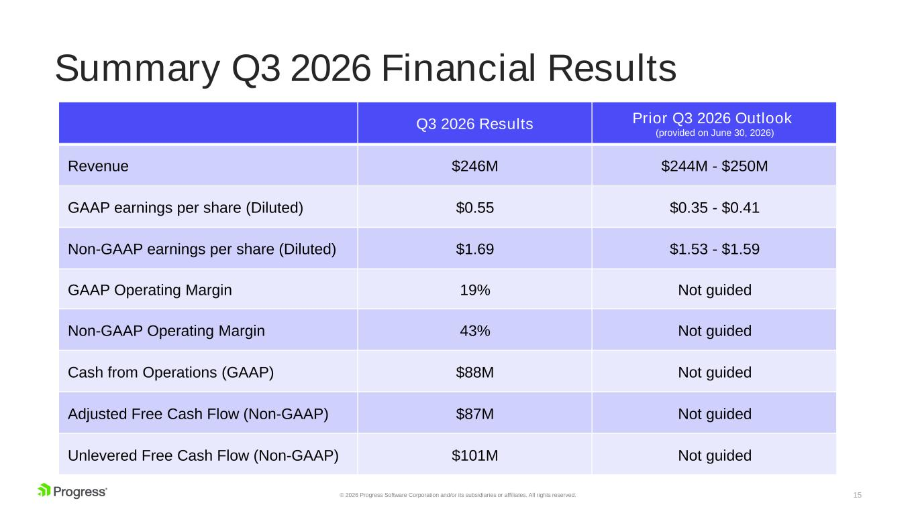
15© 2026 Progress Software Corporation and/or its subsidiaries or affiliates. All rights reserved. Summary Q3 2026 Financial Results Q3 2026 Results Prior Q3 2026 Outlook (provided on June 30, 2026) Revenue $246M $244M - $250M GAAP earnings per share (Diluted) $0.55 $0.35 - $0.41 Non-GAAP earnings per share (Diluted) $1.69 $1.53 - $1.59 GAAP Operating Margin 19% Not guided Non-GAAP Operating Margin 43% Not guided Cash from Operations (GAAP) $88M Not guided Adjusted Free Cash Flow (Non-GAAP) $87M Not guided Unlevered Free Cash Flow (Non-GAAP) $101M Not guided

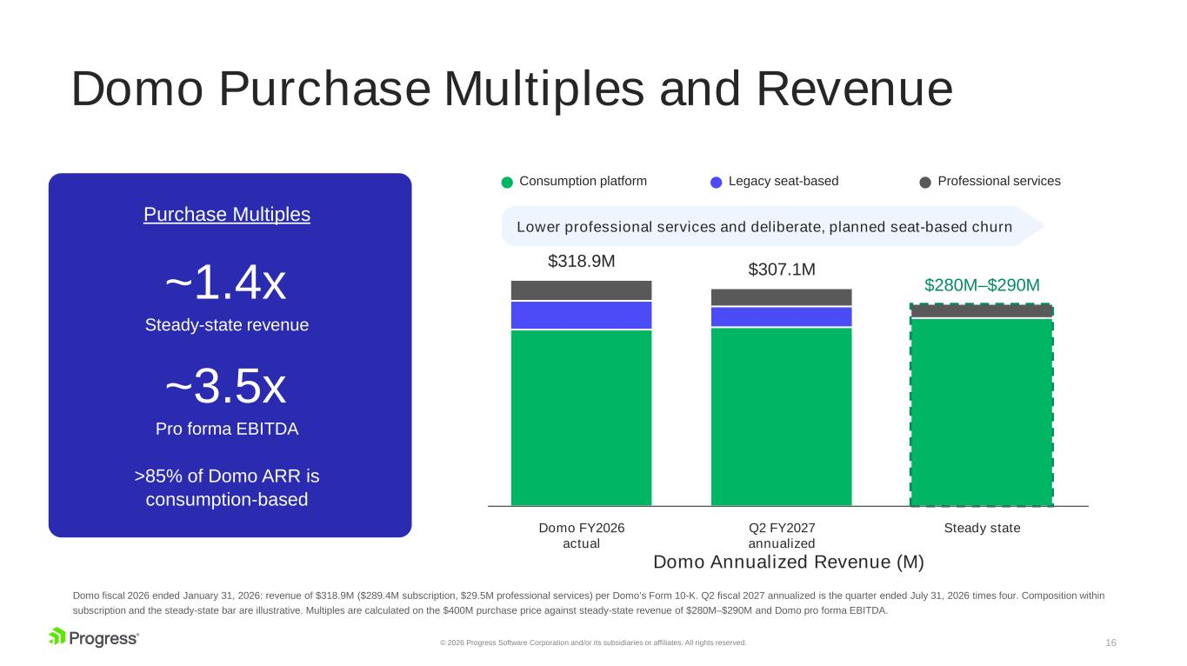
16© 2026 Progress Software Corporation and/or its subsidiaries or affiliates. All rights reserved. Domo Purchase Multiples and Revenue Purchase Multiples ~1.4x Steady-state revenue ~3.5x Pro forma EBITDA >85% of Domo ARR is consumption-based Consumption platform Legacy seat-based Professional services $318.9M Domo FY2026 actual $307.1M Q2 FY2027 annualized $280M–$290M Steady state Lower professional services and deliberate, planned seat-based churn Domo Annualized Revenue (M) Domo fiscal 2026 ended January 31, 2026: revenue of $318.9M ($289.4M subscription, $29.5M professional services) per Domo’s Form 10-K. Q2 fiscal 2027 annualized is the quarter ended July 31, 2026 times four. Composition within subscription and the steady-state bar are illustrative. Multiples are calculated on the $400M purchase price against steady-state revenue of $280M–$290M and Domo pro forma EBITDA.

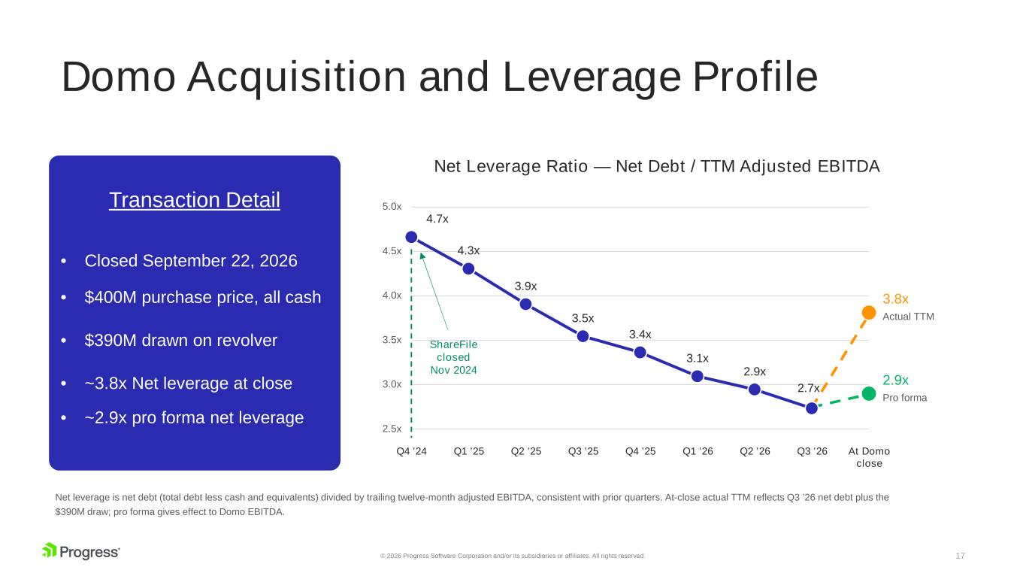
17© 2026 Progress Software Corporation and/or its subsidiaries or affiliates. All rights reserved. Domo Acquisition and Leverage Profile Transaction Detail • Closed September 22, 2026 • $400M purchase price, all cash • $390M drawn on revolver • ~3.8x Net leverage at close • ~2.9x pro forma net leverage 2.5x 3.0x 3.5x 4.0x 4.5x 5.0x 4.7x Q4 ’24 4.3x Q1 ’25 3.9x Q2 ’25 3.5x Q3 ’25 3.4x Q4 ’25 3.1x Q1 ’26 2.9x Q2 ’26 2.7x Q3 ’26 3.8x Actual TTM 2.9x Pro forma At Domo close ShareFile closed Nov 2024 Net Leverage Ratio — Net Debt / TTM Adjusted EBITDA Net leverage is net debt (total debt less cash and equivalents) divided by trailing twelve-month adjusted EBITDA, consistent with prior quarters. At-close actual TTM reflects Q3 ’26 net debt plus the $390M draw; pro forma gives effect to Domo EBITDA.

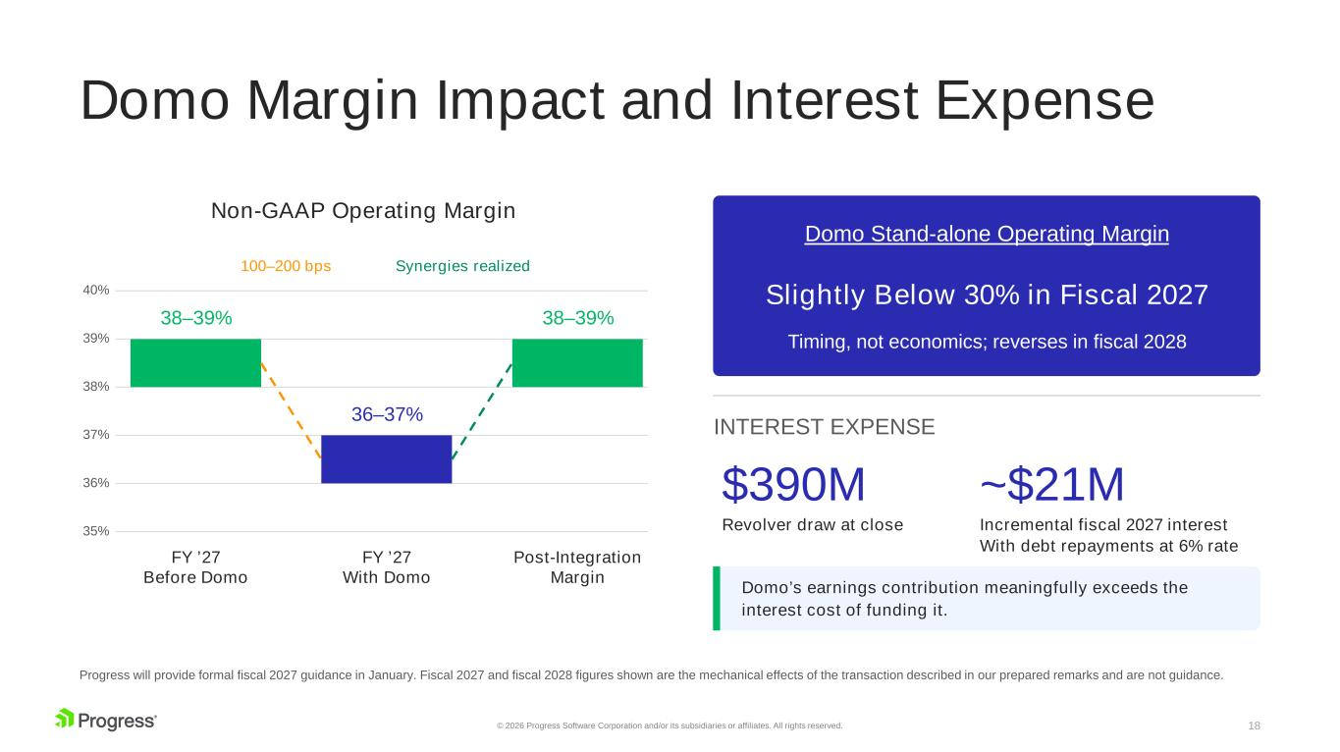
18© 2026 Progress Software Corporation and/or its subsidiaries or affiliates. All rights reserved. Domo Margin Impact and Interest Expense 35% 36% 37% 38% 39% 40% 38–39% FY ’27 Before Domo 36–37% FY ’27 With Domo 38–39% Post-Integration Margin 100–200 bps Synergies realized Non-GAAP Operating Margin Domo Stand-alone Operating Margin Slightly Below 30% in Fiscal 2027 Timing, not economics; reverses in fiscal 2028 INTEREST EXPENSE $390M Revolver draw at close ~$21M Incremental fiscal 2027 interest With debt repayments at 6% rate Domo’s earnings contribution meaningfully exceeds the interest cost of funding it. Progress will provide formal fiscal 2027 guidance in January. Fiscal 2027 and fiscal 2028 figures shown are the mechanical effects of the transaction described in our prepared remarks and are not guidance.

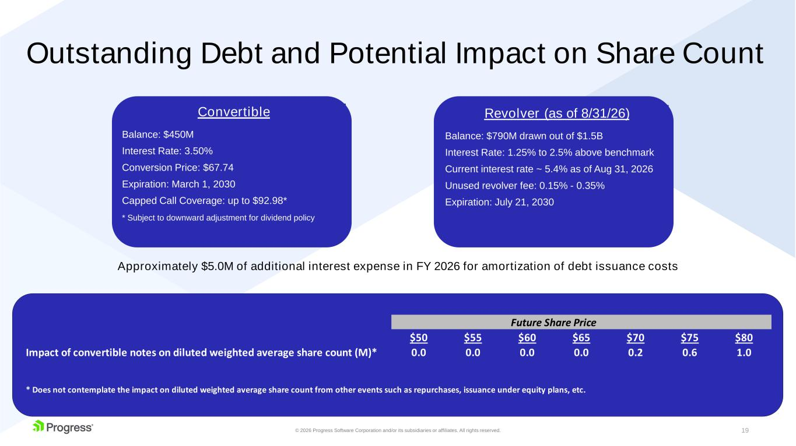
19© 2026 Progress Software Corporation and/or its subsidiaries or affiliates. All rights reserved. Outstanding Debt and Potential Impact on Share Count Approximately $5.0M of additional interest expense in FY 2026 for amortization of debt issuance costs Convertible Balance: $450M Interest Rate: 3.50% Conversion Price: $67.74 Expiration: March 1, 2030 Capped Call Coverage: up to $92.98* * Subject to downward adjustment for dividend policy Revolver (as of 8/31/26) Balance: $790M drawn out of $1.5B Interest Rate: 1.25% to 2.5% above benchmark Current interest rate ~ 5.4% as of Aug 31, 2026 Unused revolver fee: 0.15% - 0.35% Expiration: July 21, 2030 $50 $55 $60 $65 $70 $75 $80 Impact of convertible notes on diluted weighted average share count (M)* 0.0 0.0 0.0 0.0 0.2 0.6 1.0 * Does not contemplate the impact on diluted weighted average share count from other events such as repurchases, issuance under equity plans, etc. Future Share Price

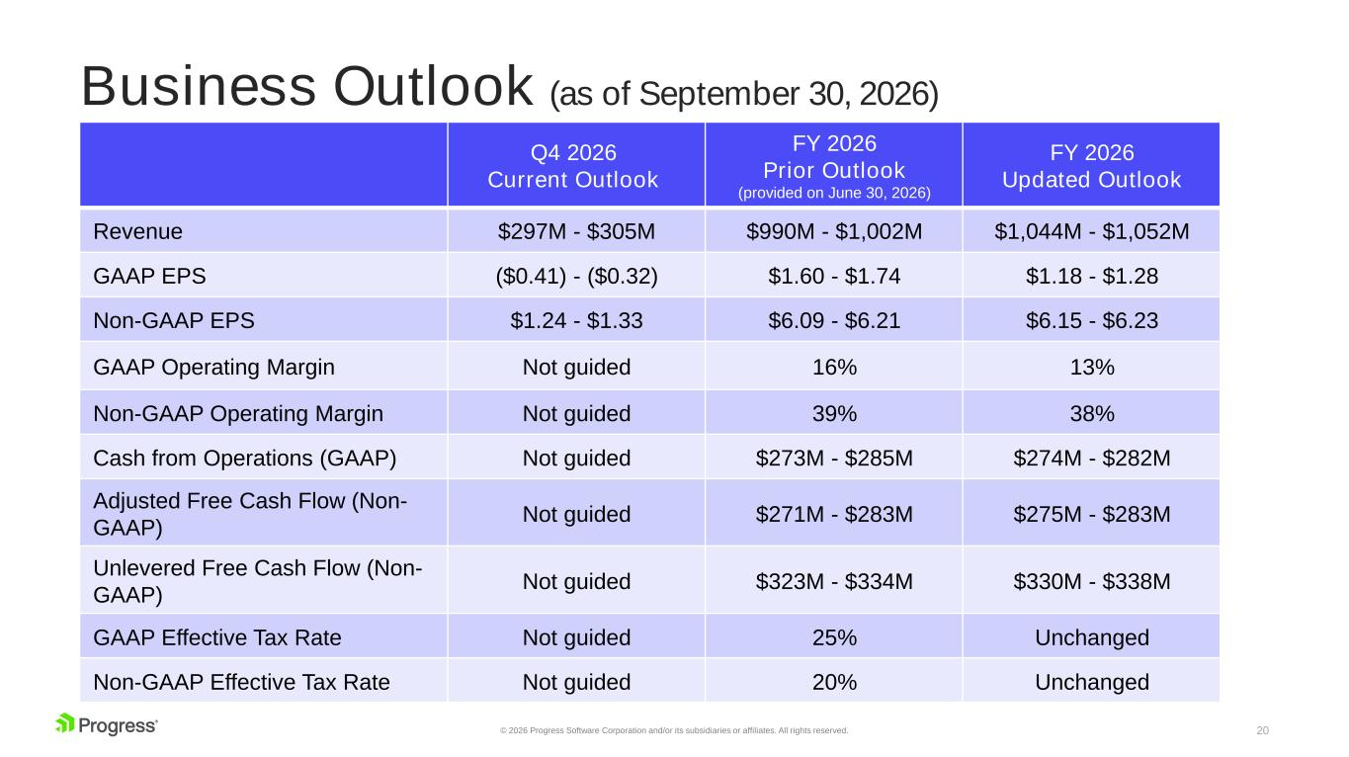
20© 2026 Progress Software Corporation and/or its subsidiaries or affiliates. All rights reserved. Business Outlook (as of September 30, 2026) Q4 2026 Current Outlook FY 2026 Prior Outlook (provided on June 30, 2026) FY 2026 Updated Outlook Revenue $297M - $305M $990M - $1,002M $1,044M - $1,052M GAAP EPS ($0.41) - ($0.32) $1.60 - $1.74 $1.18 - $1.28 Non-GAAP EPS $1.24 - $1.33 $6.09 - $6.21 $6.15 - $6.23 GAAP Operating Margin Not guided 16% 13% Non-GAAP Operating Margin Not guided 39% 38% Cash from Operations (GAAP) Not guided $273M - $285M $274M - $282M Adjusted Free Cash Flow (Non- GAAP) Not guided $271M - $283M $275M - $283M Unlevered Free Cash Flow (Non- GAAP) Not guided $323M - $334M $330M - $338M GAAP Effective Tax Rate Not guided 25% Unchanged Non-GAAP Effective Tax Rate Not guided 20% Unchanged

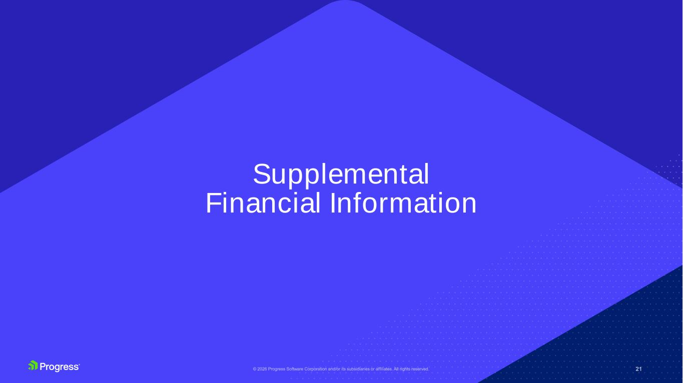
Supplemental Financial Information

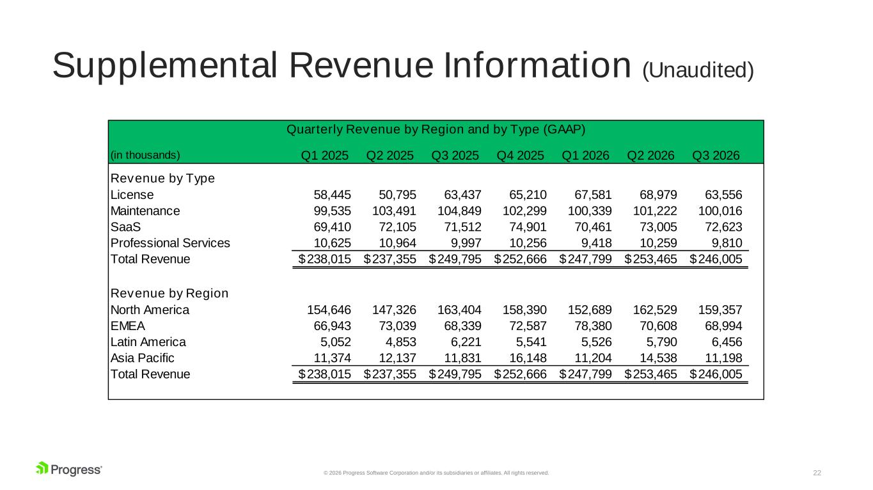
22© 2026 Progress Software Corporation and/or its subsidiaries or affiliates. All rights reserved. Supplemental Revenue Information (Unaudited) (in thousands) Q1 2025 Q2 2025 Q3 2025 Q4 2025 Q1 2026 Q2 2026 Q3 2026 Revenue by Type License 58,445 50,795 63,437 65,210 67,581 68,979 63,556 Maintenance 99,535 103,491 104,849 102,299 100,339 101,222 100,016 SaaS 69,410 72,105 71,512 74,901 70,461 73,005 72,623 Professional Services 10,625 10,964 9,997 10,256 9,418 10,259 9,810 Total Revenue 238,015$ 237,355$ 249,795$ 252,666$ 247,799$ 253,465$ 246,005$ Revenue by Region North America 154,646 147,326 163,404 158,390 152,689 162,529 159,357 EMEA 66,943 73,039 68,339 72,587 78,380 70,608 68,994 Latin America 5,052 4,853 6,221 5,541 5,526 5,790 6,456 Asia Pacific 11,374 12,137 11,831 16,148 11,204 14,538 11,198 Total Revenue 238,015$ 237,355$ 249,795$ 252,666$ 247,799$ 253,465$ 246,005$ Quarterly Revenue by Region and by Type (GAAP)

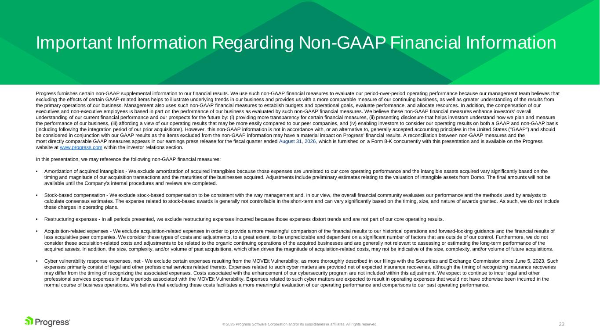
23© 2026 Progress Software Corporation and/or its subsidiaries or affiliates. All rights reserved. Progress furnishes certain non-GAAP supplemental information to our financial results. We use such non-GAAP financial measures to evaluate our period-over-period operating performance because our management team believes that excluding the effects of certain GAAP-related items helps to illustrate underlying trends in our business and provides us with a more comparable measure of our continuing business, as well as greater understanding of the results from the primary operations of our business. Management also uses such non-GAAP financial measures to establish budgets and operational goals, evaluate performance, and allocate resources. In addition, the compensation of our executives and non-executive employees is based in part on the performance of our business as evaluated by such non-GAAP financial measures. We believe these non-GAAP financial measures enhance investors’ overall understanding of our current financial performance and our prospects for the future by: (i) providing more transparency for certain financial measures, (ii) presenting disclosure that helps investors understand how we plan and measure the performance of our business, (iii) affording a view of our operating results that may be more easily compared to our peer companies, and (iv) enabling investors to consider our operating results on both a GAAP and non-GAAP basis (including following the integration period of our prior acquisitions). However, this non-GAAP information is not in accordance with, or an alternative to, generally accepted accounting principles in the United States ("GAAP") and should be considered in conjunction with our GAAP results as the items excluded from the non-GAAP information may have a material impact on Progress’ financial results. A reconciliation between non-GAAP measures and the most directly comparable GAAP measures appears in our earnings press release for the fiscal quarter ended August 31, 2026, which is furnished on a Form 8-K concurrently with this presentation and is available on the Progress website at www.progress.com within the investor relations section. In this presentation, we may reference the following non-GAAP financial measures: • Amortization of acquired intangibles - We exclude amortization of acquired intangibles because those expenses are unrelated to our core operating performance and the intangible assets acquired vary significantly based on the timing and magnitude of our acquisition transactions and the maturities of the businesses acquired. Adjustments include preliminary estimates relating to the valuation of intangible assets from Domo. The final amounts will not be available until the Company's internal procedures and reviews are completed. • Stock-based compensation - We exclude stock-based compensation to be consistent with the way management and, in our view, the overall financial community evaluates our performance and the methods used by analysts to calculate consensus estimates. The expense related to stock-based awards is generally not controllable in the short-term and can vary significantly based on the timing, size, and nature of awards granted. As such, we do not include these charges in operating plans. • Restructuring expenses - In all periods presented, we exclude restructuring expenses incurred because those expenses distort trends and are not part of our core operating results. • Acquisition-related expenses - We exclude acquisition-related expenses in order to provide a more meaningful comparison of the financial results to our historical operations and forward-looking guidance and the financial results of less acquisitive peer companies. We consider these types of costs and adjustments, to a great extent, to be unpredictable and dependent on a significant number of factors that are outside of our control. Furthermore, we do not consider these acquisition-related costs and adjustments to be related to the organic continuing operations of the acquired businesses and are generally not relevant to assessing or estimating the long-term performance of the acquired assets. In addition, the size, complexity, and/or volume of past acquisitions, which often drives the magnitude of acquisition-related costs, may not be indicative of the size, complexity, and/or volume of future acquisitions. • Cyber vulnerability response expenses, net - We exclude certain expenses resulting from the MOVEit Vulnerability, as more thoroughly described in our filings with the Securities and Exchange Commission since June 5, 2023. Such expenses primarily consist of legal and other professional services related thereto. Expenses related to such cyber matters are provided net of expected insurance recoveries, although the timing of recognizing insurance recoveries may differ from the timing of recognizing the associated expenses. Costs associated with the enhancement of our cybersecurity program are not included within this adjustment. We expect to continue to incur legal and other professional services expenses in future periods associated with the MOVEit Vulnerability. Expenses related to such cyber matters are expected to result in operating expenses that would not have otherwise been incurred in the normal course of business operations. We believe that excluding these costs facilitates a more meaningful evaluation of our operating performance and comparisons to our past operating performance. Important Information Regarding Non-GAAP Financial Information

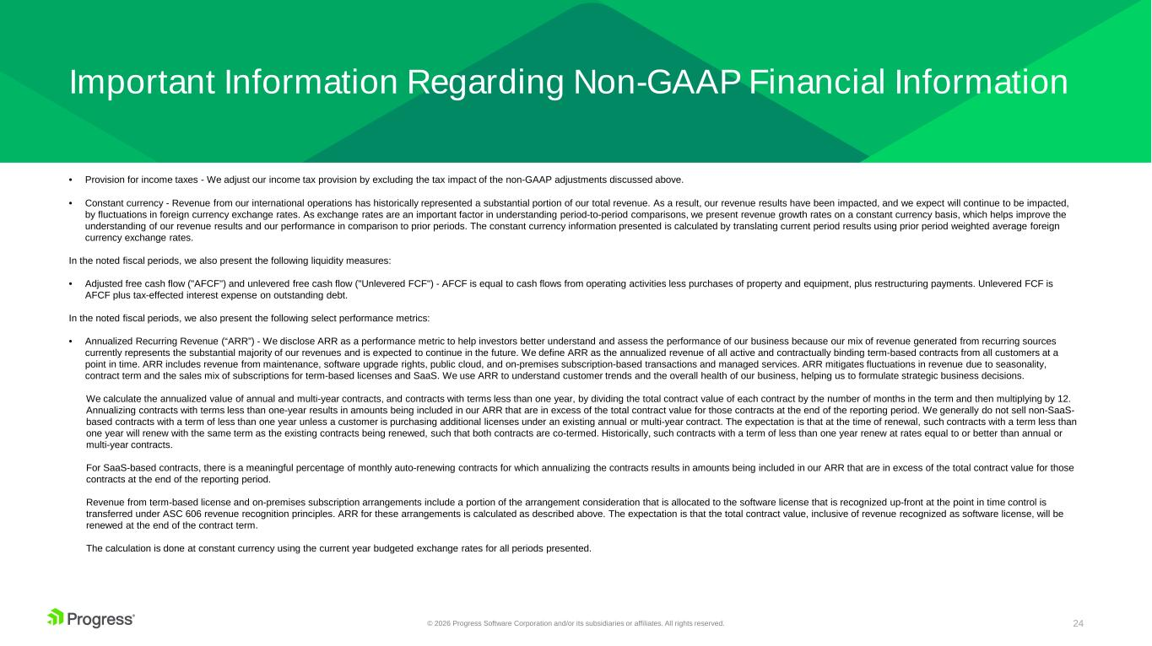
24© 2026 Progress Software Corporation and/or its subsidiaries or affiliates. All rights reserved. Important Information Regarding Non-GAAP Financial Information • Provision for income taxes - We adjust our income tax provision by excluding the tax impact of the non-GAAP adjustments discussed above. • Constant currency - Revenue from our international operations has historically represented a substantial portion of our total revenue. As a result, our revenue results have been impacted, and we expect will continue to be impacted, by fluctuations in foreign currency exchange rates. As exchange rates are an important factor in understanding period-to-period comparisons, we present revenue growth rates on a constant currency basis, which helps improve the understanding of our revenue results and our performance in comparison to prior periods. The constant currency information presented is calculated by translating current period results using prior period weighted average foreign currency exchange rates. In the noted fiscal periods, we also present the following liquidity measures: • Adjusted free cash flow ("AFCF") and unlevered free cash flow ("Unlevered FCF") - AFCF is equal to cash flows from operating activities less purchases of property and equipment, plus restructuring payments. Unlevered FCF is AFCF plus tax-effected interest expense on outstanding debt. In the noted fiscal periods, we also present the following select performance metrics: • Annualized Recurring Revenue (“ARR”) - We disclose ARR as a performance metric to help investors better understand and assess the performance of our business because our mix of revenue generated from recurring sources currently represents the substantial majority of our revenues and is expected to continue in the future. We define ARR as the annualized revenue of all active and contractually binding term-based contracts from all customers at a point in time. ARR includes revenue from maintenance, software upgrade rights, public cloud, and on-premises subscription-based transactions and managed services. ARR mitigates fluctuations in revenue due to seasonality, contract term and the sales mix of subscriptions for term-based licenses and SaaS. We use ARR to understand customer trends and the overall health of our business, helping us to formulate strategic business decisions. We calculate the annualized value of annual and multi-year contracts, and contracts with terms less than one year, by dividing the total contract value of each contract by the number of months in the term and then multiplying by 12. Annualizing contracts with terms less than one-year results in amounts being included in our ARR that are in excess of the total contract value for those contracts at the end of the reporting period. We generally do not sell non-SaaS- based contracts with a term of less than one year unless a customer is purchasing additional licenses under an existing annual or multi-year contract. The expectation is that at the time of renewal, such contracts with a term less than one year will renew with the same term as the existing contracts being renewed, such that both contracts are co-termed. Historically, such contracts with a term of less than one year renew at rates equal to or better than annual or multi-year contracts. For SaaS-based contracts, there is a meaningful percentage of monthly auto-renewing contracts for which annualizing the contracts results in amounts being included in our ARR that are in excess of the total contract value for those contracts at the end of the reporting period. Revenue from term-based license and on-premises subscription arrangements include a portion of the arrangement consideration that is allocated to the software license that is recognized up-front at the point in time control is transferred under ASC 606 revenue recognition principles. ARR for these arrangements is calculated as described above. The expectation is that the total contract value, inclusive of revenue recognized as software license, will be renewed at the end of the contract term. The calculation is done at constant currency using the current year budgeted exchange rates for all periods presented.

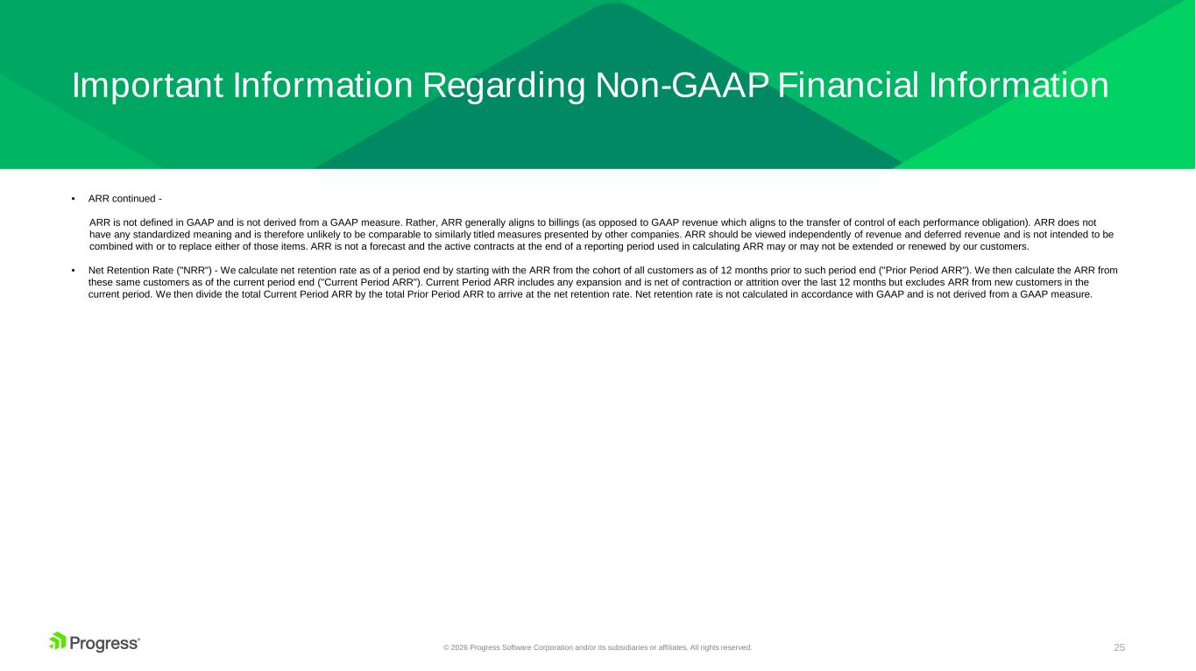
25© 2026 Progress Software Corporation and/or its subsidiaries or affiliates. All rights reserved. Important Information Regarding Non-GAAP Financial Information • ARR continued - ARR is not defined in GAAP and is not derived from a GAAP measure. Rather, ARR generally aligns to billings (as opposed to GAAP revenue which aligns to the transfer of control of each performance obligation). ARR does not have any standardized meaning and is therefore unlikely to be comparable to similarly titled measures presented by other companies. ARR should be viewed independently of revenue and deferred revenue and is not intended to be combined with or to replace either of those items. ARR is not a forecast and the active contracts at the end of a reporting period used in calculating ARR may or may not be extended or renewed by our customers. • Net Retention Rate ("NRR") - We calculate net retention rate as of a period end by starting with the ARR from the cohort of all customers as of 12 months prior to such period end ("Prior Period ARR"). We then calculate the ARR from these same customers as of the current period end ("Current Period ARR"). Current Period ARR includes any expansion and is net of contraction or attrition over the last 12 months but excludes ARR from new customers in the current period. We then divide the total Current Period ARR by the total Prior Period ARR to arrive at the net retention rate. Net retention rate is not calculated in accordance with GAAP and is not derived from a GAAP measure.



