UNITED STATES
SECURITIES AND EXCHANGE COMMISSION
Washington, D.C. 20549
FORM 8-K
CURRENT REPORT
Pursuant to Section 13 OR 15(d) of the Securities Exchange Act of 1934

Date of Report (Date of earliest event reported): March 30, 2026

Progress Software Corporation
(Exact name of registrant as specified in its charter)

Delaware |  |  | 0-19417 |  |  | 04-2746201
(State or other jurisdiction of incorporation or organization) |  |  | (Commission file number) |  |  | (I.R.S. Employer Identification No.)
15 Wayside Road, Suite 400, Burlington, Massachusetts |  |  |  |  |  | 01803
(Address of principal executive offices) |  |  |  |  |  | (Zip code)
Registrant’s telephone number, including area code: (781) 280-4000
Not applicable
(Former name or former address, if changed since last report.)

Check the appropriate box below if the Form 8-K filing is intended to simultaneously satisfy the filing obligation of the registrant under any of the following provisions:
☐ |  |  | Written communications pursuant to Rule 425 under the Securities Act (17 CFR 230.425)
☐ |  |  | Soliciting material pursuant to Rule 14a-12 under the Exchange Act (17 CFR 240.14a-12)
☐ |  |  | Pre-commencement communications pursuant to Rule 14d-2(b) under the Exchange Act (17 CFR 240.14d-2(b))
☐ |  |  | Pre-commencement communications pursuant to Rule 13e-4(c) under the Exchange Act (17 CFR 240.13e-4(c))

Securities registered pursuant to Section 12(b) of the Act:
Title of each class |  |  |  |  |  | Trading Symbol(s) |  |  |  |  |  | Name of each exchange on which registered
Common Stock, $0.01 par value per share |  |  |  |  |  | PRGS |  |  |  |  |  | The Nasdaq Stock Market LLC

Indicate by check mark whether the registrant is an emerging growth company as defined in Rule 405 of the Securities Act of 1933 (§230.405 of this chapter) or Rule 12b-2 of the Securities Exchange Act of 1934 (§240.12b-2 of this chapter).

Emerging growth company ☐

If an emerging growth company, indicate by check mark if the registrant has elected not to use the extended transition period for complying with any new or revised financial accounting standards provided pursuant to Section 13(a) of the Exchange Act.
☐

Item 2.02 Results of Operations and Financial Condition

On March 30, 2026, Progress Software Corporation ("Progress") issued a press release announcing its financial results for the fiscal first quarter ended February 28, 2026. A copy of the press release is attached to this Current Report on Form 8-K as Exhibit 99.1 and is incorporated herein by reference.

The information furnished pursuant to this Item 2.02, including Exhibit 99.1, shall not be deemed "filed" for purposes of Section 18 of the Securities Exchange Act of 1934, as amended (the "Exchange Act"), or otherwise subject to the liability of that Section, and shall not be incorporated by reference into any other filing by Progress under the Securities Act of 1933, as amended (the "Securities Act"), or the Exchange Act, except as shall be expressly set forth by specific reference in such a filing.

Item 7.01 Regulation FD Disclosure

In connection with the issuance of the press release attached hereto as Exhibit 99.1, the supplemental data attached as Exhibit 99.2 to this Current Report will be available on the Progress website within the investor relations section prior to the live conference call.

The information furnished pursuant to this Item 7.01, including Exhibit 99.2, shall not be deemed "filed" for purposes of Section 18 of the Exchange Act, or otherwise subject to the liability of that Section, and shall not be incorporated by reference into any other filing by Progress under the Securities Act or the Exchange Act, except as shall be expressly set forth by specific reference in such a filing.

Item 9.01 Financial Statements and Exhibits

(d) Exhibits.
Exhibit No. |  |  |  |  |  | Description
99.1 |  |  |  |  |  | Press release issued by Progress Software Corporation dated March 30, 2026
99.2 |  |  |  |  |  | Q1 2026 Supplemental Data
104 |  |  |  |  |  | Cover Page Interactive Data File (embedded within the Inline XBRL document)

SIGNATURES
Pursuant to the requirements of the Securities Exchange Act of 1934, the registrant has duly caused this report to be signed on its behalf by the undersigned hereunto duly authorized.

Date: |  |  | March 30, 2026 |  |  | Progress Software Corporation
 |  |  |  |  |  | By: |  |  | /s/ ANTHONY FOLGER
 |  |  |  |  |  |  |  |  | Anthony Folger
 |  |  |  |  |  |  |  |  | Chief Financial Officer

 |  |  |  |  |  | Exhibit 99.1

P R E S S A N N O U N C E M E N T

Progress Software Announces First Quarter 2026 Financial Results

Revenue Growth 4%, Exceptional Margins and Cash Flow;
Debt Paydown and Buybacks Continue

BURLINGTON, Mass., March 30, 2026 — Progress Software (Nasdaq: PRGS), the trusted provider of AI-powered digital experience and infrastructure software, today announced financial results for its fiscal first quarter ended February 28, 2026.

First Quarter 2026 Highlights:

•Revenue of $248 million increased 4% year-over-year on an actual currency basis and 2% on a constant currency basis.
•Annualized Recurring Revenue ("ARR") of $863 million increased 2% year-over-year on a constant currency basis.
•Operating margin was 19% and non-GAAP operating margin was 41%.
•Diluted earnings per share was $0.53 compared to $0.24 in the same quarter last year, an increase of 121%.
•Non-GAAP diluted earnings per share was $1.60 compared to $1.31 in the same quarter last year, an increase of 22%.

"We’re extremely pleased that the momentum from 2025 is carrying over into FY26," said Yogesh Gupta, CEO of Progress Software. "Revenue growth, margins, collections, and business operations continued strong through the first quarter. Our Q1 results reflect the durability of our model - driving profitable growth, generating robust cash flow, strengthening our balance sheet, and returning capital to shareholders through buybacks, as customers continue to derive measurable business value from the AI capabilities across our product portfolio."

Additional financial highlights included:
 |  |  | Three Months Ended
 |  |  | GAAP |  |  |  |  |  |  |  |  |  |  |  |  |  |  |  |  |  | Non-GAAP
(in thousands, except percentages and per share amounts) |  |  | February 28, 2026 |  |  |  |  |  | February 28, 2025 |  |  |  |  |  | % Change |  |  |  |  |  | February 28, 2026 |  |  |  |  |  | February 28, 2025 |  |  |  |  |  | % Change
Revenue |  |  | $ | 247,799 |  |  |  |  | $ | 238,015 |  |  |  |  | 4 |  | % |  |  |  | $ | 247,799 |  |  |  |  | $ | 238,015 |  |  |  |  | 4 |  | %
Income from operations |  |  | $ | 46,465 |  |  |  |  | $ | 32,426 |  |  |  |  | 43 |  | % |  |  |  | $ | 102,185 |  |  |  |  | $ | 93,595 |  |  |  |  | 9 |  | %
Operating margin |  |  | 19 |  | % |  |  |  | 14 |  | % |  |  |  | 500 bps |  |  |  |  |  | 41 |  | % |  |  |  | 39 |  | % |  |  |  | 200 bps
Net income |  |  | $ | 22,813 |  |  |  |  | $ | 10,946 |  |  |  |  | 108 |  | % |  |  |  | $ | 68,300 |  |  |  |  | $ | 58,995 |  |  |  |  | 16 |  | %
Diluted earnings per share |  |  | $ | 0.53 |  |  |  |  | $ | 0.24 |  |  |  |  | 121 |  | % |  |  |  | $ | 1.60 |  |  |  |  | $ | 1.31 |  |  |  |  | 22 |  | %
Cash from operations (GAAP) /  Adjusted free cash flow (non-GAAP) / Unlevered free cash flow (non-GAAP) |  |  | $ | 98,626 |  |  |  |  | $ | 68,947 |  |  |  |  | 43 |  | % |  |  |  | $ | 98,845 |  |  |  |  | $ | 73,211 |  |  |  |  | 35 |  | %
 |  |  |  |  |  |  |  |  |  |  |  |  |  |  |  |  |  |  |  |  | $ | 111,042 |  |  |  |  | $ | 87,954 |  |  |  |  | 26 |  | %

See Important Information Regarding Non-GAAP Financial Measures, Liquidity Measures, and Select Performance Metrics and a reconciliation of non-GAAP adjustments to Progress' GAAP financial results at the end of this press release.

Other fiscal first quarter 2026 metrics and recent results included:

•Cash and cash equivalents were $113.2 million at the end of the quarter.
•Days sales outstanding was 52 days compared to 48 days in the fiscal first quarter of 2025 and 73 days in the fiscal fourth quarter of 2025.

Anthony Folger, Progress CFO, said: "We delivered particularly strong margins and cash flow in the first quarter and our balance sheet is stronger and better able to support our investments in long-term value creation."

1
2026 Business Outlook

Progress provides the following guidance for the fiscal year ending November 30, 2026 and the fiscal second quarter ending May 31, 2026:
 |  |  | Updated FY 2026 Guidance  (March 30, 2026) |  |  |  |  |  |  |  |  |  |  |  | Prior FY 2026 Guidance  (January 20, 2026)
(in millions, except percentages and per share amounts) |  |  | GAAP |  |  |  |  |  | Non-GAAP |  |  |  |  |  | GAAP |  |  |  |  |  | Non-GAAP
Revenue |  |  | $988 - $1,000 |  |  |  |  |  | $988 - $1,000 |  |  |  |  |  | $986 - $1,000 |  |  |  |  |  | $986 - $1,000
Diluted earnings per share |  |  | $1.71 - $1.87 |  |  |  |  |  | $5.91 - $6.03 |  |  |  |  |  | $1.74 - $1.91 |  |  |  |  |  | $5.82 - $5.96
Operating margin |  |  | 16% - 17% |  |  |  |  |  | 39 |  | % |  |  |  | 16% - 17% |  |  |  |  |  | 39 |  | %
Cash from operations (GAAP) /  Adjusted free cash flow (non-GAAP) / Unlevered free cash flow (non-GAAP) |  |  | $266 - $278 |  |  |  |  |  | $263 - $275 |  |  |  |  |  | $263 - $277 |  |  |  |  |  | $260 - $274
 |  |  |  |  |  |  |  |  | $315 - $326 |  |  |  |  |  |  |  |  |  |  |  | $313 - $326
Effective tax rate |  |  | 23 |  | % |  |  |  | 20 |  | % |  |  |  | 21 |  | % |  |  |  | 20 |  | %

 |  |  | Q2 2026 Guidance
(in millions, except per share amounts) |  |  | GAAP |  |  |  |  |  | Non-GAAP
Revenue |  |  | $240 - $246 |  |  |  |  |  | $240 - $246
Diluted earnings per share |  |  | $0.35 - $0.41 |  |  |  |  |  | $1.47 - $1.53

Based on current exchange rates, the expected positive currency translation impact on our:

•Fiscal year 2026 business outlook compared to 2025 exchange rates is approximately $9.4 million on revenue.
•GAAP and non-GAAP diluted earnings per share for fiscal year 2026 is approximately $0.10.
•Fiscal Q2 2026 business outlook compared to 2025 exchange rates is approximately $2.6 million on revenue.
•GAAP and non-GAAP diluted earnings per share for fiscal Q2 2026 is approximately $0.03.

To the extent that there are changes in exchange rates versus the current environment and/or our expectations, this may have an impact on Progress' business outlook.

Conference Call

Progress will hold a conference call to review its financial results for the fiscal first quarter of 2026 at 5:00 p.m. ET on Monday, March 30, 2026. Participants must register for the conference call here: https://register-conf.media-server.com/register/BI542715e40bbb4fada1a15d15f1d523e3. The webcast can be accessed at: https://edge.media-server.com/mmc/p/p8chxb6v. The conference call will include comments followed by questions and answers. Attendees must register for the webcast and an archived version of the conference call and supporting materials will be available on the Progress website within the investor relations section after the live conference call.

About Progress

Progress Software (Nasdaq: PRGS) empowers organizations to achieve transformational success in the face of disruptive change. Our software enables our customers to develop, deploy and manage responsible AI-powered applications and personalized digital experiences with agility and ease. Businesses of all sizes get a trusted provider in Progress, with the products, expertise and vision they need to turn AI disruption into a competitive advantage. Millions of developers and technologists at hundreds of thousands of organizations depend on Progress every day. Learn more at www.progress.com.

Progress and Progress Software are trademarks or registered trademarks of Progress Software Corporation and/or its subsidiaries or affiliates in the U.S. and other countries. Any other names contained herein may be trademarks of their respective owners.
Investor Contact: |  |  |  |  |  | Press Contact:
Michael Micciche |  |  |  |  |  | Jeff Young
Progress Software |  |  |  |  |  | Progress Software
+1 781 850 8450 |  |  |  |  |  | +1 781 280 4000
Investor-Relations@progress.com |  |  |  |  |  | PR@progress.com

2
CONDENSED CONSOLIDATED STATEMENTS OF OPERATIONS
(Unaudited)
 |  |  | Three Months Ended
(in thousands, except per share data) |  |  | February 28, 2026 |  |  |  |  |  | February 28, 2025 |  |  |  |  |  | % Change
Revenue:
Software licenses |  |  | $ | 67,581 |  |  |  |  | $ | 58,445 |  |  |  |  | 16 |  | %
Maintenance, SaaS, and professional services |  |  | 180,218 |  |  |  |  |  | 179,570 |  |  |  |  |  | — |  | %
Total revenue |  |  | 247,799 |  |  |  |  |  | 238,015 |  |  |  |  |  | 4 |  | %
Costs of revenue:
Cost of software licenses |  |  | 3,013 |  |  |  |  |  | 2,925 |  |  |  |  |  | 3 |  | %
Cost of maintenance, SaaS, and professional services |  |  | 32,100 |  |  |  |  |  | 32,884 |  |  |  |  |  | (2) |  | %
Amortization of acquired intangibles |  |  | 8,751 |  |  |  |  |  | 10,422 |  |  |  |  |  | (16) |  | %
Total costs of revenue |  |  | 43,864 |  |  |  |  |  | 46,231 |  |  |  |  |  | (5) |  | %
Gross profit |  |  | 203,935 |  |  |  |  |  | 191,784 |  |  |  |  |  | 6 |  | %
Operating expenses:
Sales and marketing |  |  | 51,997 |  |  |  |  |  | 51,296 |  |  |  |  |  | 1 |  | %
Product development |  |  | 50,474 |  |  |  |  |  | 46,375 |  |  |  |  |  | 9 |  | %
General and administrative |  |  | 26,504 |  |  |  |  |  | 25,623 |  |  |  |  |  | 3 |  | %
Amortization of acquired intangibles |  |  | 25,617 |  |  |  |  |  | 25,808 |  |  |  |  |  | (1) |  | %
Cyber vulnerability response expenses, net |  |  | 1,358 |  |  |  |  |  | 737 |  |  |  |  |  | 84 |  | %
Restructuring expenses |  |  | 706 |  |  |  |  |  | 7,029 |  |  |  |  |  | (90) |  | %
Acquisition-related expenses |  |  | 814 |  |  |  |  |  | 2,490 |  |  |  |  |  | (67) |  | %
Total operating expenses |  |  | 157,470 |  |  |  |  |  | 159,358 |  |  |  |  |  | (1) |  | %
Income from operations |  |  | 46,465 |  |  |  |  |  | 32,426 |  |  |  |  |  | 43 |  | %
Other expense, net |  |  | (16,173) |  |  |  |  |  | (19,124) |  |  |  |  |  | 15 |  | %
Income before income taxes |  |  | 30,292 |  |  |  |  |  | 13,302 |  |  |  |  |  | 128 |  | %
Provision for income taxes |  |  | 7,479 |  |  |  |  |  | 2,356 |  |  |  |  |  | 217 |  | %
Net income |  |  | $ | 22,813 |  |  |  |  | $ | 10,946 |  |  |  |  | 108 |  | %
Earnings per share:
Basic |  |  | $ | 0.54 |  |  |  |  | $ | 0.25 |  |  |  |  | 116 |  | %
Diluted |  |  | $ | 0.53 |  |  |  |  | $ | 0.24 |  |  |  |  | 121 |  | %
Weighted average shares outstanding:
Basic |  |  | 42,155 |  |  |  |  |  | 43,256 |  |  |  |  |  | (3) |  | %
Diluted |  |  | 42,729 |  |  |  |  |  | 44,887 |  |  |  |  |  | (5) |  | %

Stock-based compensation is included in the condensed consolidated statements of operations, as follows:
Cost of revenue |  |  | $ | 1,618 |  |  |  |  | $ | 1,195 |  |  |  |  | 35 |  | %
Sales and marketing |  |  | 4,083 |  |  |  |  |  | 3,032 |  |  |  |  |  | 35 |  | %
Product development |  |  | 5,595 |  |  |  |  |  | 4,410 |  |  |  |  |  | 27 |  | %
General and administrative |  |  | 7,178 |  |  |  |  |  | 6,046 |  |  |  |  |  | 19 |  | %
Total |  |  | $ | 18,474 |  |  |  |  | $ | 14,683 |  |  |  |  | 26 |  | %

3
CONDENSED CONSOLIDATED BALANCE SHEETS
(Unaudited)

(in thousands) |  |  | February 28, 2026 |  |  |  |  |  | November 30, 2025
Assets
Current assets:
Cash and cash equivalents |  |  | $ | 113,171 |  |  |  |  | $ | 94,807
Accounts receivable, net |  |  | 147,612 |  |  |  |  |  | 195,783
Unbilled receivables, current portion |  |  | 40,759 |  |  |  |  |  | 46,599
Other current assets |  |  | 68,599 |  |  |  |  |  | 62,776
Total current assets |  |  | 370,141 |  |  |  |  |  | 399,965
Property and equipment, net |  |  | 14,901 |  |  |  |  |  | 13,694
Goodwill and intangible assets, net |  |  | 1,858,830 |  |  |  |  |  | 1,893,082
Right-of-use lease assets |  |  | 30,595 |  |  |  |  |  | 25,842
Unbilled receivables, non-current portion |  |  | 28,477 |  |  |  |  |  | 29,950
Other assets |  |  | 91,830 |  |  |  |  |  | 95,125
Total assets |  |  | $ | 2,394,774 |  |  |  |  | $ | 2,457,658
Liabilities and stockholders' equity
Current liabilities:
Accounts payable and other current liabilities |  |  | $ | 88,821 |  |  |  |  | $ | 117,331
Convertible senior notes, current portion, net |  |  | 359,723 |  |  |  |  |  | 359,163
Operating lease liabilities, current portion |  |  | 8,811 |  |  |  |  |  | 8,490
Deferred revenue, current portion |  |  | 330,766 |  |  |  |  |  | 324,750
Total current liabilities |  |  | 788,121 |  |  |  |  |  | 809,734
Long-term debt, net |  |  | 540,000 |  |  |  |  |  | 600,000
Operating lease liabilities, non-current portion |  |  | 25,311 |  |  |  |  |  | 21,077
Deferred revenue, non-current portion |  |  | 93,845 |  |  |  |  |  | 100,329
Convertible senior notes, non-current portion, net |  |  | 441,664 |  |  |  |  |  | 441,186
Other non-current liabilities |  |  | 7,038 |  |  |  |  |  | 6,983
Stockholders' equity:
Common stock and additional paid-in capital |  |  | 398,454 |  |  |  |  |  | 384,119
Retained earnings |  |  | 100,341 |  |  |  |  |  | 94,230
Total stockholders' equity |  |  | 498,795 |  |  |  |  |  | 478,349
Total liabilities and stockholders' equity |  |  | $ | 2,394,774 |  |  |  |  | $ | 2,457,658

4
CONDENSED CONSOLIDATED STATEMENTS OF CASH FLOWS
(Unaudited)
 |  |  | Three Months Ended
(in thousands) |  |  | February 28, 2026 |  |  |  |  |  | February 28, 2025
Operating activities:
Net income |  |  | $ | 22,813 |  |  |  |  | $ | 10,946
Depreciation and amortization |  |  | 37,460 |  |  |  |  |  | 39,209
Stock-based compensation |  |  | 18,474 |  |  |  |  |  | 14,683
Other non-cash adjustments |  |  | 7,248 |  |  |  |  |  | 3,070
Changes in operating assets and liabilities |  |  | 12,631 |  |  |  |  |  | 1,039
Net cash flows from operating activities |  |  | 98,626 |  |  |  |  |  | 68,947
Capital expenditures |  |  | (2,705) |  |  |  |  |  | (1,290)
Repurchases of common stock, net of issuances |  |  | (14,965) |  |  |  |  |  | (23,870)
Dividend equivalent payments to stockholders |  |  | — |  |  |  |  |  | (359)
Payments for acquisitions |  |  | — |  |  |  |  |  | (1,195)
Repayment of revolving line of credit |  |  | (60,000) |  |  |  |  |  | (30,000)
Other |  |  | (2,592) |  |  |  |  |  | (6,149)
Net change in cash and cash equivalents |  |  | 18,364 |  |  |  |  |  | 6,084
Cash and cash equivalents, beginning of period |  |  | 94,807 |  |  |  |  |  | 118,077
Cash and cash equivalents, end of period |  |  | $ | 113,171 |  |  |  |  | $ | 124,161

5
RECONCILIATIONS OF GAAP TO NON-GAAP SELECTED FINANCIAL MEASURES
(Unaudited)
 |  |  | Three Months Ended
(in thousands, except per share data) |  |  | February 28, 2026 |  |  |  |  |  | February 28, 2025
Adjusted income from operations:
GAAP income from operations |  |  | $ | 46,465 |  |  |  |  | $ | 32,426
Amortization of acquired intangibles |  |  | 34,368 |  |  |  |  |  | 36,230
Stock-based compensation |  |  | 18,474 |  |  |  |  |  | 14,683
Restructuring expenses |  |  | 706 |  |  |  |  |  | 7,029
Acquisition-related expenses |  |  | 814 |  |  |  |  |  | 2,490
Cyber vulnerability response expenses, net |  |  | 1,358 |  |  |  |  |  | 737
Non-GAAP income from operations |  |  | $ | 102,185 |  |  |  |  | $ | 93,595
Adjusted net income:
GAAP net income |  |  | $ | 22,813 |  |  |  |  | $ | 10,946
Amortization of acquired intangibles |  |  | 34,368 |  |  |  |  |  | 36,230
Stock-based compensation |  |  | 18,474 |  |  |  |  |  | 14,683
Restructuring expenses |  |  | 706 |  |  |  |  |  | 7,029
Acquisition-related expenses |  |  | 814 |  |  |  |  |  | 2,490
Cyber vulnerability response expenses, net |  |  | 1,358 |  |  |  |  |  | 737
Provision for income taxes |  |  | (10,233) |  |  |  |  |  | (13,120)
Non-GAAP net income |  |  | $ | 68,300 |  |  |  |  | $ | 58,995
Adjusted diluted earnings per share:
GAAP diluted earnings per share |  |  | $ | 0.53 |  |  |  |  | $ | 0.24
Amortization of acquired intangibles |  |  | 0.80 |  |  |  |  |  | 0.80
Stock-based compensation |  |  | 0.44 |  |  |  |  |  | 0.32
Restructuring expenses |  |  | 0.02 |  |  |  |  |  | 0.16
Acquisition-related expenses |  |  | 0.02 |  |  |  |  |  | 0.06
Cyber vulnerability response expenses, net |  |  | 0.03 |  |  |  |  |  | 0.02
Provision for income taxes |  |  | (0.24) |  |  |  |  |  | (0.29)
Non-GAAP diluted earnings per share |  |  | $ | 1.60 |  |  |  |  | $ | 1.31
Non-GAAP weighted avg shares outstanding - diluted |  |  | 42,729 |  |  |  |  |  | 44,887

OTHER NON-GAAP FINANCIAL MEASURES
(Unaudited)

Adjusted Free Cash Flow and Unlevered Free Cash Flow
 |  |  | Three Months Ended
(in thousands) |  |  | February 28, 2026 |  |  |  |  |  | February 28, 2025 |  |  |  |  |  | % Change
Cash flows from operations |  |  | $ | 98,626 |  |  |  |  | $ | 68,947 |  |  |  |  | 43 |  | %
Purchases of property and equipment |  |  | (2,705) |  |  |  |  |  | (1,290) |  |  |  |  |  | 110 |  | %
Free cash flow |  |  | 95,921 |  |  |  |  |  | 67,657 |  |  |  |  |  | 42 |  | %
Add back: restructuring payments |  |  | 2,924 |  |  |  |  |  | 5,554 |  |  |  |  |  | (47) |  | %
Adjusted free cash flow |  |  | $ | 98,845 |  |  |  |  | $ | 73,211 |  |  |  |  | 35 |  | %
Add back: tax-effected interest expense |  |  | 12,197 |  |  |  |  |  | 14,743 |  |  |  |  |  | (17) |  | %
Unlevered free cash flow |  |  | $ | 111,042 |  |  |  |  | $ | 87,954 |  |  |  |  | 26 |  | %

6
RECONCILIATIONS OF GAAP TO NON-GAAP FINANCIAL MEASURES FOR FISCAL YEAR 2026 GUIDANCE
(Unaudited)

Fiscal Year 2026 Updated Non-GAAP Operating Margin Guidance
 |  |  | Fiscal Year Ending November 30, 2026
(in millions) |  |  | Low |  |  |  |  |  | High
GAAP income from operations |  |  | $ | 162.0 |  |  |  |  | $ | 170.4
GAAP operating margin |  |  | 16 |  | % |  |  |  | 17 |  | %
Restructuring expense |  |  | 1.7 |  |  |  |  |  | 1.7
Stock-based compensation |  |  | 70.6 |  |  |  |  |  | 70.6
Acquisition-related expenses |  |  | 5.0 |  |  |  |  |  | 5.0
Amortization of acquired intangibles |  |  | 137.3 |  |  |  |  |  | 137.3
Cyber vulnerability response expenses, net |  |  | 7.7 |  |  |  |  |  | 7.7
Total adjustments(1) |  |  | 222.3 |  |  |  |  |  | 222.3
Non-GAAP income from operations |  |  | $ | 384.3 |  |  |  |  | $ | 392.7
Non-GAAP operating margin |  |  | 39 |  | % |  |  |  | 39 |  | %

Fiscal Year 2026 Updated Non-GAAP Earnings per Share and Effective Tax Rate Guidance
 |  |  | Fiscal Year Ending November 30, 2026
(in millions, except per share data) |  |  | Low |  |  |  |  |  | High
GAAP net income |  |  | $ | 73.9 |  |  |  |  | $ | 81.2
Adjustments (from previous table) |  |  | 222.3 |  |  |  |  |  | 222.3
Income tax adjustment(2) |  |  | (41.5) |  |  |  |  |  | (41.3)
Non-GAAP net income |  |  | $ | 254.7 |  |  |  |  | $ | 262.2
GAAP diluted earnings per share |  |  | $ | 1.71 |  |  |  |  | $ | 1.87
Non-GAAP diluted earnings per share |  |  | $ | 5.91 |  |  |  |  | $ | 6.03
Diluted weighted average shares outstanding |  |  | 43.1 |  |  |  |  |  | 43.5

1 Total adjustments include preliminary estimates relating to the valuation of intangible assets acquired from Nuclia and restructuring expenses. The final amounts will not be available until the Company's internal procedures and reviews are completed.
2 Tax adjustment is based on a non-GAAP effective tax rate of approximately 20%, calculated as follows:
 |  |  |  |  |  | Fiscal Year Ending November 30, 2026
 |  |  |  |  |  | Low |  |  |  |  |  | High
Non-GAAP income from operations |  |  |  |  |  | $ | 384.3 |  |  |  |  | $ | 392.7
Other (expense) income |  |  |  |  |  | (66.0) |  |  |  |  |  | (65.0)
Non-GAAP income from continuing operations before income taxes |  |  |  |  |  | 318.3 |  |  |  |  |  | 327.7
Non-GAAP net income |  |  |  |  |  | 254.7 |  |  |  |  |  | 262.2
Tax provision |  |  |  |  |  | $ | 63.6 |  |  |  |  | $ | 65.5
Non-GAAP tax rate |  |  |  |  |  | 20 |  | % |  |  |  | 20 |  | %

7
RECONCILIATIONS OF GAAP TO NON-GAAP FINANCIAL MEASURES FOR FISCAL YEAR 2026 GUIDANCE
(Unaudited)

Fiscal Year 2026 Adjusted Free Cash Flow and Unlevered Free Cash Flow Guidance
 |  |  | Fiscal Year Ending November 30, 2026
(in millions) |  |  | Low |  |  |  |  |  | High
Cash flows from operations (GAAP) |  |  | $ | 266 |  |  |  |  | $ | 278
Purchases of property and equipment |  |  | (8) |  |  |  |  |  | (8)
Add back: restructuring payments |  |  | 5 |  |  |  |  |  | 5
Adjusted free cash flow (non-GAAP) |  |  | 263 |  |  |  |  |  | 275
Add back: tax-effected interest expense |  |  | 52 |  |  |  |  |  | 51
Unlevered free cash flow (non-GAAP) |  |  | $ | 315 |  |  |  |  | $ | 326

RECONCILIATIONS OF GAAP TO NON-GAAP FINANCIAL MEASURES FOR Q2 2026 GUIDANCE
(Unaudited)

Q2 2026 Non-GAAP Earnings per Share Guidance
 |  |  | Three Months Ending May 31, 2026
 |  |  | Low |  |  |  |  |  | High
GAAP diluted earnings per share |  |  | $ | 0.35 |  |  |  |  | $ | 0.41
Acquisition-related expense |  |  | 0.04 |  |  |  |  |  | 0.04
Stock-based compensation |  |  | 0.43 |  |  |  |  |  | 0.43
Amortization of acquired intangibles |  |  | 0.82 |  |  |  |  |  | 0.82
Restructuring expense |  |  | 0.01 |  |  |  |  |  | 0.01
Cyber vulnerability response expenses, net |  |  | 0.07 |  |  |  |  |  | 0.07
Total adjustments(3) |  |  | 1.37 |  |  |  |  |  | 1.37
Income tax adjustment |  |  | (0.25) |  |  |  |  |  | (0.25)
Non-GAAP diluted earnings per share |  |  | $ | 1.47 |  |  |  |  | $ | 1.53

3 Total adjustments include preliminary estimates relating to the valuation of intangible assets acquired from Nuclia and restructuring expenses. The final amounts will not be available until the Company's internal procedures and reviews are completed.

8
Important Information Regarding Non-GAAP Financial Measures, Liquidity Measures, and Select Performance Metrics

Progress furnishes certain non-GAAP supplemental information to our financial results. We use such non-GAAP financial measures to evaluate our period-over-period operating performance because our management team believes that excluding the effects of certain GAAP-related items helps to illustrate underlying trends in our business and provides us with a more comparable measure of our continuing business, as well as greater understanding of the results from the primary operations of our business. Management also uses such non-GAAP financial measures to establish budgets and operational goals, evaluate performance, and allocate resources. In addition, the compensation of our executives and non-executive employees is based in part on the performance of our business as evaluated by such non-GAAP financial measures. We believe these non-GAAP financial measures enhance investors' overall understanding of our current financial performance and our prospects for the future by: (i) providing more transparency for certain financial measures, (ii) presenting disclosure that helps investors understand how we plan and measure the performance of our business, (iii) affording a view of our operating results that may be more easily compared to our peer companies, and (iv) enabling investors to consider our operating results on both a GAAP and non-GAAP basis (including following the integration period of our prior acquisitions). However, this non-GAAP information is not in accordance with, or an alternative to, generally accepted accounting principles in the United States ("GAAP") and should be considered in conjunction with our GAAP results as the items excluded from the non-GAAP information may have a material impact on Progress' financial results. A reconciliation of non-GAAP adjustments to Progress' GAAP financial results is included in the tables above.

In the noted fiscal periods, we adjusted for the following items from our GAAP financial results to arrive at our non-GAAP financial measures:

•Amortization of acquired intangibles - We exclude amortization of acquired intangibles because those expenses are unrelated to our core operating performance and the intangible assets acquired vary significantly based on the timing and magnitude of our acquisition transactions and the maturities of the businesses acquired. Adjustments include preliminary estimates relating to the valuation of intangible assets from Nuclia. The final amounts will not be available until the Company's internal procedures and reviews are completed.
•Stock-based compensation - We exclude stock-based compensation to be consistent with the way management and, in our view, the overall financial community evaluates our performance and the methods used by analysts to calculate consensus estimates. The expense related to stock-based awards is generally not controllable in the short-term and can vary significantly based on the timing, size, and nature of awards granted. As such, we do not include these charges in operating plans.
•Restructuring expenses - In all periods presented, we exclude restructuring expenses incurred because those expenses distort trends and are not part of our core operating results.
•Acquisition-related expenses - We exclude acquisition-related expenses in order to provide a more meaningful comparison of the financial results to our historical operations and forward-looking guidance and the financial results of less acquisitive peer companies. We consider these types of costs and adjustments, to a great extent, to be unpredictable and dependent on a significant number of factors that are outside of our control. Furthermore, we do not consider these acquisition-related costs and adjustments to be related to the organic continuing operations of the acquired businesses and are generally not relevant to assessing or estimating the long-term performance of the acquired assets. In addition, the size, complexity, and/or volume of past acquisitions, which often drives the magnitude of acquisition-related costs, may not be indicative of the size, complexity, and/or volume of future acquisitions.
•Cyber vulnerability response expenses, net - We exclude certain expenses resulting from the MOVEit Vulnerability, as more thoroughly described in our filings with the Securities and Exchange Commission since June 5, 2023. Such expenses primarily consist of legal and other professional services related thereto. Expenses related to such cyber matters are provided net of expected insurance recoveries, although the timing of recognizing insurance recoveries may differ from the timing of recognizing the associated expenses. Costs associated with the enhancement of our cybersecurity program are not included within this adjustment. We expect to continue to incur legal and other professional services expenses in future periods associated with the MOVEit Vulnerability. Expenses related to such cyber matters are expected to result in operating expenses that would not have otherwise been incurred in the normal course of business operations. We believe that excluding these costs facilitates a more meaningful evaluation of our operating performance and comparisons to our past operating performance.
•Provision for income taxes - We adjust our income tax provision by excluding the tax impact of the non-GAAP adjustments discussed above.

9
•Constant currency - Revenue from our international operations has historically represented a substantial portion of our total revenue. As a result, our revenue results have been impacted, and we expect will continue to be impacted, by fluctuations in foreign currency exchange rates. As exchange rates are an important factor in understanding period-to-period comparisons, we present revenue growth rates on a constant currency basis, which helps improve the understanding of our revenue results and our performance in comparison to prior periods. The constant currency information presented is calculated by translating current period results using prior period weighted average foreign currency exchange rates.

In the noted fiscal periods, we also present the following liquidity measures:

•Adjusted free cash flow ("AFCF") and unlevered free cash flow ("Unlevered FCF") - AFCF is equal to cash flows from operating activities less purchases of property and equipment, plus restructuring payments. Unlevered FCF is AFCF plus tax-effected interest expense on outstanding debt.

In the noted fiscal periods, we also present the following select performance metrics:

•Annualized Recurring Revenue ("ARR") - We disclose ARR as a performance metric to help investors better understand and assess the performance of our business because our mix of revenue generated from recurring sources currently represents the substantial majority of our revenues and is expected to continue in the future. We define ARR as the annualized revenue of all active and contractually binding term-based contracts from all customers at a point in time. ARR includes revenue from maintenance, software upgrade rights, public cloud, and on-premises subscription-based transactions and managed services. ARR mitigates fluctuations in revenue due to seasonality, contract term and the sales mix of subscriptions for term-based licenses and SaaS. We use ARR to understand customer trends and the overall health of our business, helping us to formulate strategic business decisions.

We calculate the annualized value of annual and multi-year contracts, and contracts with terms less than one year, by dividing the total contract value of each contract by the number of months in the term and then multiplying by 12. Annualizing contracts with terms less than one-year results in amounts being included in our ARR that are in excess of the total contract value for those contracts at the end of the reporting period. We generally do not sell non-SaaS-based contracts with a term of less than one year unless a customer is purchasing additional licenses under an existing annual or multi-year contract. The expectation is that at the time of renewal, such contracts with a term less than one year will renew with the same term as the existing contracts being renewed, such that both contracts are co-termed. Historically, such contracts with a term of less than one year renew at rates equal to or better than annual or multi-year contracts.

For SaaS-based contracts, there is a meaningful percentage of monthly auto-renewing contracts for which annualizing the contracts results in amounts being included in our ARR that are in excess of the total contract value for those contracts at the end of the reporting period.

Revenue from term-based license and on-premises subscription arrangements include a portion of the arrangement consideration that is allocated to the software license that is recognized up-front at the point in time control is transferred under ASC 606 revenue recognition principles. ARR for these arrangements is calculated as described above. The expectation is that the total contract value, inclusive of revenue recognized as software license, will be renewed at the end of the contract term.

The calculation is done at constant currency using the current year budgeted exchange rates for all periods presented.

ARR is not defined in GAAP and is not derived from a GAAP measure. Rather, ARR generally aligns to billings (as opposed to GAAP revenue which aligns to the transfer of control of each performance obligation). ARR does not have any standardized meaning and is therefore unlikely to be comparable to similarly titled measures presented by other companies. ARR should be viewed independently of revenue and deferred revenue and is not intended to be combined with or to replace either of those items. ARR is not a forecast and the active contracts at the end of a reporting period used in calculating ARR may or may not be extended or renewed by our customers.

10
•Net Retention Rate ("NRR") - We calculate net retention rate as of a period end by starting with the ARR from the cohort of all customers as of 12 months prior to such period end ("Prior Period ARR"). We then calculate the ARR from these same customers as of the current period end ("Current Period ARR"). Current Period ARR includes any expansion and is net of contraction or attrition over the last 12 months but excludes ARR from new customers in the current period. We then divide the total Current Period ARR by the total Prior Period ARR to arrive at the net retention rate. Net retention rate is not calculated in accordance with GAAP and is not derived from a GAAP measure.

Note Regarding Forward-Looking Statements

This press release contains statements that are "forward-looking statements" within the meaning of Section 27A of the Securities Act of 1933, as amended, and Section 21E of the Securities Exchange Act of 1934, as amended. Progress has identified some of these forward-looking statements with words like "believe," "may," "could," "would," "might," "should," "expect," "intend," "plan," "target," "anticipate" and "continue," the negative of these words, other terms of similar meaning or the use of future dates. Forward-looking statements in this press release include, but are not limited to, statements regarding Progress' business outlook (including future acquisition activity) and financial guidance. There are a number of factors that could cause actual results or future events to differ materially from those anticipated by the forward-looking statements, including, without limitation: (i) economic, geopolitical, and market conditions can adversely affect our business, results of operations, and financial condition, including our revenue growth and profitability, which in turn could adversely affect our stock price; (ii) our international sales and operations subject us to additional risks that can adversely affect our operating results, including risks relating to foreign currency gains and losses; (iii) we may fail to achieve our financial forecasts due to such factors as delays or size reductions in transactions, fewer large transactions in a particular quarter, fluctuations in currency exchange rates, or a decline in our renewal rates for contracts; (iv) if the security measures for our software, services, other offerings or our internal information technology infrastructure are compromised or subject to a successful cyber-attack, or if our software offerings contain significant coding or configuration errors or zero-day vulnerabilities, we may experience reputational harm, legal claims and financial exposure; and the results of inquiries, investigations and legal claims regarding the MOVEit Vulnerability remain uncertain, while the ultimate resolution of these matters could result in losses that may be material to our financial results for a particular period; and (v) future acquisitions may not be successful or may involve unanticipated costs or other integration issues that could disrupt our existing operations. For further information regarding risks and uncertainties associated with Progress' business, please refer to our filings with the Securities and Exchange Commission, including our Annual Report on Form 10-K for the fiscal year ended November 30, 2025. Progress undertakes no obligation to update any forward-looking statements, which speak only as of the date of this press release.



11
March 30, 2026 Q1 2026 Supplemental Information Progress Financial Results

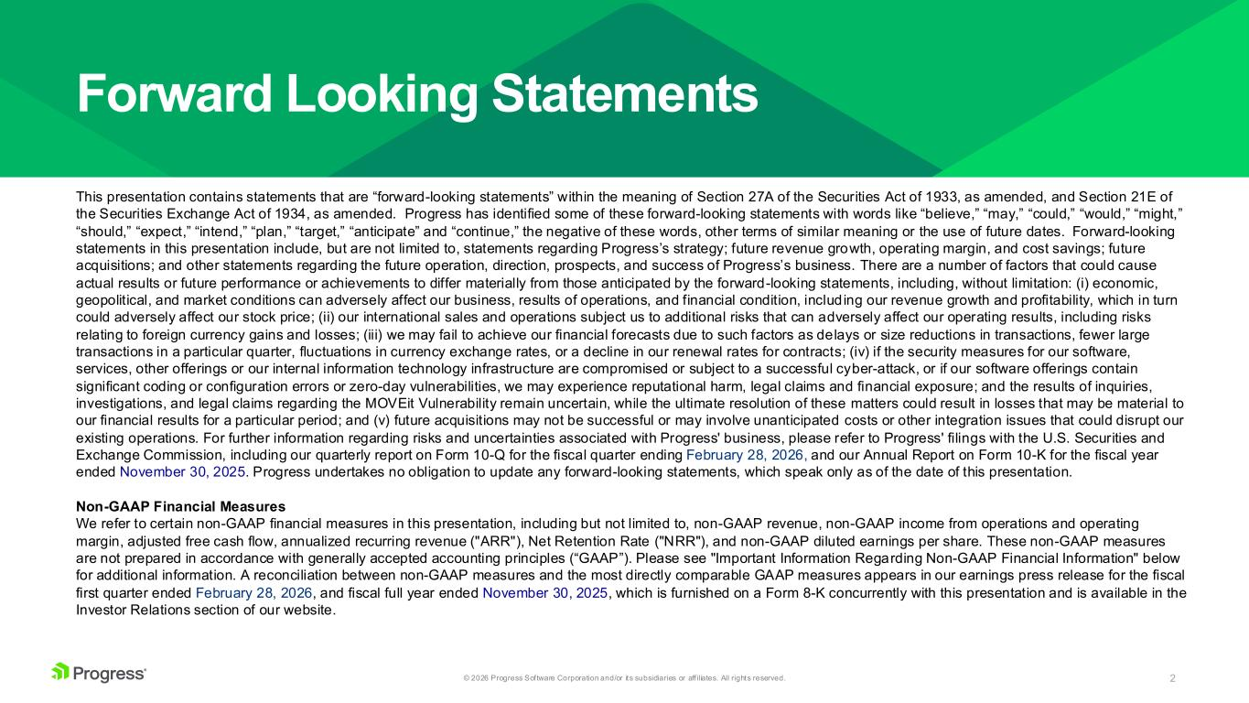
2© 2026 Progress Software Corporation and/or its subsidiaries or aff iliates. All rights reserved. Forward Looking Statements This presentation contains statements that are “forward-looking statements” within the meaning of Section 27A of the Securities Act of 1933, as amended, and Section 21E of the Securities Exchange Act of 1934, as amended. Progress has identified some of these forward-looking statements with words like “believe,” “may,” “could,” “would,” “might,” “should,” “expect,” “intend,” “plan,” “target,” “anticipate” and “continue,” the negative of these words, other terms of similar meaning or the use of future dates. Forward-looking statements in this presentation include, but are not limited to, statements regarding Progress’s strategy; future revenue growth, operating margin, and cost savings; future acquisitions; and other statements regarding the future operation, direction, prospects, and success of Progress’s business. There are a number of factors that could cause actual results or future performance or achievements to differ materially from those anticipated by the forward-looking statements, including, without limitation: (i) economic, geopolitical, and market conditions can adversely affect our business, results of operations, and financial condition, including our revenue growth and profitability, which in turn could adversely affect our stock price; (ii) our international sales and operations subject us to additional risks that can adversely affect our operating results, including risks relating to foreign currency gains and losses; (iii) we may fail to achieve our financial forecasts due to such factors as delays or size reductions in transactions, fewer large transactions in a particular quarter, fluctuations in currency exchange rates, or a decline in our renewal rates for contracts; (iv) if the security measures for our software, services, other offerings or our internal information technology infrastructure are compromised or subject to a successful cyber-attack, or if our software offerings contain significant coding or configuration errors or zero-day vulnerabilities, we may experience reputational harm, legal claims and financial exposure; and the results of inquiries, investigations, and legal claims regarding the MOVEit Vulnerability remain uncertain, while the ultimate resolution of these matters could result in losses that may be material to our financial results for a particular period; and (v) future acquisitions may not be successful or may involve unanticipated costs or other integration issues that could disrupt our existing operations. For further information regarding risks and uncertainties associated with Progress' business, please refer to Progress' filings with the U.S. Securities and Exchange Commission, including our quarterly report on Form 10-Q for the fiscal quarter ending February 28, 2026, and our Annual Report on Form 10-K for the fiscal year ended November 30, 2025. Progress undertakes no obligation to update any forward-looking statements, which speak only as of the date of this presentation. Non-GAAP Financial Measures We refer to certain non-GAAP financial measures in this presentation, including but not limited to, non-GAAP revenue, non-GAAP income from operations and operating margin, adjusted free cash flow, annualized recurring revenue ("ARR"), Net Retention Rate ("NRR"), and non-GAAP diluted earnings per share. These non-GAAP measures are not prepared in accordance with generally accepted accounting principles (“GAAP”). Please see "Important Information Regarding Non-GAAP Financial Information" below for additional information. A reconciliation between non-GAAP measures and the most directly comparable GAAP measures appears in our earnings press release for the fiscal first quarter ended February 28, 2026, and fiscal full year ended November 30, 2025, which is furnished on a Form 8-K concurrently with this presentation and is available in the Investor Relations section of our website.

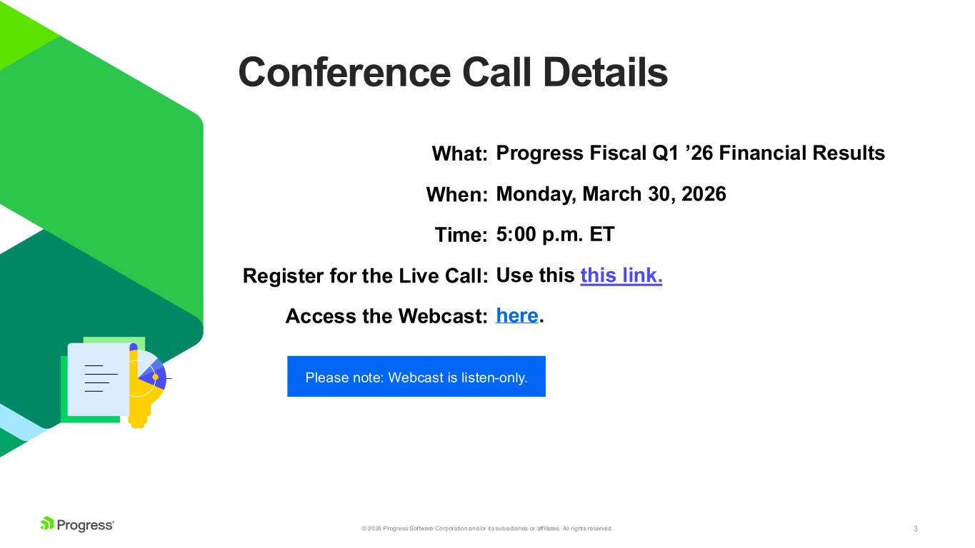
3© 2026 Progress Software Corporation and/or its subsidiaries or aff iliates. All rights reserved. Conference Call Details Please note: Webcast is listen-only. What: When: Time: Register for the Live Call: Access the Webcast: Progress Fiscal Q1 ’26 Financial Results Monday, March 30, 2026 5:00 p.m. ET Use this this link. here.

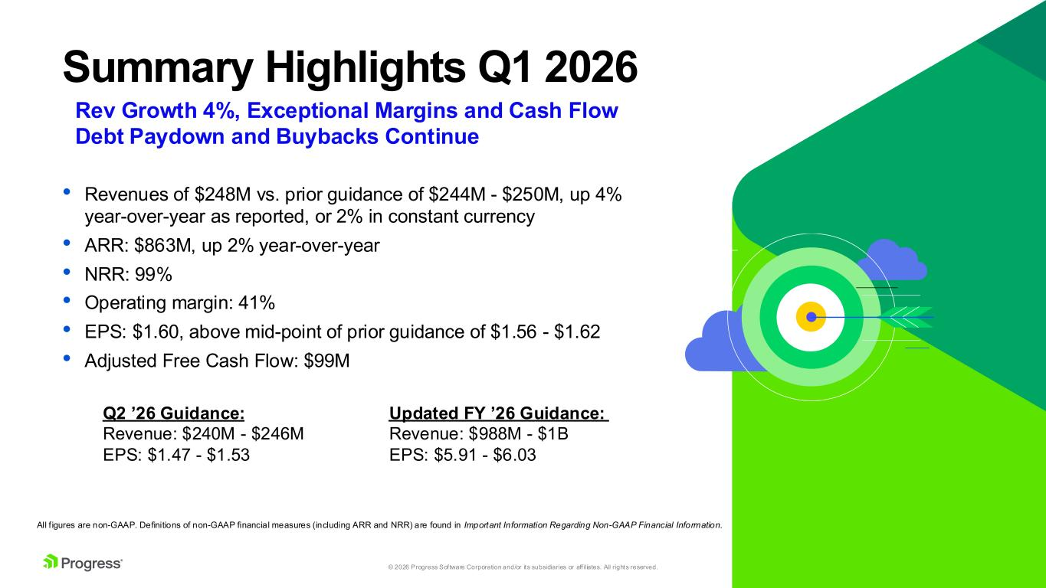
4© 2026 Progress Software Corporation and/or its subsidiaries or aff iliates. All rights reserved. Summary Highlights Q1 2026 • Revenues of $248M vs. prior guidance of $244M - $250M, up 4% year-over-year as reported, or 2% in constant currency • ARR: $863M, up 2% year-over-year • NRR: 99% • Operating margin: 41% • EPS: $1.60, above mid-point of prior guidance of $1.56 - $1.62 • Adjusted Free Cash Flow: $99M All f igures are non-GAAP. Definitions of non-GAAP financial measures (including ARR and NRR) are found in Important Information Regarding Non-GAAP Financial Information. Rev Growth 4%, Exceptional Margins and Cash Flow Debt Paydown and Buybacks Continue Updated FY ’26 Guidance: Revenue: $988M - $1B EPS: $5.91 - $6.03 Q2 ’26 Guidance: Revenue: $240M - $246M EPS: $1.47 - $1.53

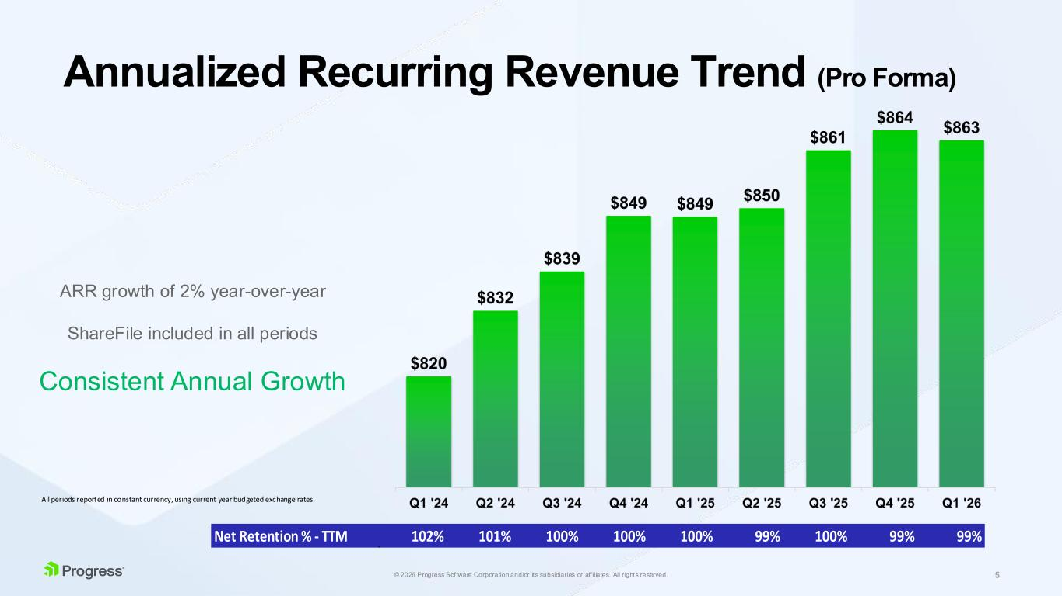
5© 2026 Progress Software Corporation and/or its subsidiaries or aff iliates. All rights reserved. Net Retention % - TTM 102% 101% 100% 100% 100% 99% 100% 99% 99% Annualized Recurring Revenue Trend (Pro Forma) All periods reported in constant currency, using current year budgeted exchange rates ARR growth of 2% year-over-year ShareFile included in all periods Consistent Annual Growth

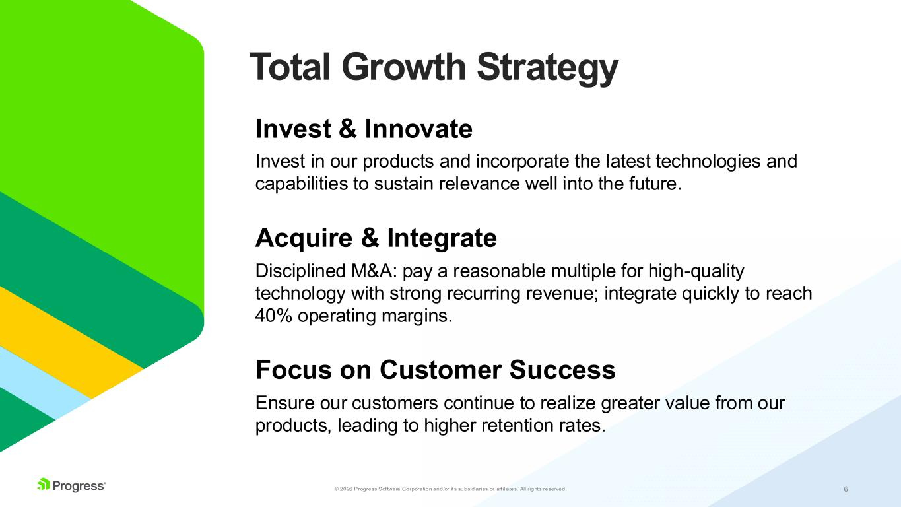
6© 2026 Progress Software Corporation and/or its subsidiaries or aff iliates. All rights reserved. Total Growth Strategy Invest & Innovate Invest in our products and incorporate the latest technologies and capabilities to sustain relevance well into the future. Acquire & Integrate Disciplined M&A: pay a reasonable multiple for high-quality technology with strong recurring revenue; integrate quickly to reach 40% operating margins. Focus on Customer Success Ensure our customers continue to realize greater value from our products, leading to higher retention rates.

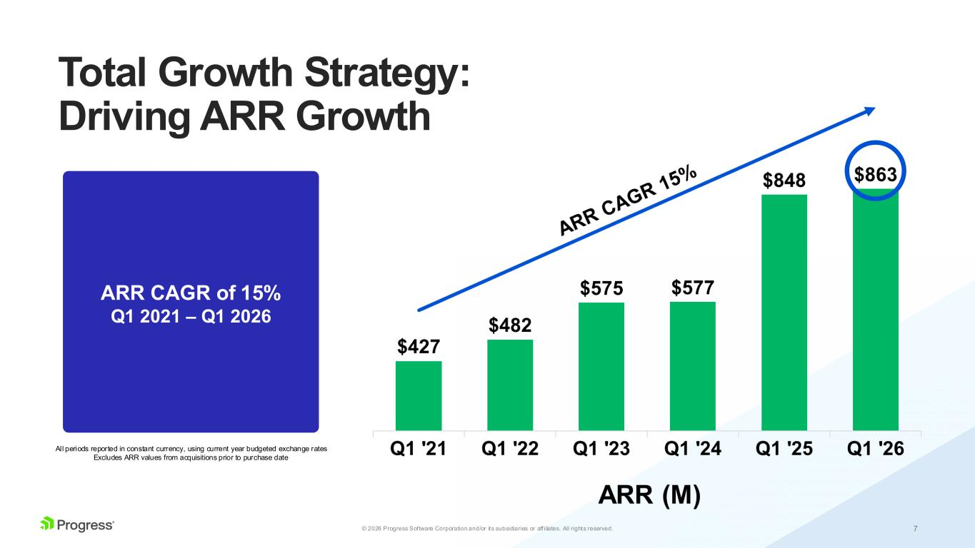
7© 2026 Progress Software Corporation and/or its subsidiaries or aff iliates. All rights reserved. Total Growth Strategy: Driving ARR Growth ARR CAGR of 15% Q1 2021 – Q1 2026 All periods reported in constant currency, using current year budgeted exchange rates Excludes ARR values from acquisitions prior to purchase date

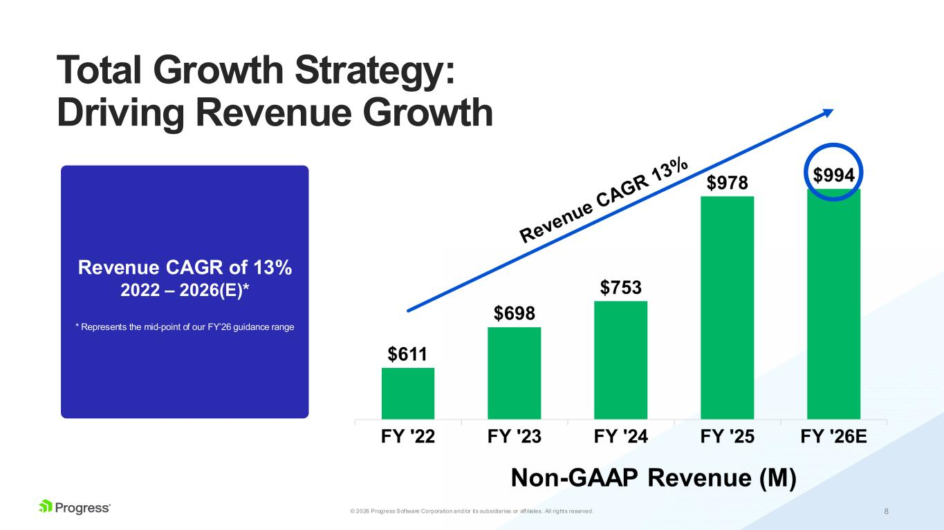
8© 2026 Progress Software Corporation and/or its subsidiaries or aff iliates. All rights reserved. Total Growth Strategy: Driving Revenue Growth Revenue CAGR of 13% 2022 – 2026(E)* * Represents the mid-point of our FY’26 guidance range

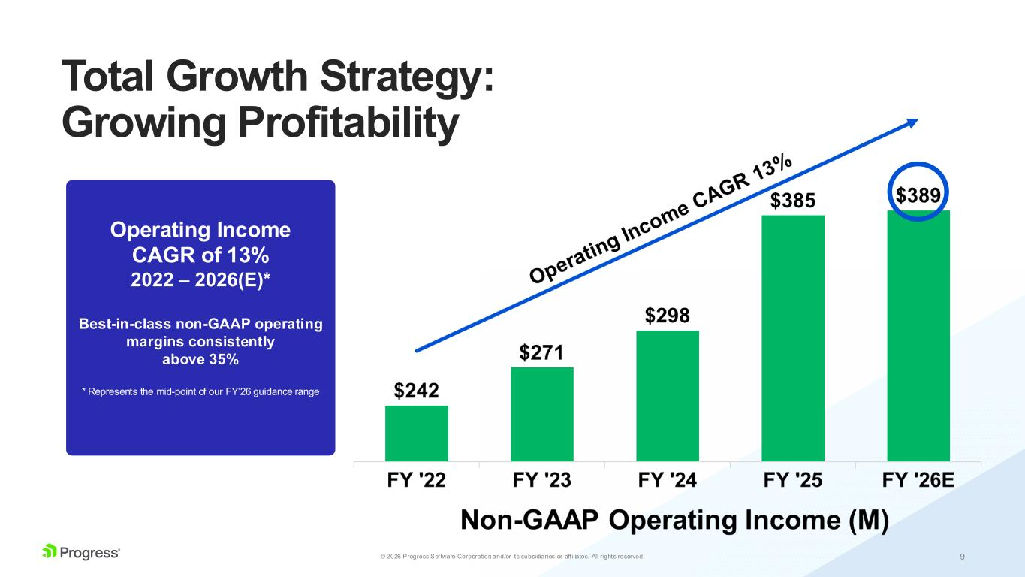
9© 2026 Progress Software Corporation and/or its subsidiaries or aff iliates. All rights reserved. Operating Income CAGR of 13% 2022 – 2026(E)* Best-in-class non-GAAP operating margins consistently above 35% * Represents the mid-point of our FY’26 guidance range Total Growth Strategy: Growing Profitability

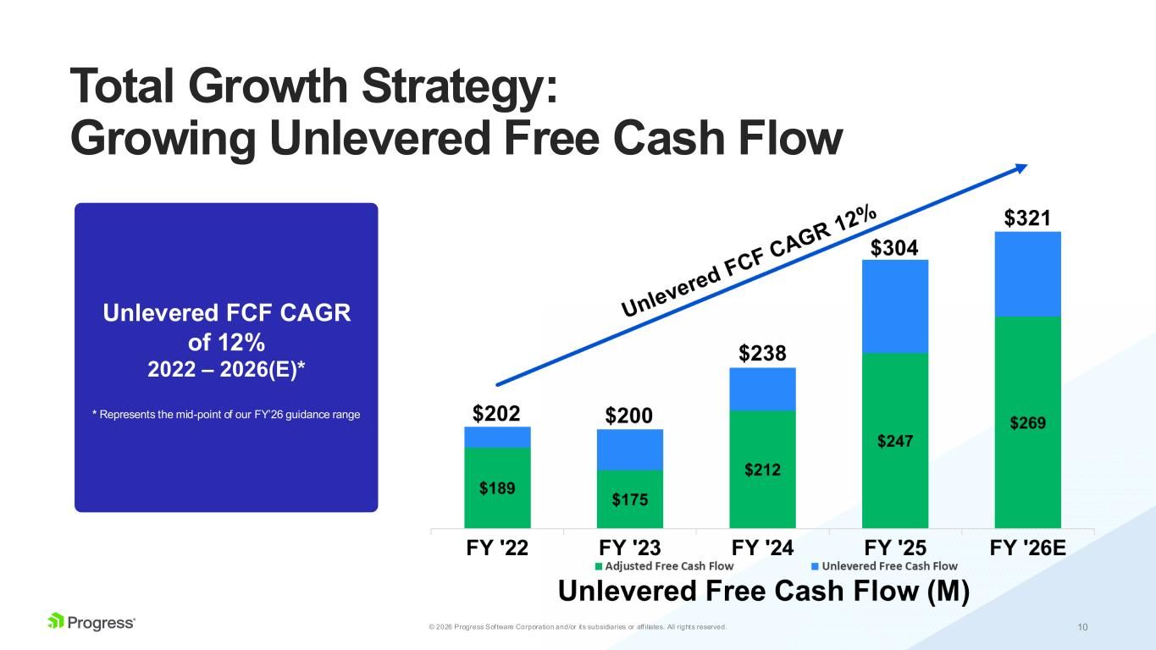
10© 2026 Progress Software Corporation and/or its subsidiaries or aff iliates. All rights reserved. Unlevered FCF CAGR of 12% 2022 – 2026(E)* * Represents the mid-point of our FY’26 guidance range Total Growth Strategy: Growing Unlevered Free Cash Flow

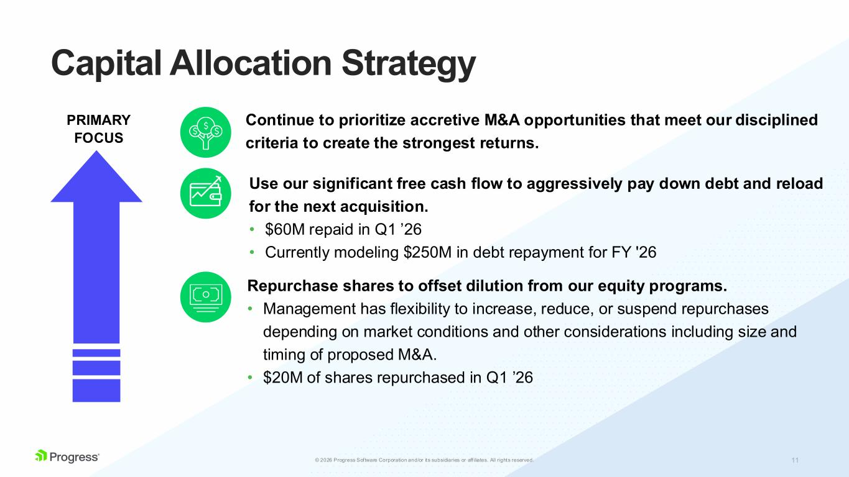
11© 2025 Progress Software Corporation and/or its subsidiaries or aff iliates. All rights reserved.6 Capital Allocation Strategy PRIMARY FOCUS Continue to prioritize accretive M&A opportunities that meet our disciplined criteria to create the strongest returns. Repurchase shares to offset dilution from our equity programs. • Management has flexibility to increase, reduce, or suspend repurchases depending on market conditions and other considerations including size and timing of proposed M&A. • $20M of shares repurchased in Q1 ’26 Use our significant free cash flow to aggressively pay down debt and reload for the next acquisition. • $60M repaid in Q1 ’26 • Currently modeling $250M in debt repayment for FY '26

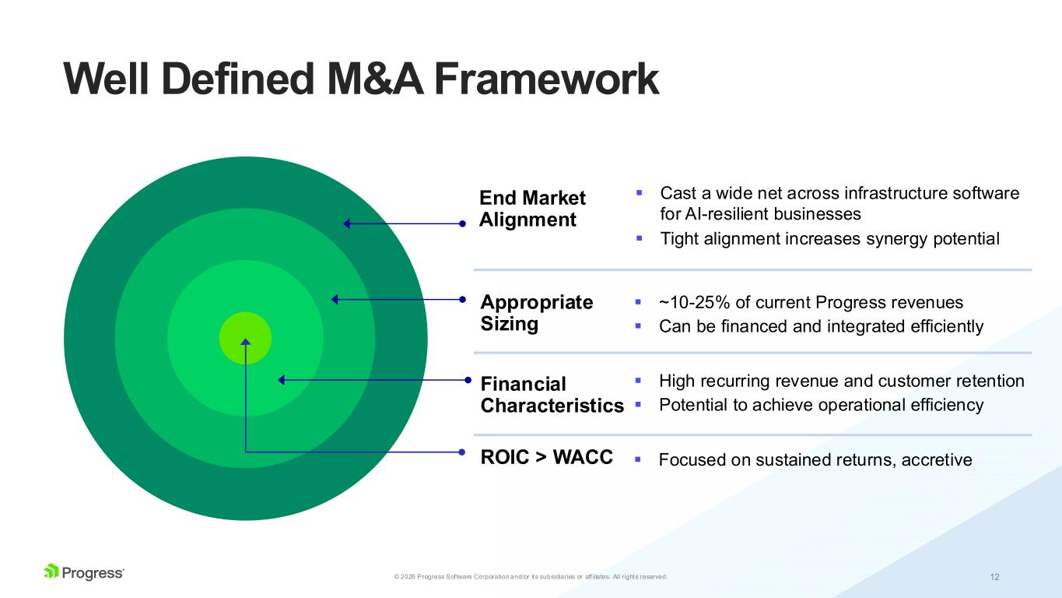
12© 2026 Progress Software Corporation and/or its subsidiaries or aff iliates. All rights reserved. Well Defined M&A Framework ▪ Cast a wide net across infrastructure software for AI-resilient businesses ▪ Tight alignment increases synergy potential ▪ ~10-25% of current Progress revenues ▪ Can be financed and integrated efficiently ▪ High recurring revenue and customer retention ▪ Potential to achieve operational efficiency ▪ Focused on sustained returns, accretiveROIC > WACC Financial Characteristics Appropriate Sizing End Market Alignment

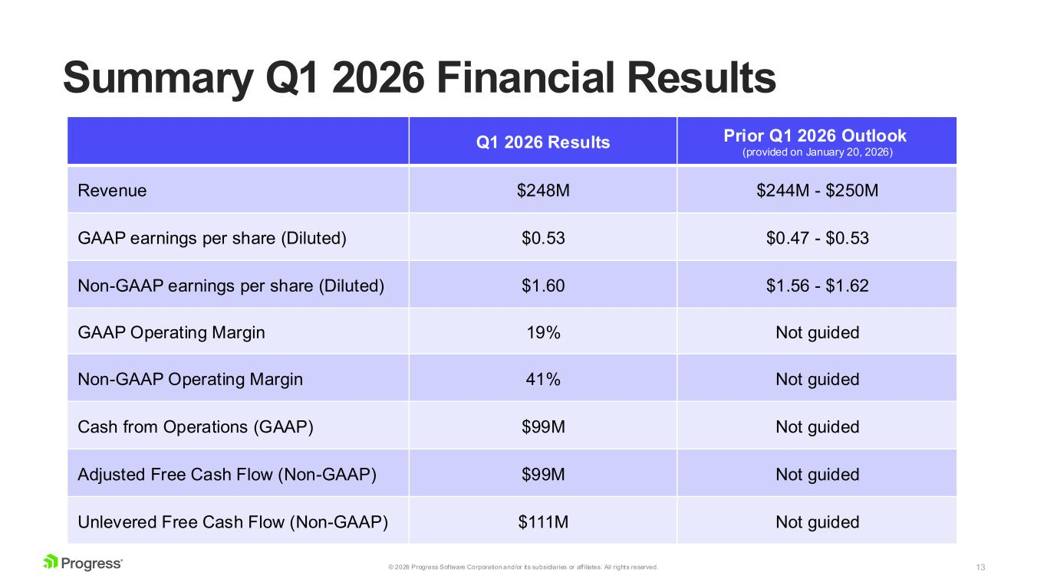
13© 2026 Progress Software Corporation and/or its subsidiaries or aff iliates. All rights reserved. Summary Q1 2026 Financial Results Q1 2026 Results Prior Q1 2026 Outlook (provided on January 20, 2026) Revenue $248M $244M - $250M GAAP earnings per share (Diluted) $0.53 $0.47 - $0.53 Non-GAAP earnings per share (Diluted) $1.60 $1.56 - $1.62 GAAP Operating Margin 19% Not guided Non-GAAP Operating Margin 41% Not guided Cash from Operations (GAAP) $99M Not guided Adjusted Free Cash Flow (Non-GAAP) $99M Not guided Unlevered Free Cash Flow (Non-GAAP) $111M Not guided

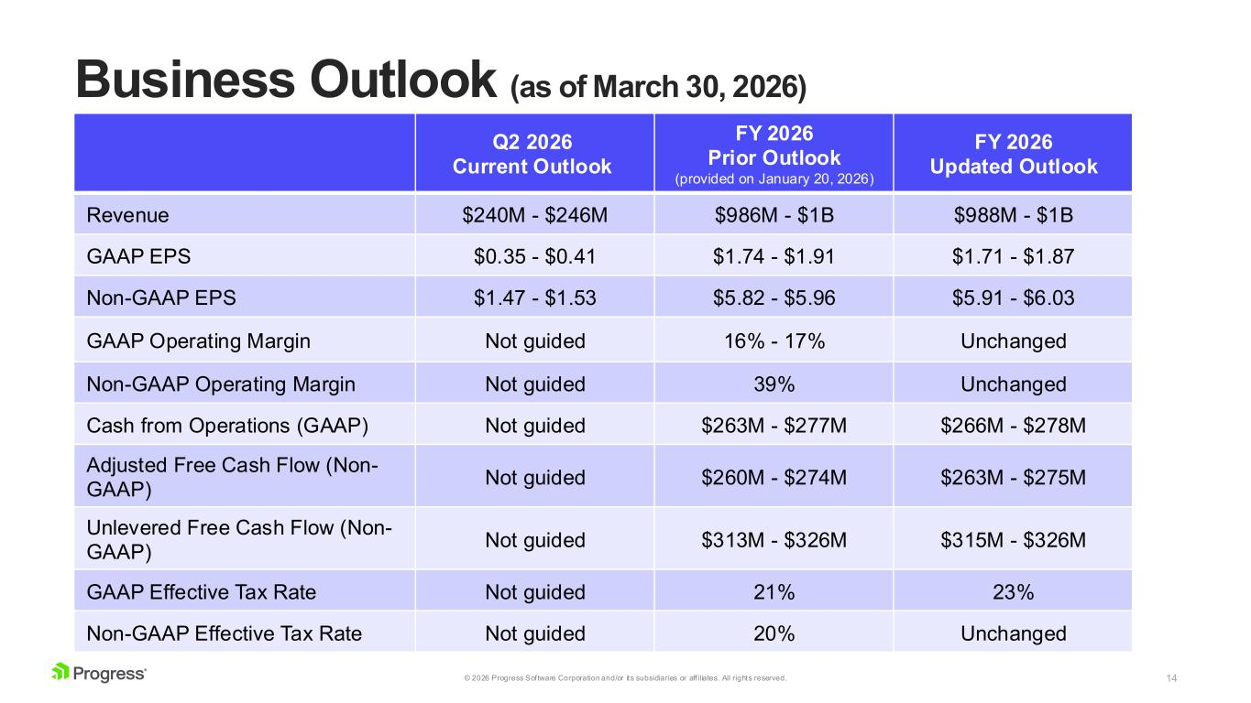
14© 2026 Progress Software Corporation and/or its subsidiaries or aff iliates. All rights reserved. Business Outlook (as of March 30, 2026) Q2 2026 Current Outlook FY 2026 Prior Outlook (provided on January 20, 2026) FY 2026 Updated Outlook Revenue $240M - $246M $986M - $1B $988M - $1B GAAP EPS $0.35 - $0.41 $1.74 - $1.91 $1.71 - $1.87 Non-GAAP EPS $1.47 - $1.53 $5.82 - $5.96 $5.91 - $6.03 GAAP Operating Margin Not guided 16% - 17% Unchanged Non-GAAP Operating Margin Not guided 39% Unchanged Cash from Operations (GAAP) Not guided $263M - $277M $266M - $278M Adjusted Free Cash Flow (Non- GAAP) Not guided $260M - $274M $263M - $275M Unlevered Free Cash Flow (Non- GAAP) Not guided $313M - $326M $315M - $326M GAAP Effective Tax Rate Not guided 21% 23% Non-GAAP Effective Tax Rate Not guided 20% Unchanged

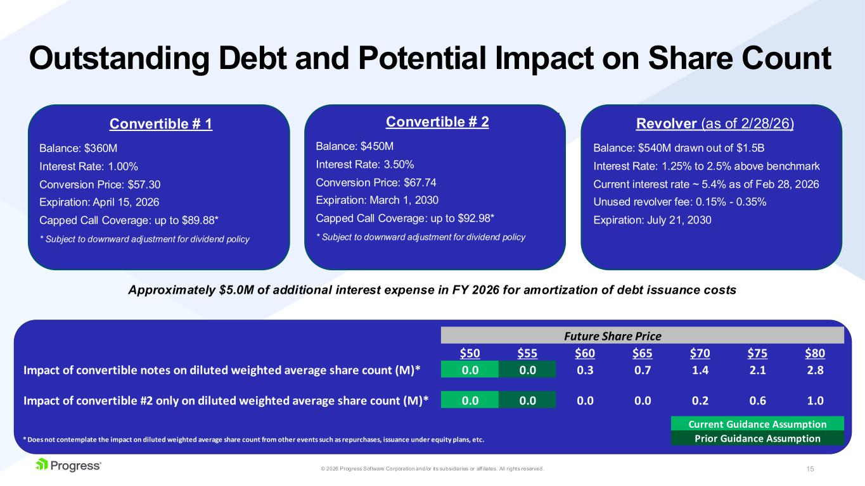
15© 2026 Progress Software Corporation and/or its subsidiaries or aff iliates. All rights reserved. Outstanding Debt and Potential Impact on Share Count Convertible # 1 Balance: $360M Interest Rate: 1.00% Conversion Price: $57.30 Expiration: April 15, 2026 Capped Call Coverage: up to $89.88* * Subject to downward adjustment for dividend policy Convertible # 2 Balance: $450M Interest Rate: 3.50% Conversion Price: $67.74 Expiration: March 1, 2030 Capped Call Coverage: up to $92.98* * Subject to downward adjustment for dividend policy Revolver (as of 2/28/26) Balance: $540M drawn out of $1.5B Interest Rate: 1.25% to 2.5% above benchmark Current interest rate ~ 5.4% as of Feb 28, 2026 Unused revolver fee: 0.15% - 0.35% Expiration: July 21, 2030 Approximately $5.0M of additional interest expense in FY 2026 for amortization of debt issuance costs $50 $55 $60 $65 $70 $75 $80 Impact of convertible notes on diluted weighted average share count (M)* 0.0 0.0 0.3 0.7 1.4 2.1 2.8 Impact of convertible #2 only on diluted weighted average share count (M)* 0.0 0.0 0.0 0.0 0.2 0.6 1.0 Current Guidance Assumption * Does not contemplate the impact on diluted weighted average share count from other events such as repurchases, issuance under equity plans, etc. Prior Guidance Assumption Future Share Price

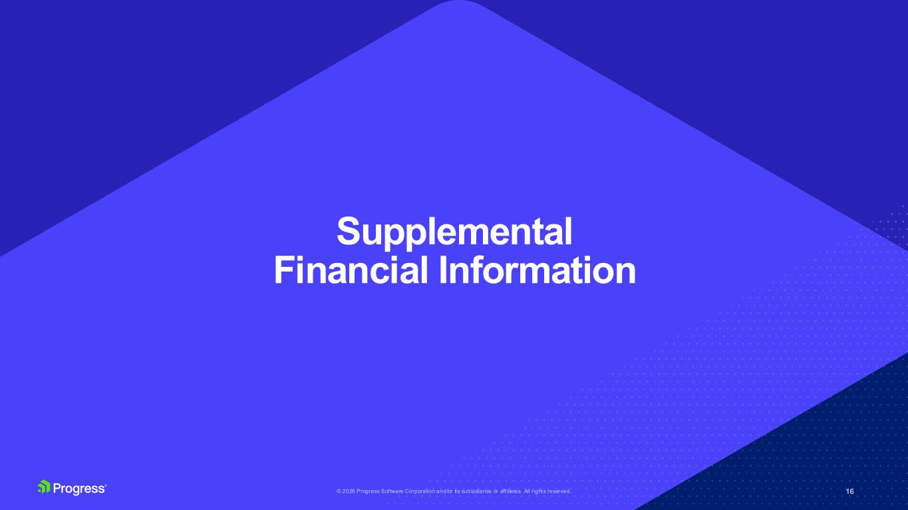
Supplemental Financial Information

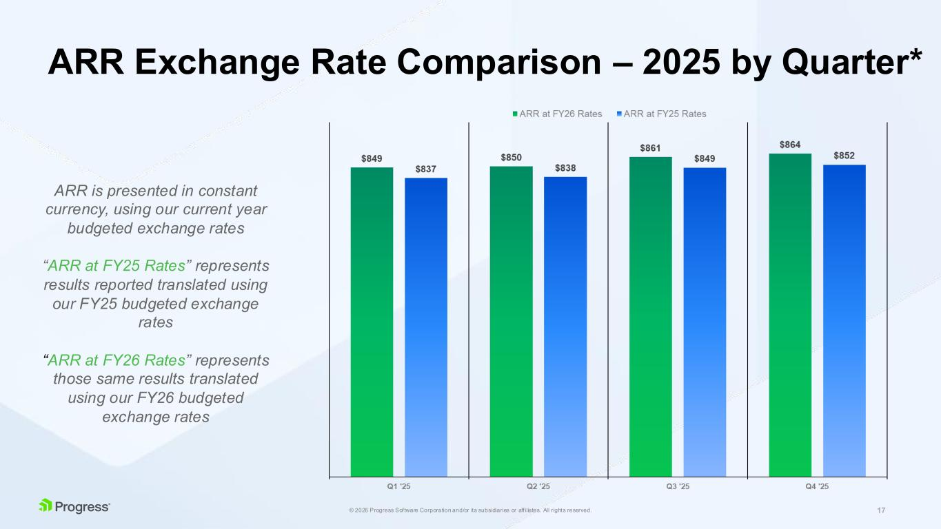
17© 2026 Progress Software Corporation and/or its subsidiaries or aff iliates. All rights reserved. ARR Exchange Rate Comparison – 2025 by Quarter* ARR is presented in constant currency, using our current year budgeted exchange rates “ARR at FY25 Rates” represents results reported translated using our FY25 budgeted exchange rates “ARR at FY26 Rates” represents those same results translated using our FY26 budgeted exchange rates

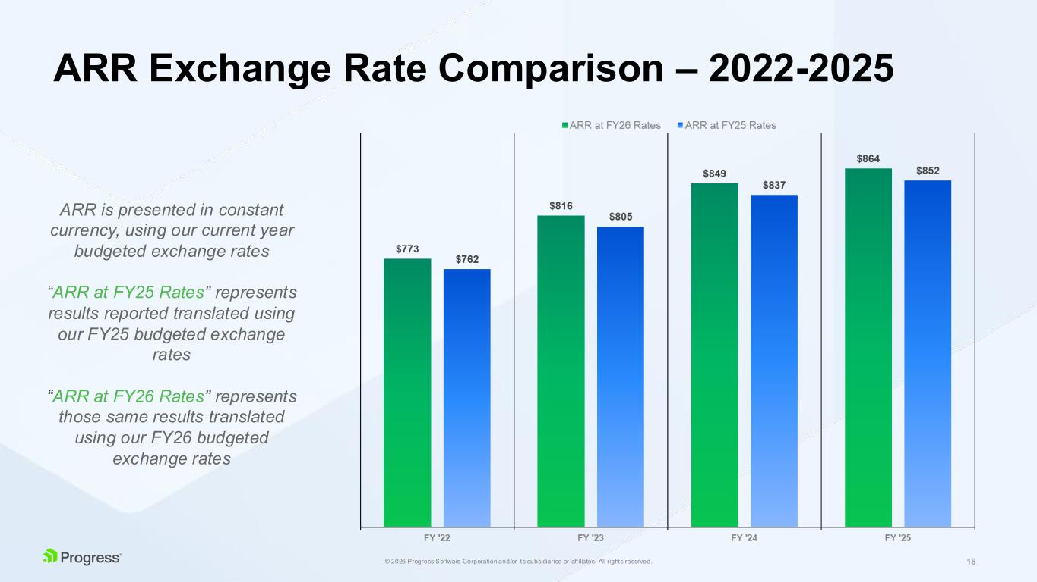
18© 2026 Progress Software Corporation and/or its subsidiaries or aff iliates. All rights reserved. ARR Exchange Rate Comparison – 2022-2025 ARR is presented in constant currency, using our current year budgeted exchange rates “ARR at FY25 Rates” represents results reported translated using our FY25 budgeted exchange rates “ARR at FY26 Rates” represents those same results translated using our FY26 budgeted exchange rates

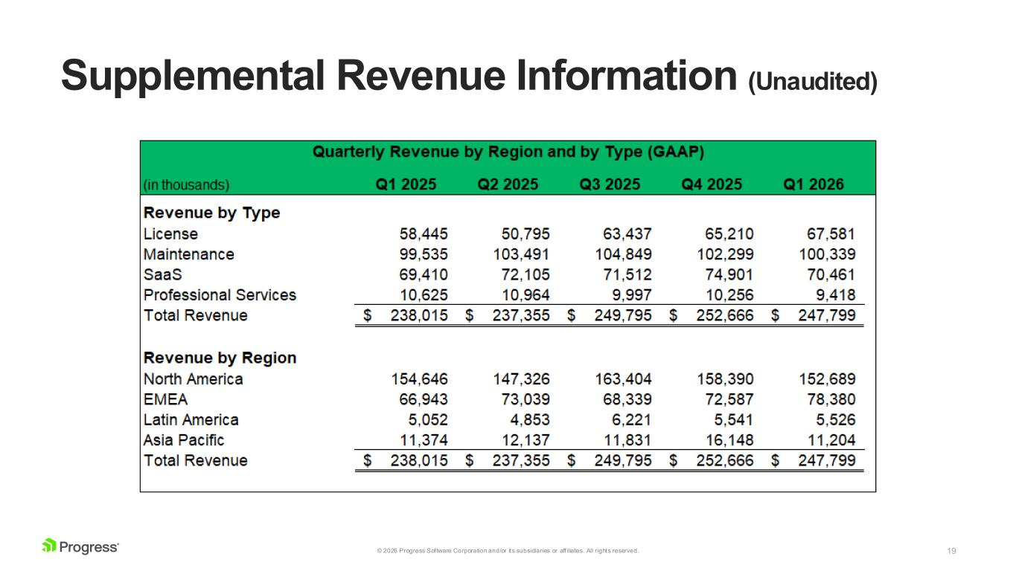
19© 2026 Progress Software Corporation and/or its subsidiaries or aff iliates. All rights reserved. Supplemental Revenue Information (Unaudited)

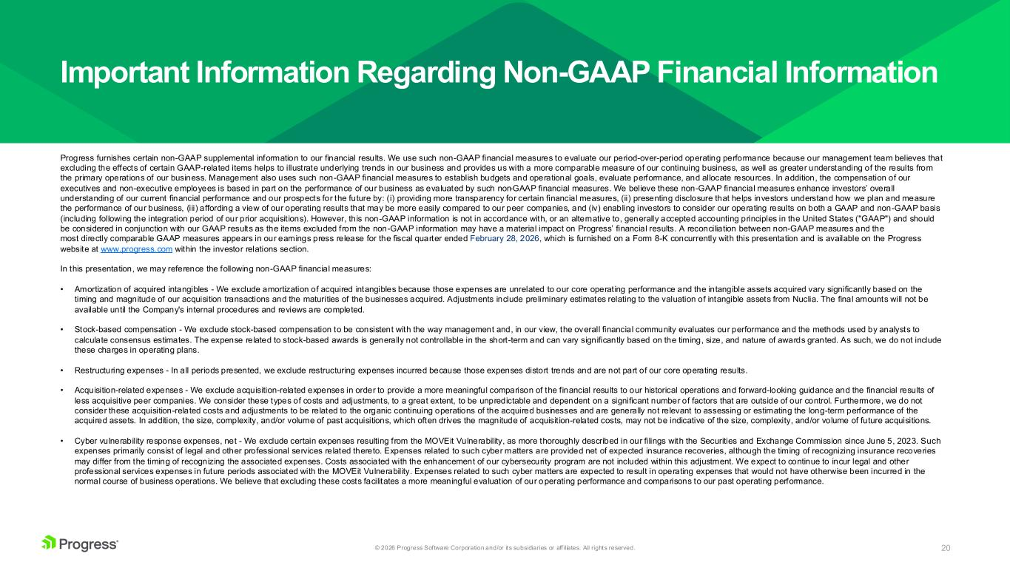
20© 2026 Progress Software Corporation and/or its subsidiaries or aff iliates. All rights reserved. Progress furnishes certain non-GAAP supplemental information to our financial results. We use such non-GAAP financial measures to evaluate our period-over-period operating performance because our management team believes that excluding the effects of certain GAAP-related items helps to illustrate underlying trends in our business and provides us with a more comparable measure of our continuing business, as well as greater understanding of the results from the primary operations of our business. Management also uses such non-GAAP financial measures to establish budgets and operational goals, evaluate performance, and allocate resources. In addition, the compensation of our executives and non-executive employees is based in part on the performance of our business as evaluated by such non-GAAP financial measures. We believe these non-GAAP financial measures enhance investors’ overall understanding of our current financial performance and our prospects for the future by: (i) providing more transparency for certain financial measures, (ii) presenting disclosure that helps investors understand how we plan and measure the performance of our business, (iii) affording a view of our operating results that may be more easily compared to our peer companies, and (iv) enabling investors to consider our operating results on both a GAAP and non-GAAP basis (including following the integration period of our prior acquisit ions). However, this non-GAAP information is not in accordance with, or an alternative to, generally accepted accounting principles in the United States ("GAAP") and should be considered in conjunction with our GAAP results as the items excluded from the non-GAAP information may have a material impact on Progress’ financial results. A reconciliation between non-GAAP measures and the most directly comparable GAAP measures appears in our earnings press release for the fiscal quarter ended February 28, 2026, which is furnished on a Form 8-K concurrently with this presentation and is available on the Progress website at www.progress.com within the investor relations section. In this presentation, we may reference the following non-GAAP financial measures: • Amortization of acquired intangibles - We exclude amortization of acquired intangibles because those expenses are unrelated to our core operating performance and the intangible assets acquired vary significantly based on the timing and magnitude of our acquisition transactions and the maturities of the businesses acquired. Adjustments include preliminary estimates relating to the valuation of intangible assets from Nuclia. The final amounts will not be available until the Company's internal procedures and reviews are completed. • Stock-based compensation - We exclude stock-based compensation to be consistent with the way management and, in our view, the overall financial community evaluates our performance and the methods used by analysts to calculate consensus estimates. The expense related to stock-based awards is generally not controllable in the short-term and can vary significantly based on the timing, size, and nature of awards granted. As such, we do not include these charges in operating plans. • Restructuring expenses - In all periods presented, we exclude restructuring expenses incurred because those expenses distort trends and are not part of our core operating results. • Acquisition-related expenses - We exclude acquisition-related expenses in order to provide a more meaningful comparison of the financial results to our historical operations and forward-looking guidance and the financial results of less acquisitive peer companies. We consider these types of costs and adjustments, to a great extent, to be unpredictable and dependent on a significant number of factors that are outside of our control. Furthermore, we do not consider these acquisition-related costs and adjustments to be related to the organic continuing operations of the acquired businesses and are generally not relevant to assessing or estimating the long-term performance of the acquired assets. In addition, the size, complexity, and/or volume of past acquisitions, which often drives the magnitude of acquisit ion-related costs, may not be indicative of the size, complexity, and/or volume of future acquisitions. • Cyber vulnerability response expenses, net - We exclude certain expenses resulting from the MOVEit Vulnerability, as more thoroughly described in our filings with the Securities and Exchange Commission since June 5, 2023. Such expenses primarily consist of legal and other professional services related thereto. Expenses related to such cyber matters are provided net of expected insurance recoveries, although the timing of recognizing insurance recoveries may differ from the timing of recognizing the associated expenses. Costs associated with the enhancement of our cybersecurity program are not included within this adjustment. We expect to continue to incur legal and other professional services expenses in future periods associated with the MOVEit Vulnerability. Expenses related to such cyber matters are expected to result in operating expenses that would not have otherwise been incurred in the normal course of business operations. We believe that excluding these costs facilitates a more meaningful evaluation of our operating performance and comparisons to our past operating performance. Important Information Regarding Non-GAAP Financial Information

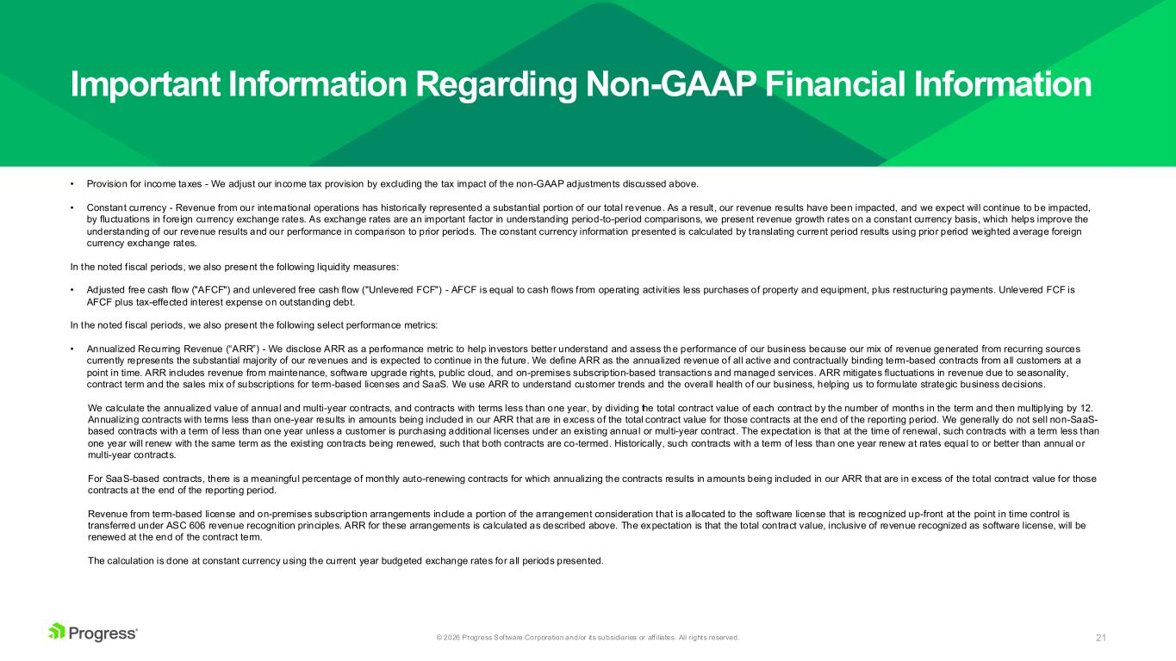
21© 2026 Progress Software Corporation and/or its subsidiaries or aff iliates. All rights reserved. Important Information Regarding Non-GAAP Financial Information • Provision for income taxes - We adjust our income tax provision by excluding the tax impact of the non-GAAP adjustments discussed above. • Constant currency - Revenue from our international operations has historically represented a substantial portion of our total revenue. As a result, our revenue results have been impacted, and we expect will continue to be impacted, by fluctuations in foreign currency exchange rates. As exchange rates are an important factor in understanding period-to-period comparisons, we present revenue growth rates on a constant currency basis, which helps improve the understanding of our revenue results and our performance in comparison to prior periods. The constant currency information presented is calculated by translating current period results using prior period weighted average foreign currency exchange rates. In the noted f iscal periods, we also present the following liquidity measures: • Adjusted free cash flow ("AFCF") and unlevered free cash flow ("Unlevered FCF") - AFCF is equal to cash flows from operating activit ies less purchases of property and equipment, plus restructuring payments. Unlevered FCF is AFCF plus tax-effected interest expense on outstanding debt. In the noted f iscal periods, we also present the following select performance metrics: • Annualized Recurring Revenue (“ARR”) - We disclose ARR as a performance metric to help investors better understand and assess the performance of our business because our mix of revenue generated from recurring sources currently represents the substantial majority of our revenues and is expected to continue in the future. We define ARR as the annualized revenue of all active and contractually binding term-based contracts from all customers at a point in time. ARR includes revenue from maintenance, software upgrade rights, public cloud, and on-premises subscription-based transactions and managed services. ARR mitigates fluctuations in revenue due to seasonality, contract term and the sales mix of subscriptions for term-based licenses and SaaS. We use ARR to understand customer trends and the overall health of our business, helping us to formulate strategic business decisions. We calculate the annualized value of annual and multi-year contracts, and contracts with terms less than one year, by dividing the total contract value of each contract by the number of months in the term and then multiplying by 12. Annualizing contracts with terms less than one-year results in amounts being included in our ARR that are in excess of the total contract value for those contracts at the end of the reporting period. We generally do not sell non-SaaS- based contracts with a term of less than one year unless a customer is purchasing additional licenses under an existing annual or multi-year contract. The expectation is that at the time of renewal, such contracts with a term less than one year will renew with the same term as the existing contracts being renewed, such that both contracts are co-termed. Historically, such contracts with a term of less than one year renew at rates equal to or better than annual or multi-year contracts. For SaaS-based contracts, there is a meaningful percentage of monthly auto-renewing contracts for which annualizing the contracts results in amounts being included in our ARR that are in excess of the total contract value for those contracts at the end of the reporting period. Revenue from term-based license and on-premises subscription arrangements include a portion of the arrangement consideration that is allocated to the software license that is recognized up-front at the point in time control is transferred under ASC 606 revenue recognition principles. ARR for these arrangements is calculated as described above. The expectation is that the total contract value, inclusive of revenue recognized as software license, will be renewed at the end of the contract term. The calculation is done at constant currency using the current year budgeted exchange rates for all periods presented.

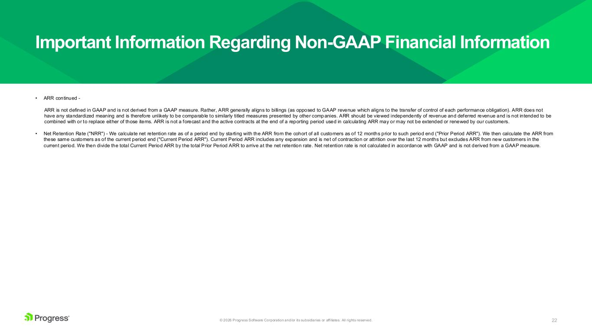
22© 2026 Progress Software Corporation and/or its subsidiaries or aff iliates. All rights reserved. Important Information Regarding Non-GAAP Financial Information • ARR continued - ARR is not defined in GAAP and is not derived from a GAAP measure. Rather, ARR generally aligns to billings (as opposed to GAAP revenue which aligns to the transfer of control of each performance obligation). ARR does not have any standardized meaning and is therefore unlikely to be comparable to similarly titled measures presented by other comp anies. ARR should be viewed independently of revenue and deferred revenue and is not intended to be combined with or to replace either of those items. ARR is not a forecast and the active contracts at the end of a reporting period used in calculating ARR may or may not be extended or renewed by our customers. • Net Retention Rate ("NRR") - We calculate net retention rate as of a period end by starting with the ARR from the cohort of all customers as of 12 months prior to such period end ("Prior Period ARR"). We then calculate the ARR from these same customers as of the current period end ("Current Period ARR"). Current Period ARR includes any expansion and is net of contraction or attrition over the last 12 months but excludes ARR from new customers in the current period. We then divide the total Current Period ARR by the total Prior Period ARR to arrive at the net retention rate. Net retention rate is not calculated in accordance with GAAP and is not derived from a GAAP measure.



